Name ___________________________________

Aldenham School

Year 12 into Year 13 Psychology Summer Prep 2019

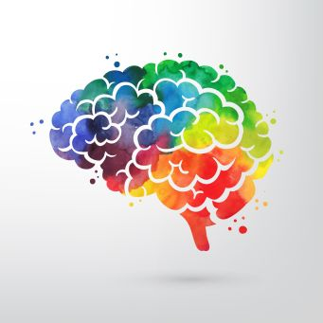

Prep submission date: Friday 13th September 2019

You can email your answers to [vevagora@aldenham.com](mailto:vevagora@aldenham.com)

Aldenham School follows the OCR Psychology A Level specification [(H567)](http://www.ocr.org.uk/qualifications/as-a-level-gce/as-a-level-gce-psychology-h167-h567-from-2015/)

www.aldenhampsychology.com

Paper 1: Inferential Statistics

Inferential statistics allow us to draw conclusions from findings.

They allow us to see whether our results are the result of something happening, or are just down to chance.

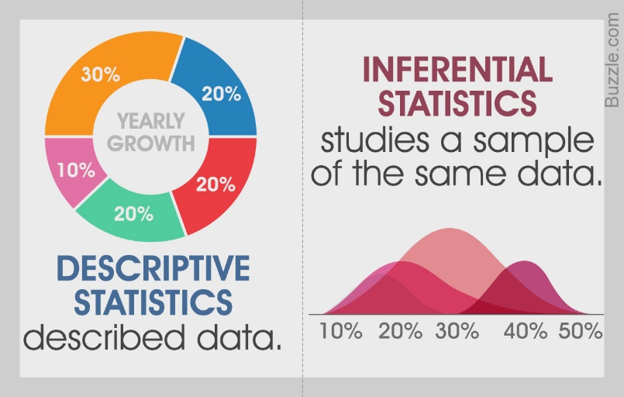

In every psychological experiment, we have a **sample** which is a group of participants which are drawn from the **target population.** The aim of the study is to take the results from our sample and apply them back to our target population.

Statistical tests are classified into two types Parametric and Non-parametric.

1. Identify the 4 criteria / assumptions for using **parametric** tests. [4]

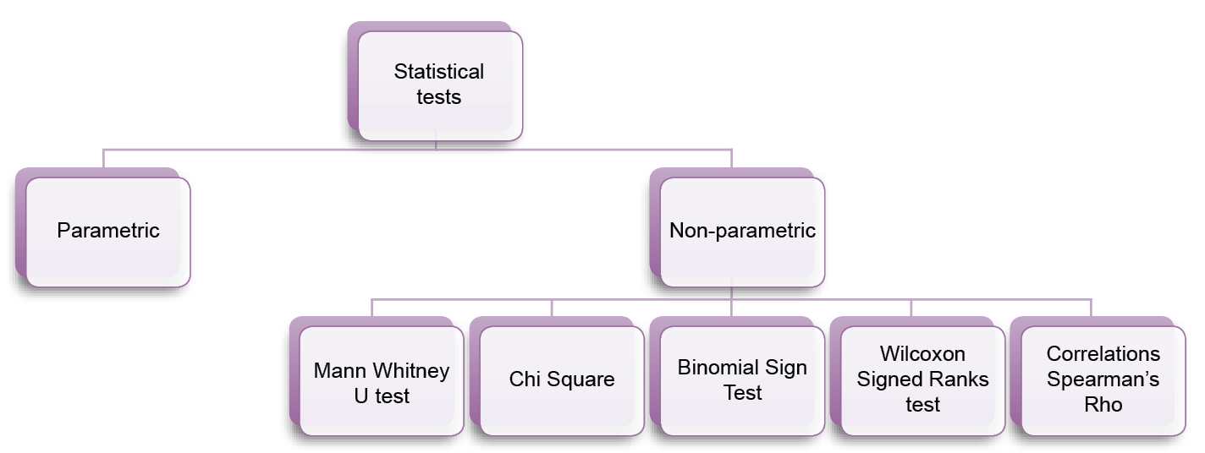We have studied 5 non-parametric tests. These are:

* Mann-Whitney U Test
* Wilcoxon Signed Ranks test
* Chi-Square
* Binomial Sign Test
* Spearman’s Rho.

2. Identify the steps needed to be taken to calculate each of the following non-parametric tests. You can use the PowerPoint at <http://www.aldenhampsychology.com/inferential-statistics.html> or the following pages in your yellow text book to help you:

1. The 8 steps to calculate Mann-Whitney U Test (page 45). [8]
2. The 7 steps to calculate Wilcoxon Signed Ranks test (page 45). [7]
3. The 5 steps to calculate **Chi-Square** (page 46). [5]
4. The 7 steps to calculate Binomial Sign Test (page 43). [7]
5. The 7 steps to calculate Spearman’s Rho (page 47). [7]

Paper 2: Debates

The issues and debates in Psychology look at some of the important arguments about HOW to conduct research and HOW explain behaviour.

These issues and debates are applied to the Core Studies and Key Research, as well as the topics in Paper 3.

3. Identify which side of the debate you belong to for each of the following. Explain one reason why you have this view.

1. Nature / nurture [3]
2. Free will / determinism [3]
3. Reductionism / holism [3]
4. Individual explanations / situational explanations of behaviour [3]
5. Is Psychology a science? [3]
6. Should socially sensitive research be conducted? [3]

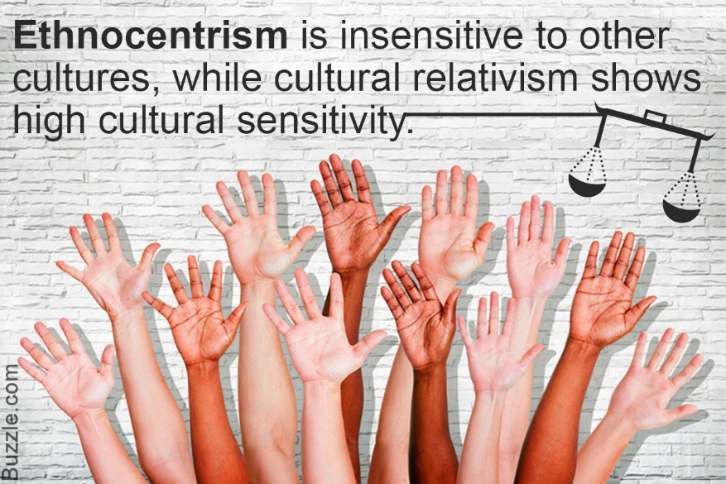Ethnocentrism has 2 versions:

* + Severe ethnocentrism: belief that one’s own group (ethnic, social, cultural) is the most important
  + Softer ethnocentrism: people from 1 certain culture find it difficult to think outside their own cultural experience

4. For the issue of ethnocentrism, define:

1. Alpha bias [2]
2. Beta Bias [2]
3. Emic and etic constructs [2]

Paper 3: Methodological Issues

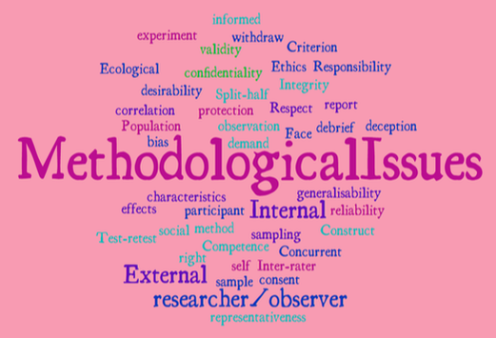Psychology is the scientific study of the brain and behaviour. Psychological research needs to be **scientific** *because p*sychologists want their ideas/theories to be tested and agreed with by other people and applicable to lots of people all over the world. Because we often investigate things we cannot physically see (intelligence, memories, perception, fears), psychologists have to be very careful when planning their investigations. Whichever way research is carried out, there will always be methodological issues.

Methodological issues are any positive or negative points about HOW research into the topic is done, such as:

* Research method (C.O.S.E.)
* Procedures / Tasks / Equipment used
* Research length (snapshot / longitudinal)
* Experimental design (R.I.M.)
* How the data is collected in
* What *type* of data is collected
* Sampling method (R.O.S.S.),
* Sample size and features
* Reliability
* Validity
* Ethics (C.D.C.D.W.P.)

**5. For each of the 15 topics in Paper 3, state WHO investigated the topic and 3 methodological issues faced [58]**

*Challenge: these 3 points form the structure of an essay ‘Discuss the methodological issues raised when researching …’ [15] Practice this essay writing.*

| Topic | Key Research | Green Textbook page | Issue #1 | Issue #2 | Issue #3 |
| --- | --- | --- | --- | --- | --- |
| Historical views of mental illness |  | 18 |  |  |  |
| Medical Model |  | 30 |  |  |  |
| Alternatives to the Medical Model |  | 46 | Ethnocentrism |  |  |
| Intelligence |  | 62 |  |  |  |
| Pre-adult brain development |  | 70 |  |  |  |
| Perceptual development |  | 78 |  |  |  |
| Cognitive development & education |  | 86 |  |  |  |
| Development of Attachment |  | 94 |  |  |  |
| Impact of advertising on children |  | 102 |  |  |  |
| What makes a criminal? |  | 118 |  |  |  |
| Collection and processing of forensic evidence |  | 126 |  |  |  |
| Collection of evidence |  | 134 | Ethnocentrism – cultural differences |  |  |
| Courtroom |  | 142 |  |  |  |
| Crime prevention |  | 150 |  |  |  |
| Effect of imprisonment |  | 158 |  |  |  |