Aldenham School

A Level Psychology

Year 11 Summer Prep 2019

Name _____________________



Prep submission date: Friday 13th September 2019

You can email your answers to [vevagora@aldenham.com](mailto:vevagora@aldenham.com)

Aldenham School follows the OCR Psychology A Level specification [(H567)](http://www.ocr.org.uk/qualifications/as-a-level-gce/as-a-level-gce-psychology-h167-h567-from-2015/)

www.aldenhampsychology.com

The Scientific Method

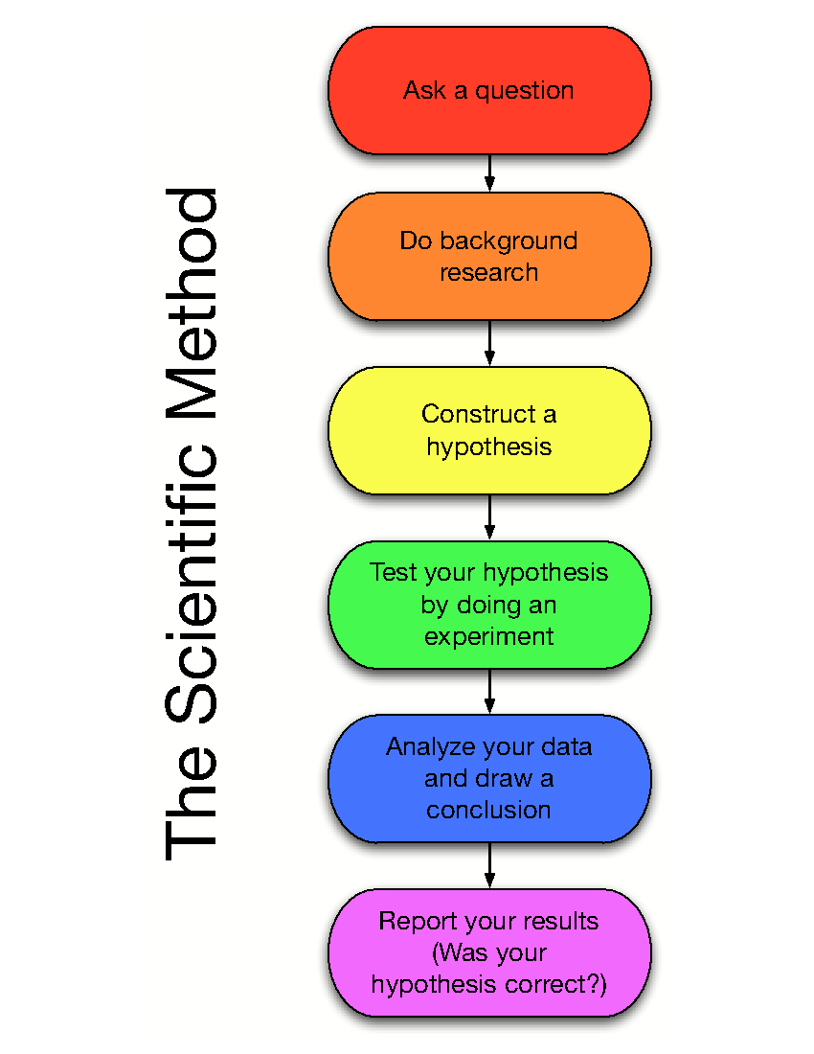Psychology is the scientific study of the brain and behaviour.

Investigations need to be *scientific.* Psychologists want their ideas/theories to be:

* Tested and agreed with by other people.
* Applicable to lots of people all over the world.
* Useful and beneficial to others.

Because we often investigate things we cannot physically see (memories, dreams, fears, plans, love), psychologists have to be very careful when planning their investigations.

Psychologists use a range of ways to carry out scientific investigations these are known as **research methods**. We look at four research methods:

1. Experiment
2. Self-report
3. Observation
4. Correlation

**Experiment – Description**

* Can manipulate one variable and keep everything else the same.
* Allocate participants into groups.
* If the groups behave differently, then you know it is the thing you have manipulated (IV) that caused the different result (DV), as everything else was kept the same.

**Self-Report – Description**

* Can ask people how they think and behave.
* Can conduct interviews or fill in questionnaires.
* Psychologists collect the data and make conclusions about how people think and behave.

**Observation – Description**

* Can watch how they behave.
* Focus on their observable behaviour.
* Gather data and make conclusions based only on what you can observe.

**Correlations – Description**

* Sometimes it is unethical to split people into different groups and treat them differently (*purposefully neglect a group of children*).
* Sometimes it is impractical or impossible to manipulate the variables (*make one group rich and another group poor*).
* Sometimes all we can do is measure two characteristics in a group and see if there is a relationship between the two.

Putting the 4 research methods into action

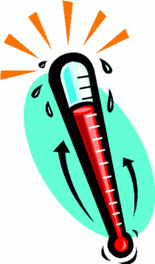

Research aim: I want to know whether the temperature of a room affects people’s ability to concentrate. To study this, I could use:

**Experiment**

* Split people into two groups
* Put one in hot and one in cold room
* Give them both the same word search puzzle test
* Then see who gets the highest score.

**Self-report**

* Ask people to rate from 1-10
* How hard they find it to concentrate on a warm or a cold day.

**Observation**

* Go to different libraries
* Record how warm it is
* Then observe how many books people read/how distracted they get/how long they stay for.

**Correlations**

* Find the average GCSE results
* And average temperatures for different regions
* Then see if they are related.

Research focus: Does sleep affect your learning?



Explain how you would design the following to study whether sleep affects your learning:

**How to answer Q1-4**

Use the bullet points in the examples above to help you achieve the full marks for each question.

1. Experiment [4]
2. Self-report [2]
3. Observation [3]
4. Correlations [3]

Mathematical Requirements

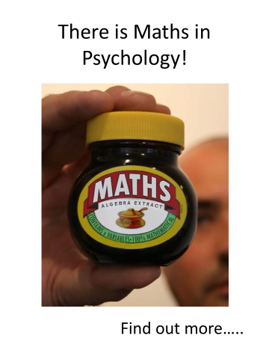Psychology is a science, requiring knowledge of how to do scientific research.

Maths is essential so that you can present and analyse data from research. At least 10% of the marks in the Psychology A-levels will require the use of mathematical skills.

These skills will be at least the standard of higher tier GCSE mathematics. This includes knowing how to:

* Calculate the mean, median, mode, range and standard deviation
* Calculate percentages
* Drawing and interpreting graphs
* Inferential statistics

You have to have a scientific calculator in the exam!

1. The following are individual participants’ scores on a memory test:

14, 8, 12, 10, 8, 8, 7, 6, 13, 11, 6, 6, 6, 14, 15, 13, 8, 14, 8, 11

Calculate the:

1. Mean [1]
2. Median [1]
3. Mode [1]
4. Range [1]
5. This table below shows the results of a study into obedience study.
6. What percentage of the **participants who obeyed** were boys? [1]
7. What percentage of the total number of participants were girls who obeyed? Give your answer to 2 significant figures. [1]

|  |  |  |
| --- | --- | --- |
|  | Boys | Girls |
| Obeyed | 36 | 24 |
| Disobeyed | 52 | 64 |

1. A psychologist has investigated the relationship between height and scores on a mood questionnaire. The results are shown in the table on page 5. Sketch an appropriate graph for this data. [4]

|  |  |
| --- | --- |
| Height (cm) | Mood Score (out of 50) |
| 150 | 20 |
| 164 | 32 |
| 100 | 10 |
| 130 | 18 |
| 140 | 30 |

Mark Scheme for Q7

1. Title which includes both variables
2. Labelling on x axis
3. Labelling on y axis
4. Appropriate type of graph, scale and accuracy



1. State what the graph and **results** show. [1]
2. State what can be **concluded** from this data. [1]

Inferential statistics allow psychologists to make conclusions based on the probability that a particular pattern of results could have arisen by chance.

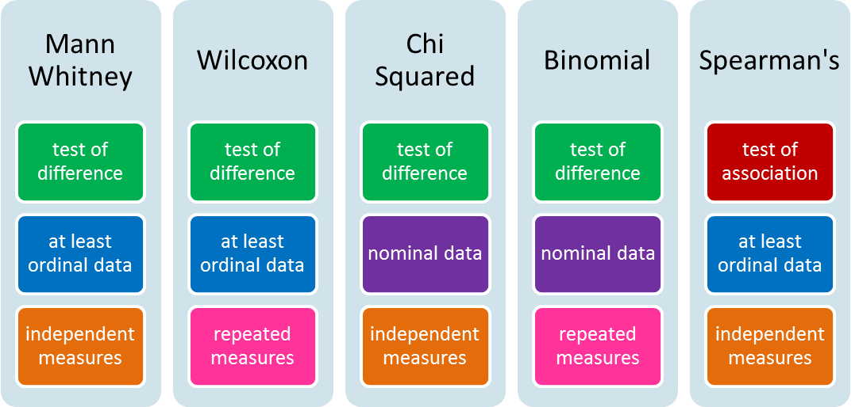11. Which of these indicates the research is significant at the 5% level of probability?

1. p<5.0
2. p<0.5
3. p<0.05
4. p>0.05

Areas and Perspectives in Psychology

An area in Psychology is a field in which psychologists work. Most will work mainly in one area and will agree with the principles of this area. A perspective in Psychology is a set of ideas that psychologists use to answer specific issues. For example, Individual Differences psychologists will sometimes take a Psychodynamic perspective on a topic like mental health.

|  |  |  |  |
| --- | --- | --- | --- |
| **Area / Perspective** | **Explains behaviour as …** | **Studies behaviour using…** | **Changes behaviour through…** |
| Behaviourist perspective | Caused by learning | * Scientifically * Through controlled observations | CBT – the client is trained to identify their thoughts and HOW these link with behaviours. They are then given better behaviours to show. |
| Biological area | Caused by   * Brain structure / activity * Chemicals in the body * Genes | * Scientifically * Use of laboratory experiments, blood tests, EEG, etc. | Tackle physical causes of the behaviour, such as brain surgery, ECT, medication |
| Cognitive area | Caused by types of unhelpful ways of thinking | * Scientifically * Through laboratory experiments | CBT – the client is trained to identify their thoughts and HOW these link with behaviours. They are then given better behaviours to show. |
| Developmental area | Due to upbringing and the stages of development | * Longitudinal studies * Interviews and observations | Change the way children are brought up and taught in schools. |
| Individual Differences area | a result of many different influences for different people | * Case studies * Interviews * Questionnaires | Different methods for different people |
| Psychodynamic perspective | Caused by the personality and childhood experiences | * Case studies | Psychoanalysis – to identify and resolve unconscious conflicts; using techniques such as free association and dream analysis |
| Social area | Due to a person’s social context, such as family, friends, institutions, and wider society. | * Observations * Laboratory studies | Change the environment around a person to change their behaviour. |

Different Areas and Perspectives in Psychology

Using these to make an assessment

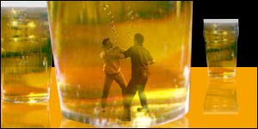

Here is an extract from a brief psychological assessment made by a psychiatrist:

‘K’ is a 30-year old man who has had a long history of violence.

He was most recently arrested (for the fifth time) for an attack on another man in a crowded pub. ‘K’ claimed that the man had knocked his drink and laughed about it. At the time of the arrest, ‘K’ was found to have abnormally high levels of testosterone (as well as high blood alcohol level).

He reported many experiences of seeing his father being aggressive and suffered himself in the form of beatings. ‘K’ said very little about his mother, who appeared to have been absent during this time, although this did not seem to be a concern for ‘K’. ‘K’ was excluded from school on many occasions for bullying other children.

If ‘K’ had a philosophy on life, and it was ‘never show weakness to others’. I recommend further detailed psychological assessment.

Mark Scheme for Q10

1. Point – what is the cause of behaviour?
2. Explanation – what does this mean?
3. Link to K

Choose **2** areas / perspectives listed on page 6.

1. Explain how each of your 2 chosen areas / perspectives would explain what is causing K’s behaviour. [3+3]

Mark Scheme for Q11

1. Point – how would the behaviour be treated?
2. Explanation – how will this be done?
3. Link to K
4. Explain how a psychologist from each of your 2 chosen areas / perspectives may treat K. [3+3]

Issues and Debates in Psychology

The issues and debates in Psychology look at some of the important arguments relating to how research is conducted and how behaviour is explained.

**Debates** in Psychology include:

* Nature / nurture
* Freewill / Determinism
* Reductionism / Holism
* Individual / Situational explanations of research

**Issues** include:

* Usefulness of Research
* Ethical Considerations
* Conducting Socially Sensitive Research
* Methodological Issues
* Ethnocentrism

The Nature / Nurture Debate

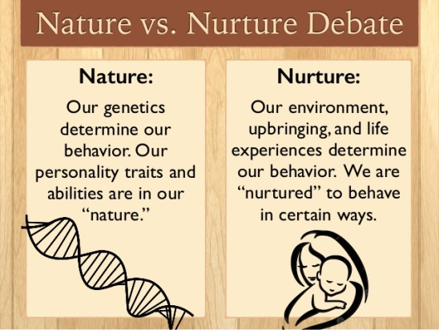This debate is very important in Psychology. It debates how important the 2 influences of nature and nurture are in explaining human behaviour.

* Nature = Inherited influences such as our genes and physiology
* Nurture = How life has influenced us through our experiences

This debate can be applied to many aspects of human behaviour, such as intelligence and crime.

When do you stand on the nature / nurture debate?

1. Are people born clever (nature) or do they become clever through hard work / good teaching (nurture)? Explain one reason for your view. [4]

Mark Scheme for Q12 and Q13

1. Your view (nature, nurture or interactionist)
2. Reason – why do you have that view?
3. Explanation – what does this view mean?
4. Example to illustrate this reason
5. Are criminals born with a tendency to commit crime (nature) or do they commit crime because they have had a difficult upbringing (nurture)? Explain one reason for your view. [4]

Core and Key Studies in Psychology

During the A Level course, you will be introduced to the central areas of investigation in Psychology organised into 10 key themes, each represented by a classic & a contemporary core study. For each of the 20 Core Studies and 15 Key studies, you need to know what was researched and to evaluate how this was researched.

Core Study: Maguire

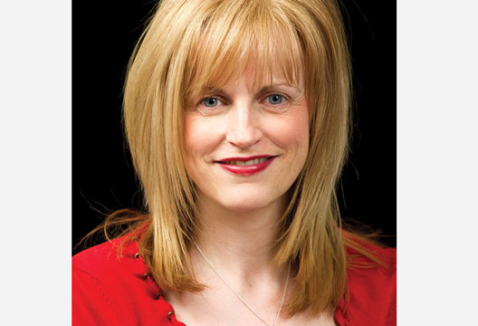Flexing your muscles may make them bigger. Is the same true for your brain? Eleanor Maguire (a neuroscientist at UCL) wanted to see if your job can actually affect the size of parts of your brain.

She investigated whether the size of a specific area of the brain (the hippocampus) would be different in London black cab drivers. She wanted to find out if it is possible for the brain to adapt itself according to the circumstances, in this case, to navigate around London.

Using MRI scans, she found that the taxi drivers had a significantly larger volume in one part of the hippocampus compared to a control group of Londoners. <https://www.youtube.com/watch?v=sfy9j0h9_O8>

1. State the names of 2 methods of scanning the brain. [2]
2. Explain the purpose of having control groups in psychological research. [2]

Core Study: Hancock

Hancock investigated the language used by psychopaths.



Hancock interviewed psychopaths and non-psychopaths and asked them all to describe the crimes that they had committed in as much detail as possible. The interviews were then analysed by **two** computerised content analysis programmes.

Several differences between psychopaths and non-psychopaths were found including the amount of cause and effect phrases, such as ‘because’ used (significantly more by psychopaths), words relating to basic needs (significantly more by psychopaths) and the number of disfluencies used, the "uhs" and "ums" that interrupt speech, (significantly more by psychopaths). Psychopaths also included less social needs, such as ‘family’ in their speech.

Mark Scheme for Q16

1. Point – what is the strength / weakness?
2. Explanation – what does this mean?
3. Conclusion – why does this strength / weakness matter?

<http://www.livescience.com/16585-psychopaths-speech-language.html>

1. Explain one strength and one weakness of using interviews in Psychology. [2x3]

Issues of Mental Health Key Study: Rosenhan

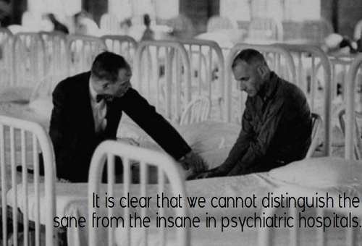David Rosenhan was a psychiatrist who investigated the question: Can we tell the sane from the insane?

He asked 8 sane people to telephone the hospital for an appointment, and turn up complaining of hearing voices.

They were all admitted to the psychiatric ward. Straightaway all 8 no longer faked these symptoms. They were told they would have to get out of the hospital by convincing staff they were sane.

Staff at the hospitals were surprised at the results because they had doubted that sane people could be admitted to their hospital.

Rosenhan showed that there is a great overlap between normal and abnormal behaviour, but once someone has being labelled as mentally ill, behaviour is interpreted differently.

<https://www.youtube.com/watch?v=D8OxdGV_7lo>

1. The research method used by Rosenhan was a field experiment. Name the 2 other types of **experiment** which are used in Psychology? [2]
2. State the name of one psychotic disorder. [1]
3. Define the term ‘mundane realism’. [2]
4. Define the term ‘ecological validity’. [2]

Criminal Psychology Key Study: Zimbardo

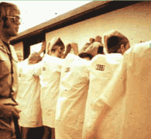In 1971, [Philip Zimbardo](http://psychology.about.com/od/profilesmz/p/philip-zimbardo.htm) and his colleagues set out to create an experiment that looked at the impact of becoming a prisoner or prison guard. Zimbardo and his researchers set up a mock prison in the basement of Stanford University's psychology building, and then selected 24 students to play the roles of both prisoners and guards. The participants were selected from a larger group of 70 volunteers because they had no criminal background, lacked psychological issues and had no major medical conditions. The volunteers agreed to participate for a one- to two-week period in exchange for $15 a day.

The fake (simulated) prison included three 6 x9 foot prison cells. Each cell held 3 prisoners and included 3beds. Other rooms across from the cells were used by the prison guards and warden. One very small space was designated as the solitary confinement room, and another small room served as the prison yard.

The 24 volunteers were randomly assigned to being either a prisoner or a guard. Prisoners were to remain in the mock prison 24-hours a day for the whole length of the study. Guards had to work in teams of 3 for 8 hour shifts. After each shift, guards were allowed to return to their homes until their next shift. Researchers were able to observe the behaviour of the prisoners and guards using hidden cameras and microphones.

While the Stanford Prison Experiment was originally going to last 14 days, it had to be stopped after just 6 days. The guards were abusive and the prisoners began to show signs of extreme stress and anxiety.

While the prisoners and guards were allowed to interact in any way they wanted, the interactions were generally hostile. The guards began to behave in ways that were aggressive and abusive toward the prisoners, while the prisoners became depressed. Five of the prisoners began to experience such severe negative emotions, including crying, that they had to be released from the fake prison early.

Mark Scheme for Q21

1. State one problem with the research
2. State your suggestion
3. Explain how your suggestion puts right or improves the problem with the research you identified.
4. Suggest one way in which this research could be improved and explain why your suggestion improves it. [3]

Course Structure



Paper 1: Research methods

How to plan, conduct, analyse and report psychological research. Students have to conduct their own practical work.

This has a 2 hour exam in Year 13, including multiple choice, short answer and data interpretation questions.

Paper 2: Core Studies

This focuses on 10 pairs of Psychology studies - both a classic and a contemporary study.

This has a 2 hour exam in Year 13, including essays and data analysis questions.

Component 3: Applied Psychology

This focuses on issues in mental health issues and options: Child, Criminal, Environmental, and Sport Psychology.

This has a 2 hour exam in Year 13, including essays and data analysis questions.

Prep submission date: Friday 13th September 2019

Total number of marks = 65

You can email your answers to vevagora@aldenham.com

Before you submit this prep:

* Have you checked the mark schemes for each of the questions?
* Does your answer fit the number of marks allocated to the question?
* Have you written in your own words – even for questions 20 -21?
* Have you answered all 22 questions?