Szasz (2011) The Myth of Mental Illness: 50 Years Later

Szasz suggested that mental diseases were in fact behaviours that made people feel uncomfortable, and, consequently, were thought by society to need treating, to make other people feel better rather than to help the person displaying the behaviours.

He believed that people with mental illnesses should not be treated in the medical sense. This essay aimed to look at his initial research on mental illness in the 1960’s and then reconsider his points.

1960s:
- Health care for mental health consisted of mental hospitals and private professionals
- Mental patients are treated no better than prisoners. Patients have few rights – e.g. held against their will
- Mental illness is not the same as physical illness
- Mental illness doesn’t exist, so it is foolish to look for causes or cures

Reconsiderations in 2010:
- All mental health care is provided by the NHS and the aim is to prevent danger to patients and others
- A false belief that is seen in research is that mental illness can be diagnosed accurately and treated successfully
- Mental illness is seen as being a disorder of the brain, despite there being no scientific evidence that it is caused ONLY by the brain
- Mental disorders are labels given to undesirable behaviours
- Doctors don’t see people as inherently bad, but if they perform negative behaviours, it is a result of their mental illness
- Consent for treating mental illness does not happen
- Medical treatments should not be used to treat mental illness. People need to be helped to overcome obstacles and treated with respect.

Prep questions: 24 marks
- Explain 2 key points in Szasz’s argument [2+2]
- Explain 2 reasons Szasz gives that the medical model is unacceptable. [2+2]
- Outline how patients with a mental illness would be treated under the medical model. [3]
- Outline how patients with a mental illness would be treated by Szasz. [3]
- Referring the research by Gottesman and the theories of Szasz, explain the reductionism / holism debate. [10]

The key points in Szasz’s argument
- Mental illness is a myth, not a disease that can be scientifically proven.
- Medical model is now the only way of dealing with people who behave differently.
- Government decides what illnesses exist, control all regulation and funding.
- Mental hospitals are more like prisons to control peoples’ behaviour.
- Economic issues – big business in pharmaceuticals and treatments to treat mentally ill.
- Mentally ill people are actively trying to cope in the world using whatever coping mechanisms they can. They are not passive players to biological forces.
- People are being deprived of the freedom to behave in the way they choose on the grounds of having a disease. This also has implications for ‘insanity’ as a defence.
- We need to try to understand the reasons for a person’s actions by respecting, understanding and helping them, not diagnosing under a loose fitting definition

Reasons Szasz gives that the medical model is unacceptable
- The causes of mental illness: there is no identifiable cause like an infection, or nutritional deficiency. It is a way of coping. It is a mistake to keep looking for biological causes.
- No alternative legal approach – government has become involved. Mental illness is not based on scientific research
- It denies people freedom and responsibility to choose how to behave. They are coerced and forced into diagnosis and treatment. This is unethical.
- Diagnosis is subjective, not based on scientific assessment. Mental illness is judging the ‘bad’ behaviour of people.
- Medical model is dehumanising, ignores suffering of person. Labels are constructed due to medicalisation of disturbed behaviour.
- Medical model has replaced religious view of mental suffering.
- Alternative ways – understanding the patient, help them help themselves. Medical treatments do not work, only supress symptoms.

Key Words and Concepts
‘First do no harm’ (primum non nocere)

Big Pharma

Having an illness does not make a person into a patient

Medical Model is dehumanising

Medicalisation of mental health

Mental illness – a legal or medical concept

Mental illness is a metaphor

Reasons that Szasz gives that the medical model is unacceptable

Point |  | Development
The causes of mental illness: there is no identifiable cause like an infection, or nutritional deficiency. |  | it is just a way of coping. It is a mistake to keep looking for biological causes.
No alternative legal approach – government has become involved. |  | And labels are constructed due to medicalisation of disturbed behaviour.
It denies people freedom and responsibility to choose how to behave. |  | Because the medical treatments do not work, only supress symptoms.
Diagnosis is subjective, not based on scientific assessment. |  | Because mental illness is judging the ‘bad’ behaviour of people.
Medical model is dehumanising, ignores suffering of person. |  | Because mental illness is not based on scientific research
Alternative ways – understanding the patient, help them help themselves. |  | Because they are forced into diagnosis and treatment. This is unethical.

Point – Explanation – Example - Conclusion - Challenge
Name _____________________________

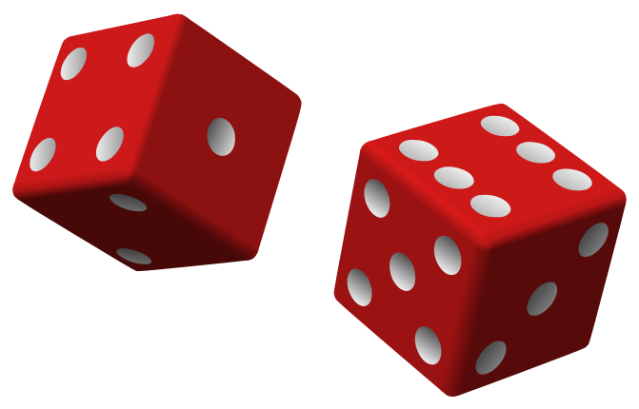
- Mental illness is a myth, not a disease that can be scientifically proven.
- Medical model is now the only way of dealing with people who behave differently.
- Mental hospitals are more like prisons to control peoples’ behaviour.
- Mentally ill people are actively trying to cope in the world using whatever coping mechanisms they can. They are not passive players to biological forces.
- People are being deprived of the freedom to behave in the way they choose on the grounds of having a disease. This also has implications for ‘insanity’ as a defence.
- We need to try to understand the reasons for a person’s actions by respecting, understanding and helping them, not diagnosing under a loose fitting definition

________________________________________________________________________________________________________________________________________________________________________________________________________________________________________________________________________________________________________________________________________________________________________________________________________________________________________________________________________________________________________________________________________________________________________________________________________________________

DEBATES RELATED TO SZASZ RESEARCH:

Ethics:
Szasz did not directly collect data from participants so in that sense it’s free from ethical issues. However, his beliefs about mental illness are highly controversial and socially sensitive. For those who suffer with a mental illness it could be extremely distressing for someone to describe their illness as a ‘myth’ when they perceive their symptoms as real and have experienced effective treatment. It also makes a rather destructive theory about the medical model of mental health, and therefore the public may then have little faith in the professionals within psychiatry.

Usefulness of research:
Szasz research has widely created empowerment for service users in mental health. His beliefs questions the usefulness of the medical model within mental health and this is useful as it may help to further understand the true effectiveness of invasive treatments such as ECT, drug therapy and involuntary confinement.

Nature vs nurture – Individual vs situational:
The theory that mental illness is a myth disregards any genetic explanation. Szasz argues that mental illness was defined due to social constructs and therefore has an environmental explanation. Mental illness is not an abnormality experienced for the individual as a result of their biological or emotional functioning, it is a product of psychiatrists’ particular views on mental health – situational.

Freewill vs determinism:
Szasz’ views would appear deterministic, as he is assuming that mental illness is a product of the environment and people are defined due to irrational views of psychiatrists. However, he also does empower mental health service users and sees involuntary confinement as wrong. This encourages are more freewill approach to service users instead of assuming that they need to have decisions made for them as they wouldn’t have the capacity to.

Reductionism and holistic – psychology as a science:
Szasz can be seen as being more holistic as he tries to see a more complex understanding of mental health explanations. Mental health is not, put simply, ‘a disease’, (reductionist) it is a complex creation developed from society and psychiatry’s labelling (holistic). Szasz has an unscientific explanation as he rejects the scientific medical model as an explanation of mental health.

Point – Explanation – Example - Conclusion - Challenge
________________________________________________________________________________________________________________________________________________________________________________________________________

Ethics

Usefulness of research

Nature vs nurture

Individual vs situational

Freewill vs determinism

Reductionism and holistic

Psychology as a science
________________________________________________________________________________________________________________________________________________________________________________________________________________________________________________________________________________________________________________________________________________________________________________________________________________________________________________________________________________________________________________________________________________________________________________________________________________________

Outline how patients with a mental illness would be treated under the medical model. [3]
If a person had symptoms of a mental health disorder, under the medical model, they might:
- Be assessed and diagnosed with an illness using the DSM (or ICD)
- Given SSRIs as a treatment to supress their symptoms.

Outline how patients with a mental illness would be treated by Szasz. [3]
Szasz would suggest that the patient presents themselves for help if they feel they need it. Talking therapies to help understand their behaviour and help them to help themselves would be on offer.

