Question 1:
Conclusion: Psychological research SHOULD be useful as it is important that it contributes to humanity by providing some form of development, research or understanding about behaviour.

Question 2
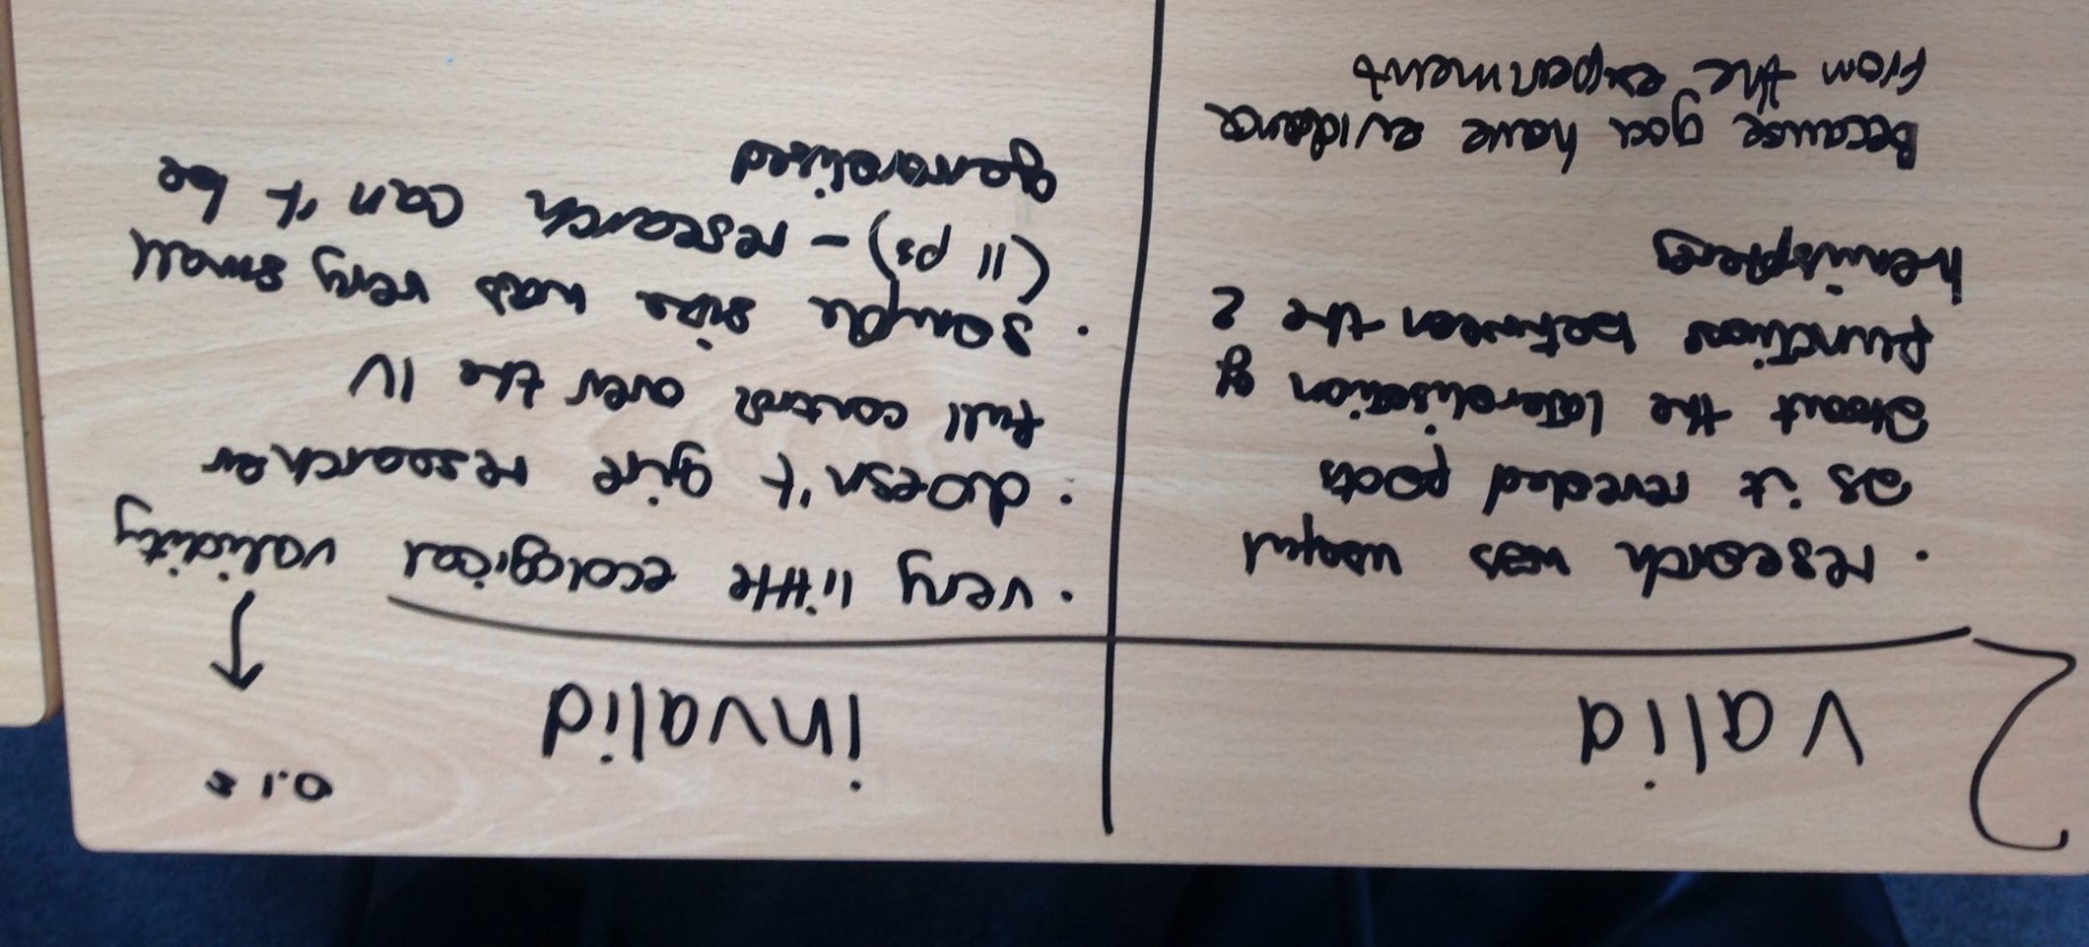
Conclusion: Psychological research SHOULD be valid so that it measures or assesses true behaviour to allow it be useful.

Question 3
Conclusion: Psychological research SHOULD be ethical so that the general public trusts psychologists and are happy to be participants in future research.

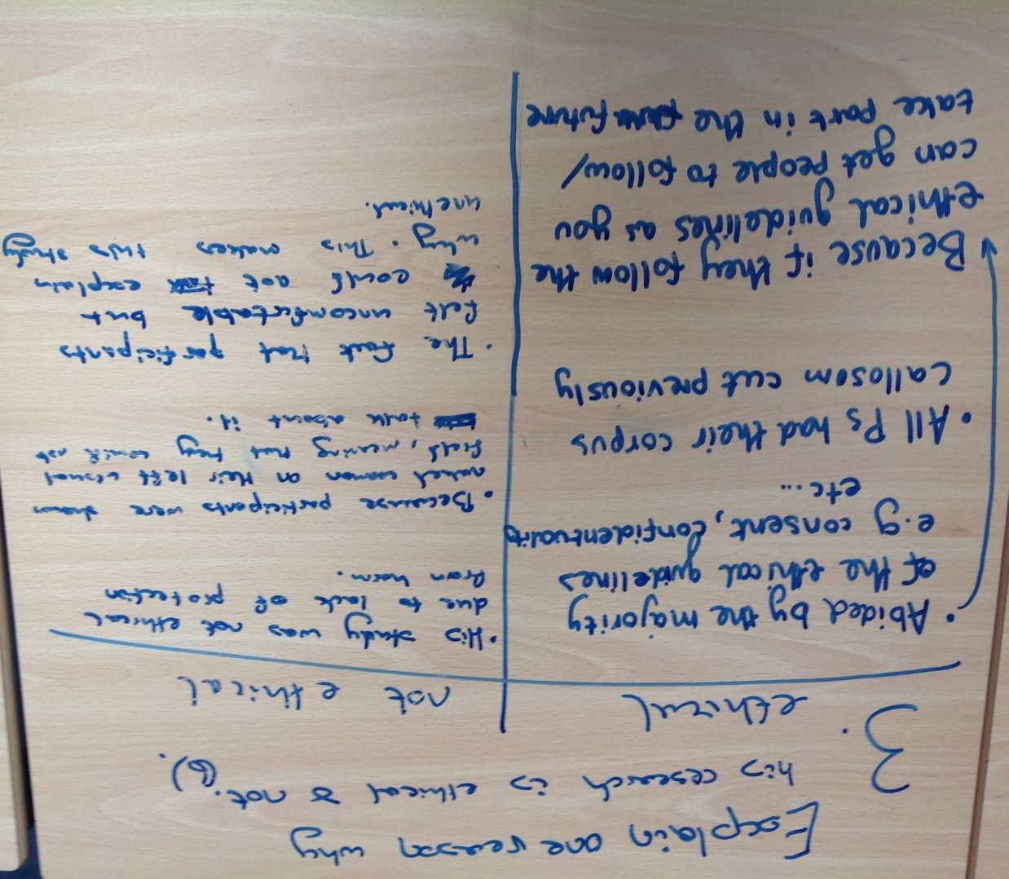

Question 4
Conclusion: Sperry’s sample was too small, androcentric and ethnocentric to be able to be generalised to the target population (all humans as all humans have a brain). This limits its usefulness.

Question 5

Conclusion: collecting quantitative data in Sperry’s study allows us to come to clear conclusions about what each hemisphere does, but quantitative data only tells us WHAT happens, when it is also useful to know HOW and WHY, so that psychologists can consider how to change behaviour for the better.
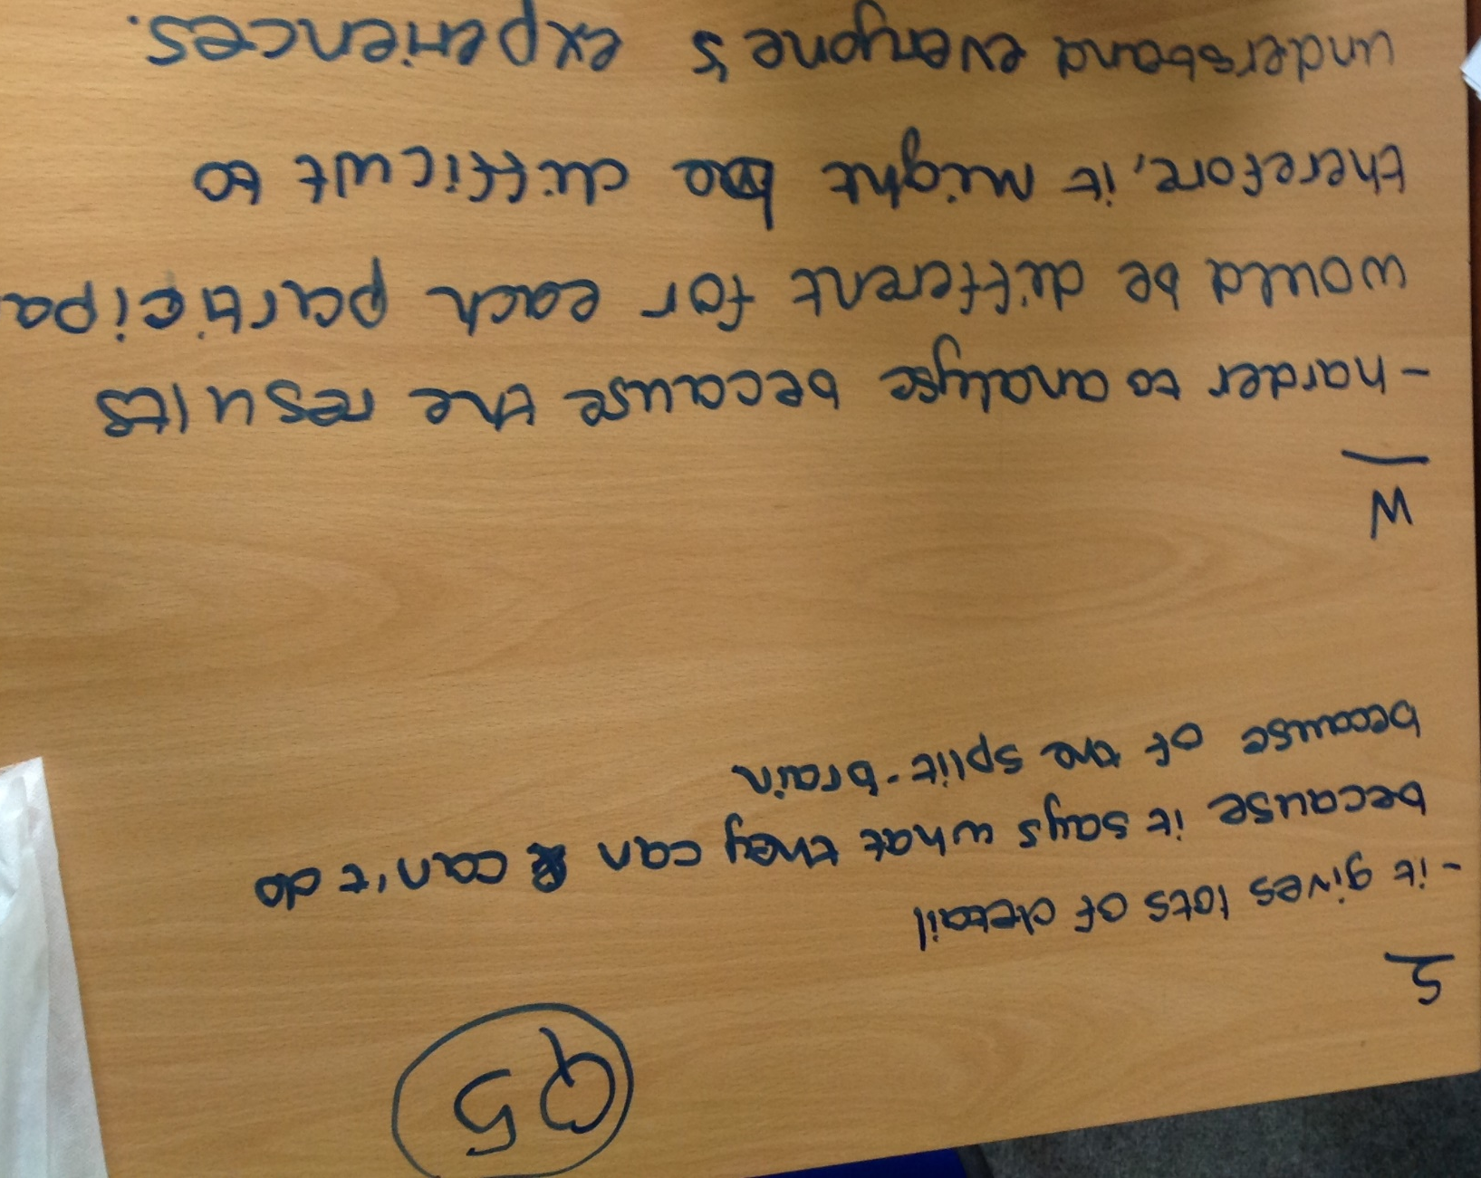

Question 6
Conclusion: Taking the nature perspective is helpful because it tells us that biology is the cause of behaviour, which means that people are not blamed for any problems they may show – it is due to their brain. However, this is also unhelpful as it limits what people are prepared to do to change or improve their behaviour.

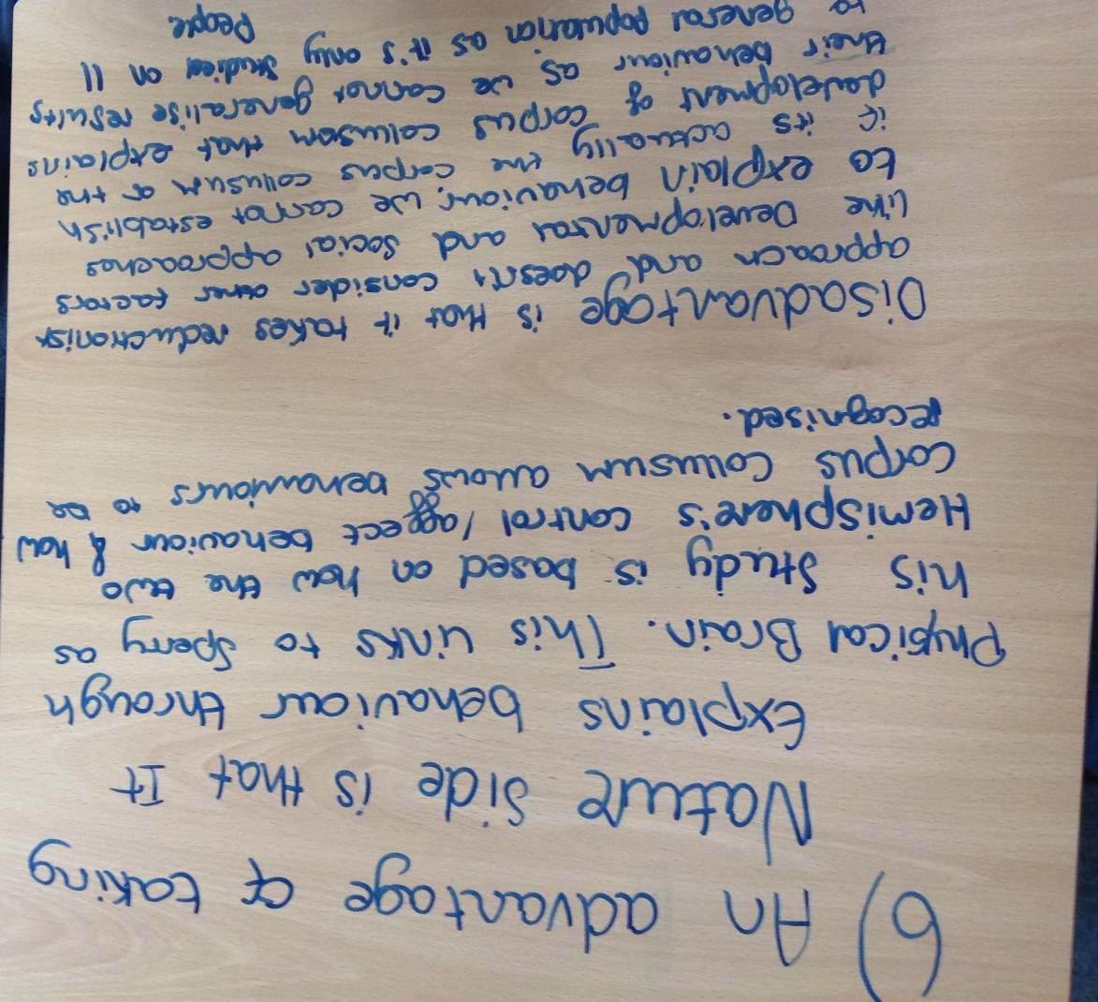

Question 7
Conclusion: Being deterministic is helpful because it tells us that biology is the cause of behaviour, which means that people are not blamed for any problems they may show – it is due to their brain. However, this is also unhelpful as it limits what people are prepared to do to change or improve their behaviour – it robs them of free will.
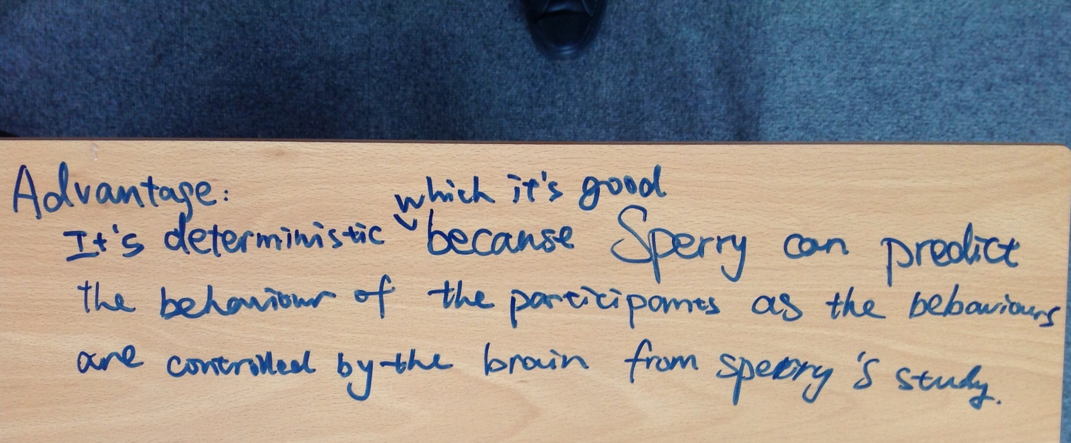

Question 8
Conclusion: Psychological research should be scientific, so that people can trust the results as being valid and are more likely to co-operate with any development based on it.

