A researcher has conducted an independent measures design experiment to investigate whether chewing gum influences concentration. She recorded how many changes were detected in a ‘spot-the-difference’ puzzle by people chewing gum when completing the task, compared to those who were not.
- Name two variables present in a lab experiment. (2)
- Outline one strength and one weakness of using a lab experiment. (6)
- Explain the difference between a lab experiment and a field experiment. (4)
- What is a quasi experiment? (2)
- Why would a quasi experiment not be appropriate for this study? (2)
- State a strength and a weakness of using quasi experiments. (4)

A researcher wanted to covertly observe how mums at a play and stay interacted with each other. He planned to use a naturalistic structured observation.
- Outline one strength and one weakness of conducting observational research. (4)
- Outline one strength and one weakness of conducting a covert observation. (4)
- Explain how you would make this observation overt and what problems this might arise. (4)
- Explain the difference between a participant and non-participant observation. (4)
- What is a structured observation. (2)
- State a strength and a weakness of using a naturalistic observation in this study. (6)
- Identify one strength and one weakness of using a structured observation in this study. (4)
- Why would an unstructured observation not be appropriate for this study? (2)

Psychologists are interested in helping people overcome their fears, anxieties and phobias. One way about finding out about these is to ask people to fill out a questionnaire. In this way they can write about their fears, anxieties and phobias and how they can overcome them without having to talk about them.
- Outline one advantage and one disadvantage of using a questionnaire in this study. (6)
- Give a strength and a weakness of using an interview instead of a questionnaire in this study. (6)
- Describe what is meant by a semi structured interview. (2)
- What is a strength of using a semi structured interview over a structured interview? (2)
- Why has an unstructured interview not been chosen to carry out this study? (2)

Researchers conducted a study investigating the correlation between amount of sleep and concentration. First, participants were asked how long they had slept the previous night in hours and minutes. This was then recorded as ‘total minutes slept’. Concentration was then assured using a letter cancellation task in which subjects had two minutes to read an extract from a book, counting the number of times that the letter ‘f’ appeared.
- Explain what is meant by a negative correlation. (1)
- Explain what is meant by a positive correlation. (1)
- Explain what is meant by no correlation. (1)
- Identify one strength and one weakness of the correlational method. (4)
- Describe two problems with the way the data was obtained in this correlation. (4)

A psychologist is interested in investigating people’s beliefs in the paranormal (e.g. ghosts, telepathy, unidentified flying objects) and decides to use a self-report measure to conduct their study.
- Describe how a volunteer (self-selecting) sampling technique could be used to obtain participants for this study. (3)
- State a strength and a weakness of using a volunteer (self-selected) sampling technique for this study. (6)
- Explain what is meant by an ‘open question’ and a ‘closed question’. (4)
- Outline one strength and one weakness of using open questions in a study investigating people’s belief in the paranormal. (4)
- Outline one strength and one weakness of using closed questions in a study investigating people’s belief in the paranormal. (4)
- Suggest a question that participants could be asked in this study, using a rating scale. (2)
- Outline one advantage of using a question involving a rating scale in this study. (3)
- What is a semantic differential rating scale? (2)

A researcher is interested in finding out why students at a large sixth form college have decided to study Psychology. He is going to use a self-report questionnaire.
- Suggest one open and one closed question that could be used to investigate subject choice. (4)
- Explain one strength in using closed questions in this study. (3)
- Explain one weakness in using closed questions in this study. (3)
- Suggest how the researcher could use an opportunity sampling technique to get 50 psychology students to complete the questionnaire. (2)
- Evaluate the use of opportunity sampling in this study. (4)

Psychologists used the self-report method to investigate gambling behaviour. They placed an advert in a local newspaper asking for men and women aged 16 to 50 to apply. Those who replied were sent a questionnaire in the post consisting of a number of open and closed questions. For example:
Give reasons why you gamble.
Which of the following gambling activities do you engage in?: ♦ national lottery ♦ fruit machines ♦ poker ♦ horse racing ♦ football
- Identify which of the above questions is a closed question and explain why. (2)
- Suggest one other closed question that could be used in this study. (2)
- Give a strength and a weakness of the sampling method used in this study. (6)
- Name and describe and alternative sampling method for this study. (3)
- Explain how using leading questions could influence the results in this study. (3)

Researchers conducted an independent measures design experiment in a local coffee bar, investigating whether receiving physical contact from someone increases their rating on friendliness. The experiment took place between 11am and 2pm on a Wednesday. As members of the public left the coffee bar after paying, some were touched lightly on the upper arm by the cashier, whereas others were not. Outside the coffee bar, members of the public were asked how friendly they thought the staff were on a scale of 1 (‘not very friendly’) to 10 (‘extremely friendly’).
- What is the independent variable in this study? (1)
- Write a two tailed hypothesis for this study. (4)
- Identify the sampling technique used to obtain participants for this study. (1)
- Suggest one weakness with the sampling method used in this study. (2)
- What is an ‘independent measures design’? (2)
- Give one advantage and one disadvantage of using an independent measures design in this study. (6)
- Describe how you would control one variable in this study. (2)
A researcher has conducted a matched pairs design experiment to investigate whether chewing gum influences concentration. Participants were matched on age and gender. She firstly recorded how many changes were detected in a ‘spot-the-difference’ puzzle by people not chewing gum when completing the task, then compared this to the matched group who did chew gum during the task. The results were then compared.
- Write a research aim for this experiment. (2)
- Write a null hypothesis for this experiment. (4)
- Outline one strength and one weakness of using a matched pairs design in this experiment. (6)
- Describe an alternative experimental design and one strength of using this design instead of a matched pairs design. (6)
- What is the Independent variable and dependent variable in this investigation? (2)
- Outline how you could select a sample that would be representative. (3)
- Explain how participant variables could bias the sample in this study. (3)

Psychologists wanted to investigate why we don’t laugh when we tickle ourselves. One idea is that it is a social act that is out of our control and must be done to us by another person. To investigate this, participants had the soles of their feet tickled by another person at any time during a 30 second period. Later on the same participants had to tickle themselves. They put their feet on a tickling machine (a feather on a rotating turntable) at any time they chose during a 30 second period. The volume of laughter was recorded in decibels.
- Identify the experimental design used in this study. (1)
- Explain the difference between an independent measures design and a repeated measures design. (4)
- Give a strength and a weakness of the experimental design used in this study. (6)
- Give an advantage of using an alternative experimental design in this study. (3)
- Write an alternative tailed hypothesis for this study. (4)
- Outline one strength and one weakness of the dependant variable in this study. (6)
- Identify one extraneous variable in this study and how it could be controlled. (3)

Psychologists wanted to investigate if smiling makes people feel happy. Participants were each shown a short video clip of a cartoon. Half the participants were asked to watch it whilst holding a pencil between their teeth, not touching their lips, so forcing them to smile. The other half were asked to watch it whilst holding the pencil just with their lips, not touching their teeth, which prevented them from smiling. Afterwards participants had to tell the psychologist how happy they felt on a scale of 1 (not very happy) to 10 (very happy).
- Write a one tailed hypothesis for this study. (3)
- What is a target population? (2)
- Outline one strength and one weakness of using an independent measures design in this study. (6)
- How could you make this study a matched pairs design? (2)
- Outline one strength in using a matched pairs design in this study. (3)
- What is the independent variable (IV) in this study and how has it been operationalised? (2)
- Evaluate the way the dependent variable has been measured this study. (6)

Researchers want to conduct an observation study of competitive behaviour at a sports centre. They conducted a naturalistic covert participant observation using time sampling.
- What is participant observation? (2)
- Identify one strength and one weakness of using the participant observation method in this study. (4)
- Explain what is meant by time sampling. (2)
- Suggest how the researchers could use time sampling in this study. (2)
- Write an appropriate behavioural checklist for this study. (3)
- Identify one strength and one weakness of using time sampling in this study. (4)
- Identify one strength and one weakness of using a behavioural checklist in this study. (4)
- Describe how you could present the data that would be collected in this study? (3)

Psychologists want to investigate university lectures anxiety levels when presenting lectures to new classes. They used event sampling to collect their data.
- Suggest how the researchers could use a snowball sample to obtain participants for this study. (2)
- State a strength and a weakness of using a snowball sample in this study. (6)
- What is meant by event sampling? (2)
- State a strength and a weakness of using event sampling in this study. (6)
- If the research used a coding frame instead of event sampling what two suggestions might you make for him to observe? (2)

Psychologists want to investigate if there is a correlation between how interested a person is in cars and their driving skills.
- Suggest an appropriate null hypothesis for this study. (4)
- How could ‘driving skills’ be measured in this study? (3)
- Evaluate the measurement of driving skills you suggested for this study. (6)
- Suggest an appropriate sampling method to be used in this study, justify your answer. (3)
- Give one strength and one weakness of the sampling method you have chosen for this study. (4)

Psychologists want to investigate if there is a correlation between a person’s ratings of how ugly snakes are and how much they fear them. They used an opportunity sample.
- Suggest an appropriate null hypothesis for this study. (4)
- Suggest a research question for this study. (2)
- Outline how fear could be measured in this correlation study. (4)
- Outline one strength and one weakness of the way you would measure fear in this study. (6)
- Suggest a more appropriate sampling method you could use to gain participants for this study, explain your answer. (3)

A researcher is interested in finding out why students at a large sixth form college have decided to study Psychology. He is going to use a self-report questionnaire.
- Discuss the validity of a closed question that could be used to investigate subject choice. (3)
- What is quantitative data? (2)
- Outline one strength and one weakness of quantitative data being collected in this study. (4)
- What is qualitative data? (2)
- Assess the reliability of the measurement of why students chose to study psychology in this study. (3)
- Would the data collected be primary or secondary? Explain your answer (2)
- How could you obtain nominal level data in this study. (3)
- Which measure of central tendency would be the most appropriate to analyse the results of this study and why? (2)

A study investigating factors influencing inter-personal attraction was conducted by psychologists using the self-report method. This involved asking people questions about how important age, appearance, personality, occupation and money were when forming romantic relationships. People were approached in a local shopping centre one weekday morning and asked if they would take a questionnaire home to complete and return using a pre-paid envelope.
- Identify one ethical issue in this study. (2)
- How could you ensure that the questionnaire would not cause too much stress to participants? (3)
- Suggest how one of these ethical issues could be addressed. (3)
- Evaluate the validity of this research. (4)
- How could the researchers ensure this study had test re test reliability. (3)
- What type of graph or chart would be the most appropriate to display the results of this questionnaire? (1)

It seems that when we make a conscious effort not to think about something specific, we can’t help but think of it! Researchers investigated this using a self-report. Participants were instructed, “Do not think of a white bear”. Each participant was studied for a period of five minutes during which time they had to say aloud what they were thinking. Following this a short interview was conducted with each participant to ask them some questions about how they felt about the task.
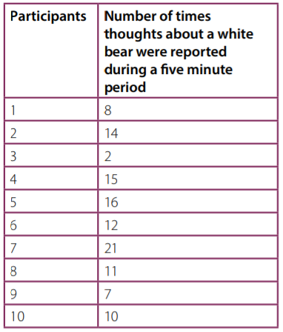
- Outline two findings from the data in this table. (4)
- Describe how an appropriate descriptive statistic could be used with the data in this table. (4)
- Give one strength and one weakness of the descriptive statistic you mentioned in the above question. (4)
- Outline one strength and one weakness of having qualitative data in this study. (6)
- Discuss the validity of using open questions in this study. (6)
- How might social desirability bean issue in this study? (2)

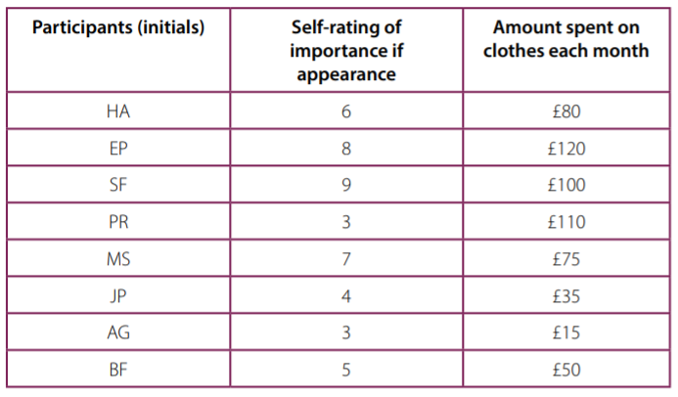
A researcher has conducted a correlational study to investigate the relationship between how important a person thinks appearance is and how much they spend on clothes each month. The first variable was ‘self rating of the importance of appearance’ measured on a ten point scale (where 1 = not important and 10 = extremely important). The second variable was ‘amount of money spent on clothes each month’ measured by asking people to estimate to the nearest five pounds how much they spent in a typical month. The results are in the table below:
- Describe how data is presented in a scatter graph. (2)
- Sketch an appropriately labelled scatter graph displaying the results of this study. (4)
- What could this graph tell you about the relationship between the two variables. (3)
- Outline two conclusions from the data in this scatter graph. (4)
- Explain what is meant by the descriptive statistic called the mean. (2)
- When would the descriptive statistic called the ‘median’ be more appropriate and why? (4)
- Which inferential test would you use to analyse the data – give reasons for your choice (3)
- What is the range for the amount of money spent on clothes each month? (1)

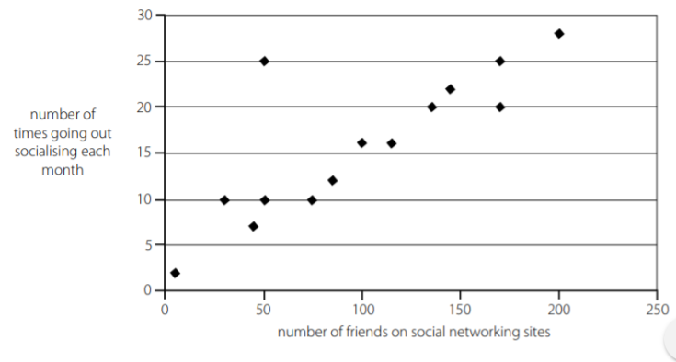
A psychologist conducted a correlation study to investigate the relationship between the number of friends people claim to have on internet social networking sites and number of times they go out socialising each month. The data was obtained from students in a psychology class who left the classroom one at a time to provide details to a researcher sitting outside. The findings from the study are presented in the scatter graph below
- From the scatter graph presented above, what is the mode for ‘the number of times going out socialising each month’ and how do you know this? (2)
- Outline two findings from the scatter graph. (4)
- What is qualitative data? (2)
- Suggest two examples of qualitative data that could have been collected in this study. (4)
- What is a strength and a weakness of collecting quantitative data in this study? (4)
- Identify one ethical issue in this study. (2)
- Discuss a problem with demand characteristics in relation to this study. (2)

Researchers want to conduct an observation study of shopping behaviour at a large local supermarket. The table below shows the number of times different behaviours were observed.
- Describe an ethical issue that the researchers need to consider when conducting this observation and suggest how this could be dealt with. (4)
- Explain what is meant by inter-rater reliability in observational research. (2)
- Suggest how the researchers could ensure that this observation has inter-rater reliability. (4)
- Sketch an appropriate graph or chart to display the findings from this stud.y (4)
- Outline two findings from the data displayed in this graph or chart. (4)
- Outline one disadvantage of having quantitative data in the study. (3)
- What level of data has been collected in this study? (1)

Couples sometimes imitate each other’s behaviours usually without realising it, such as folding arms at the same time as each other. Psychologists call this ‘postural echoing’. To study this, two researchers sat in a bar for one hour monitoring the behaviour of one couple at a time from the moment they entered until they left. Two couples were monitored and the data is presented in the table below.
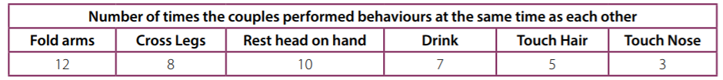
- Identify one ethical issue that the researchers needed to consider when conducting this observation. (2)
- Suggest how they could have dealt with this issue. (2)
- Suggest how the researchers could have ensured that this observation had high inter-rater reliability. (4)
- State an issue with the generalisability of the sample in this study. (2)
- Explain how observer bias may influence the results in this study. (2)
- Outline two findings from the data in this table. (4)
- Evaluate validity of using a behavioural checklist in this study. (6)
- Briefly outline what is meant by reliability in psychological research. (4)

Psychologists are interested in the factors that influence effective learning. Any strategies that can aid students in their recall of information are always welcome. Memory can be improved during the process of registration, storage or recall, and factors that may improve it may be social, physiological, environmental or psychological. A psychologist plan to use a repeated measures design experiment to test learning strategies.
- Briefly discuss one ethical issue in relation to this study. (3)
- Suggest how to measure the dependent variable in this study. (3)
- Sketch a suitable raw data recording table the researcher could use to collect their data. (3)
- What level of data would the researcher be collecting in this investigation? (2)
- Which inferential test would you use to analyse the data in this study– give reasons for your choice. (3)
- Suggest a form of secondary data the researcher could utilise to support their own data collection. (2)
- What does P<0.05 level of significance mean? (2)
- If you obtained this level of significance in this study explain what this would mean in relation to the null hypothesis (4)
- Briefly discuss one practical issue in relation to this study (3)

‘A researcher conducts an investigation into short-term memory by presenting participants with items on a tray and then asking participants to recall the items after two minutes.’ Table of results showing the number of words recalled by participants
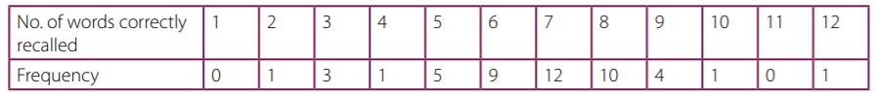
- What level of data has the researcher collected in this investigation? (1)
- Explain why the data in this study is an example of quantitative data. (1)
- Outline how the mean is calculated in this research. (2)
- Outline a conclusion that can be drawn from this study. Refer to the mode ratings as part of your answer. (2)
- Sketch a histogram with four columns to represent this data. (4)
- What is a type 1 error? (2)
- Explain the difference between researcher bias and researcher effects. (2)

Reporting Research
- Briefly outline what is meant by peer review in psychological research. (4)
- What is the purpose of an abstract in psychological research? (2)
- Where would ‘apparatus and materials’ be placed in a written report? (1)
- What style of referencing should be used in psychological research? (1)
- What is written in an introduction in a psychological report? (2)
- Name three things that are always included in an academic reference. (3)
- Name the section on a psychological report where a graph would be presented. (1)

Cognitive processes include memory and perception and just as our memories are likely to become distorted we are all susceptible to mistaken perceptions. Many of us are familiar with such classic illusions such as the Muller lyer illusion, where the line with the outgoing fins, figure (a) appears longer than the line with the ingoing fins, figure (b). In fact they are the same length.
(a) >-----------<
(b) < ---------- >
Explain how you would carry out an experiment in to whether older people more susceptible to visual illusions than younger people. Justify your decisions. As part of your explanation, you must refer to:
• Field or lab experiments
• Independent measures or matched participants
• At least one control you would use
• Collection of data.
You should refer to your own experience of research to inform your response. (15)

Questionnaires are often used to assess people attitudes to current events and to factors affecting attitude change. Psychologists have obtained information on such diverse topics as attitudes to body image and attitudes to drinking and driving this information has enabled research in to the factors affecting attitude to change.
Explain how you would carry out a questionnaire into ‘Attitudes to parental discipline’. Justify your decisions. As part of your explanation, you must refer to:
• Open and closed questions
• At least one ethical issue
• Socially desirable answers
• Bar charts.
You should refer to your own experience of research to inform your response. (15)

Psychologists use correlational designs to investigate relationships between variables that are difficult to investigate experimentally. Correlational designs are often used to investigate the relationship between environmental variables and human behaviour. For example research has examined environmental variables such as heat, sunshine, pollution and social density (crowding) and their relationships with happiness, aggression, helping behaviours, and performance on cognitive tasks.
Explain how you would carry out a correlational analysis in to the relationship between levels of exposure to sunlight and happiness. Justify your decisions. As part of your explanation, you must refer to:
• At least ordinal level data
• Data presentation
• Validly
* At least one ethical issue.
You should refer to your own experience of research to inform your response. (15)

Naturalistic observations are conducted by psychologists when they want to find out how people behave without experimental manipulation. Today psychologists should adhere to the BPS guidelines to avoid unethical treatment of participants. With sufficient training, psychologists can detect small differences in behaviour, such as facial expression and gesture, to infer how people are feeling and thinking.
Explain how you would carry out an observation in to eating behaviour. Justify your decisions. As part of your explanation, you must refer to:
• A behavioural checklist
• Participant or non-participant observation
• Time or event sampling
• Inter-rater reliability.
You should refer to your own experience of research to inform your response. (15)

Psychology as a Science
- What is meant by the term falsification? (2)
- How can a psychologist ensure their research can establish cause and effect? (2)
- Explain what is meant by the term cause and effect. (2)
- Why is it important for psychological research to be replicable? (2)
- What is meant by the term objectivity? (2)
- What is meant by quantifiable measures in psychological research? (2)
- Explain the process of induction. (4)
- Explain the process of deduction. (4)
- Explain how hypothesis testing works in experiments. (3)
- Why is the manipulation of variables important in psychological research? (2)
- How can psychologists ensure control in their research? (2)
- What is the purpose of having a standardised procedure in psychological research? (2)
- Why are quantifiable measures preferred in most psychological research than qualitative methods? (2)

Memory can be influenced by many different things, including the appearance of what it is we are trying to remember. For example, green is a natural colour that features a lot in our environment, so may help improve how we learn and remember things we see in this colour. To investigate this psychologists want to use the laboratory experiment method to investigate if presenting words in green ink compared to black helps improve memory. Participants for the study will be obtained by putting up a poster on a notice board in a large local supermarket asking for volunteers for a study investigating factors influencing memory.
- What type of sampling technique is this? (1)
- Describe one strength and one weakness of using this sampling technique in this study. (4)
- Write a one-tailed alternative hypothesis for this study. (3)

Explain how you would conduct a study using the laboratory experiment method to investigate the effect of colour on memory for a list of words. Justify your decisions. As part of your explanation, you must refer to:
- the use of independent measures design or repeated measures design
- how the variables are operationalised
- at least two control features
- level of data collected
You should refer to your own experience of research to inform your response. (15)

Evaluate the use of matched participants design if it had been used in this study. (6)

Psychologists want to conduct a follow-up study using the self-report method to investigate other things that may influence memory.
- Suggest one open question that could be used in this study. (2)
- Suggest one closed question that could be used in this study. (2)
- Suggest one question using a rating scale that could be used in this study. (2)
In an observational study, 100 cars were fitted with video cameras to record the drivers behaviour. Two psychologists used content analysis to analyse the data from the films. They found that 75% of accidents involved a lack of attention by the driver. The most common distractions were using a hands-free phone or talking to a passenger. Other distractions included looking at the scenery, smoking, eating, personal grooming and trying to reach something within the car.

- What is content analysis? (2 marks)
- Explain how the psychologists might have carried out content analysis to analyse the film clips of driver behaviour (4 marks)
- Explain how the two psychologists might have assessed the reliability of their content analysis. (3 marks)

The Psychologists then designed an experiment to test the effects of using a hands-free phone on driver’s attention. They recruited a sample of 30 experienced police drivers and asked them to take part in two computer-simulated driving tests. Both tests involved watching a threeminute film of a road. Participants were instructed to click the mouse as quickly as possible, when a potential hazard (such as a car pulling out ahead) was spotted. Each participant completed two computer-simulated driving tests:
• Test A, Whilst chatting with one of the psychologists on a handsfree phone
• Test B, in silence, with no distractions.
The order in which they completed the computer tests was counterbalanced.
- Explain why the psychologists chose to use a repeated measures design in this experiment. (3 marks)
- Identify one possible extraneous variable in this experiment. Explain how this variable may have influenced the results of this experiment. (3 marks)
- Explain how one factor in this experiment might affect its external validity (3 marks)
- Explain one or more ethical issues that the psychologists should have considered in this experiment (4 marks)
- Write a set of standardised instructions that would be suitable to read out to participants before they carry out Test A, chatting on a hands-free phone. (5 marks)

The computer simulator measured two aspects of driver behaviour:
• The number of hazards detected by each driver
• The Time taken to respond to each hazard, in seconds.

The mean scores for each of these measures is shown in Table 1.
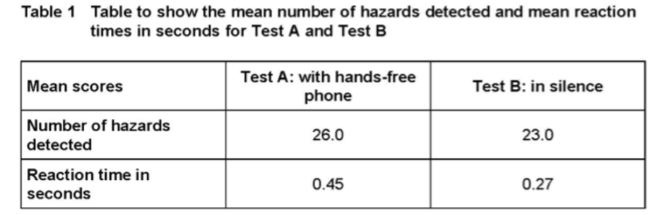

The Psychologists then used an inferential statistical test to assess whether there was a difference in the two conditions.

Identify an appropriate statistical test to analyse the difference in the number of hazards detected in the two conditions in this experiment. Explain why this test of difference would be appropriate. (3 marks)

They found no significant difference in the number of hazards detected (p >0.05), but there was a significant difference in reaction times (p ≤ 0.01).

- Explain why the psychologists did not think that they had made a Type 1 error in relation to the difference in reaction times. (2 marks)
- Replication is one feature of the scientific method. The psychologists decided to replicate this experiment using a larger sample of 250 inexperienced drivers. Explain why replication of this study would be useful (3 marks)

Some studies have suggested that there may be a relationship between intelligence and happiness. To investigate this claim, a psychologist used a standardized test to measure intelligence in a sample of 30 children aged 11 years, who were chosen from a local secondary school. He also asked the children to complete a self-report questionnaire designed to measure happiness. The score from the intelligence test was correlated with the score from the happiness questionnaire. The psychologist used a Spearman’s rho test to analyse the data. He found that the correlation between intelligence and happiness at age 11 was +0.42

- Write an operationalized non-directional hypothesis for this study (2 marks)
- Identify an alternative method which could have been used to collect data about happiness in this study. Explain why this method might be better than using a questionnaire. (4 marks)
- What is meant by internal validity? (1 mark)
- Describe how the internal validity of the happiness questionnaire could be assessed (3 marks)
- A Spearman’s rho test was used to analyse the data. Give two reasons why this test was used (2 marks)

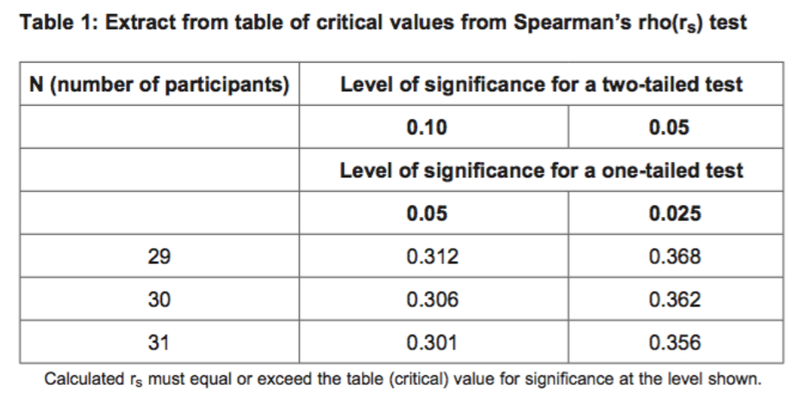

The psychologist used a non-directional hypothesis. Using Table 1, state whether or not the correlation between intelligence and happiness at age 11 (+0.42) was significant. Explain your answer. (3 marks)

Five years later, the same young people were asked to complete the intelligence test and the happiness questionnaire for a second time. This time the correlation was −0.29.
- With reference to both correlation scores, outline what these findings seem to show about the link between intelligence and happiness. (4 marks)

The report was subjected to peer review before it was published in a journal.
- What is meant by peer review? (2 marks)
- Explain why peer review is an important aspect of the scientific process. (4 marks)

A teacher has worked in the same primary school for two years. While chatting to the children, she is concerned to find that the majority of them come to school without having eaten a healthy breakfast. In her opinion, children who eat ‘a decent breakfast’ learn to read more quickly and are better behaved than children who do not. She now wants to set up a pre-school breakfast club for the children so that they can all have this beneficial start to the day. The local authority is not willing to spend money on this project purely on the basis of the teacher’s opinion and insists on having scientific evidence for the claimed benefits of eating a healthy breakfast.

Explain why the teacher’s personal opinion cannot be accepted as scientific evidence. Refer to features of science in your answer. (6 marks)

A psychologist at the local university agrees to carry out a study to investigate the claim that eating a healthy breakfast improves reading skills. He has access to 400 five-year-old children from 10 local schools, and decides to use 100 children (50 in the experimental group and 50 in the control group). Since the children are so young, he needs to obtain parental consent for them to take part in his study.

- The psychologist used a random sampling method. Explain how he could have obtained his sample using this method. (3 marks)
- Explain limitations of using random sampling in this study. (3 marks)
- Explain why it is important to operationalise the independent variable and the dependent variable in this study and suggest how the psychologist might do this. (5 marks)
- The psychologist used a Mann-Whitney test to analyse the data. Give two reasons why he chose this test. (2 marks)
- He could have used a matched pairs design. Explain why this design would have been more difficult to use in this study. (2 marks)
- Other than parental consent, identify one ethical issue raised in this study and explain how the psychologist might address it. (2 marks)

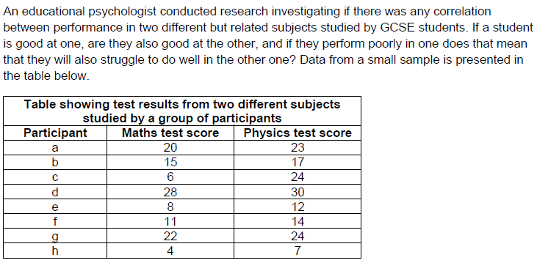

- Identify two findings from the data presented in this table. (4)
- Draw a scattergram displaying the results of this study. (4)
- Calculate the range for each test taken. (2)
- What conclusion could be drawn by interpreting the ranges for each test identified in the previous question? (4)
- Suggest one advantage of using standard deviation instead of the range to analyse the data from each test. (3)
- Suggest two strengths of using correlation in this study. (4)
- Suggest two weaknesses of using correlation in this study. (4)
- The psychologist used the Spearman’s ranked correlation coefficient test to analyse the data from this study. Explain why this was an appropriate test to use. (2)
- Explain how the data would be ranked for use in this test. (2)
- The inferential test result produced a calculated value of +0.7083. Explain what this means. (3)
- What does the term ‘critical value’ refer to? (1)
- How would the critical value be obtained in this study? (2)

A psychologist used an observation to investigate the effect of environment on individuals’ need for personal space. They decided to carry out a covert observation in three settings: a nightclub, a college library and the changing room in a leisure centre. Members of the public using the facilities made up the sample. The psychologist observed key behaviours, such as reduced eye contact, defensive body posture and movement away from people.

- Outline one strength of using an observation compared to self-report. (2)
- Identify three ethical issues that would need to be considered when carrying out this observation. (3)
- The psychologist used an opportunity sample for their research. Explain one strength and one weakness of using an opportunity sample for this study. (6)
- Name and outline one other sampling technique for selecting participants. (2)
- Describe one strength and one weakness of the sampling technique you have chosen (4)

You have been asked to carry out a further observational study to investigate the differences in use of personal space between rural and urban environments. This will be part of an experiment using one village and one city.

Write a one-tailed (directional) or two-tailed (non-directional) hypothesis for your investigation. (3)

Explain how you would carry out an observation to investigate the differences in use of personal space between rural and urban environments. Justify your decisions as part of your explanation. You must refer to:
- structured or unstructured observations
- participant or non-participant observations
- time or event sampling
- collection of data.
In OCR, you should use your own experience of carrying out an observation to inform your response. (15)

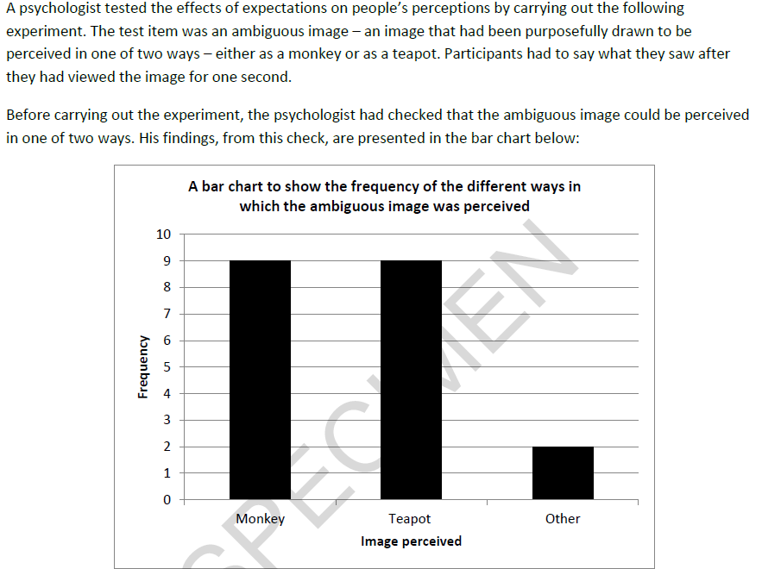

- Identify two findings from the bar chart. (2)
- Explain why a bar chart is appropriate for presenting this data. (2)
- Calculate the percentage number of times that the image was identified as neither a monkey nor a teapot. Show your workings. (2)

Fifty participants were recruited and then randomly allocated into two groups. In one condition, five drawings of other animals were presented, one after the other, before the ambiguous image. Participants had to name each one of these. In the second condition, the set up was the same but five images of kitchen items were used.

- Name and briefly describe the experimental design used in this study. (2)
- Explain how the psychologist would have randomly allocated participants to each group. (2)
- Discuss why this experimental design was appropriate for this study. (5)

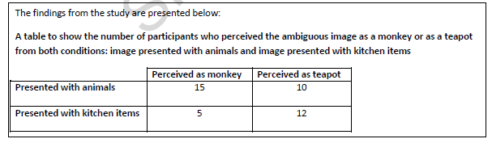

- Identify and simplify the ratio of the number of participants who perceived a monkey in the first condition and the number who perceived a monkey in the second condition. (2)
- Identify and simplify the ratio of the number of participants who perceived a teapot in the first condition and the number who perceived a teapot in the second condition. (2)
- The psychologist analysed the data using Chi Squared test. Give two reasons for this choice of test with reference to the study. (4)
- Explain how the psychologist would determine the appropriate degrees of freedom (df) for this test. (2)
- The Chi Squared test gave an observed (calculated) value of 3.80.
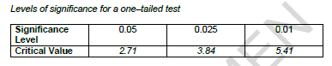
Using the above critical values, explain whether the psychologist has found a significant difference or not. (4)
- Outline what is meant by each of the following features of science and state how they apply to this experiment into perception:
  - Cause and effect (3)
  - Objectivity (3)

Dreaming is something that we all do, regularly, yet despite this we know very little about it. Why is it that some people seem to remember their dreams more than others? Why do some people have pleasant dreams whereas others have nightmares? Perhaps what we have done in the day, or even type of foods we have eaten influence our dreams. Do we have more dreams, or less as we get older? There is clearly much we do not know. To investigate further, psychologists want to use the self-report method to find out more about dreaming.

- Write a research aim for this study. (2)
- What is a semi-structured interview? (2)
- Briefly outline how you could use a semi-structured interview for this study. (4)
- Evaluate the use of a semi-structured interview in this study. (6)

Explain how you would use the self-report method to investigate dreaming. Justify your decisions as part of your explanation. You must refer to:
- sample and sampling technique
- your questionnaire
- open and closed questions
- likert scale questions
You should refer to your own experience of research to inform your response. (15)

Explain one strength and one weakness of using the self-report method in this study. (6)

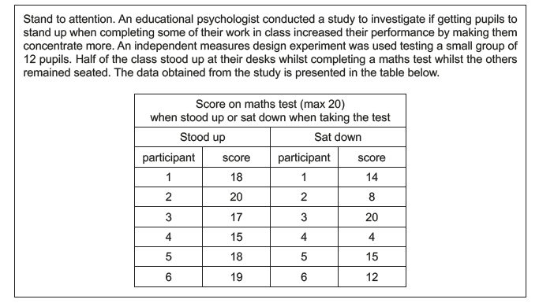

- Identify two findings from the data presented in this table. (4)
- Calculate the mean for the “stood up” condition and present your findings to 2 decimal places. Show your workings. (2)
- Calculate the mean for the “sat down” condition and present your findings to 2 significant figures. Show your workings. (2)
- Calculate the mean percentage number of words recalled in each condition. Show your workings. (2)
- Explain how you would calculate the standard deviation for each condition of this study. (5)
- What information would the standard deviation provide if it was calculated for the data in this study? (2)
- The standard deviation for each condition is presented below. What do these findings inform us about the effect of standing up or sitting down when performing a test. (4)
Stood up – 1.72
Sat down – 5.60
- What would be the appropriate inferential statistics test to use to analyse the data from the study? Give reasons for your answer. (2)
- Outline how the data in this study would be ranked before using the inferential statistics test. (2)
- Outline one advantage and one disadvantage of having quantitative data in this study. (4)
- Outline what is meant by each of the following features of science and state how they apply to this study:
  - Hypothesis testing (3)
  - Manipulation of variables (3)

Do like me. The extent to which people mimic each other’s behaviour (e.g. fold arms at the same time) is often regarded as an indicator of how well they are getting on together, especially if in a romantic relationship. A psychologist wants to conduct a study using the observation method to investigate this by studying the behaviour of couples having a drink in a bar. Behaviour was observed every 10 minutes during a period from 8 pm to 10 pm.

- Write an appropriate research aim for this study. (2)
- Describe one strength of using the observational method in this study. (3)
- Describe one weakness of using the observational method in this study. (3)
- Describe one strength of using time sampling in this study. (3)
- Describe one weakness of using time sampling in this study. (3)
- Explain the difference between a naturalistic observation and a controlled observation. (2)
- What does inter-rater reliability refer to in this study? (3)
- Suggest one open question that could have been asked if the researcher had used self-report instead of observation in this study. (2)
- Suggest one closed question that could have been asked if the researcher had used self-report instead of observation in this study. (2)

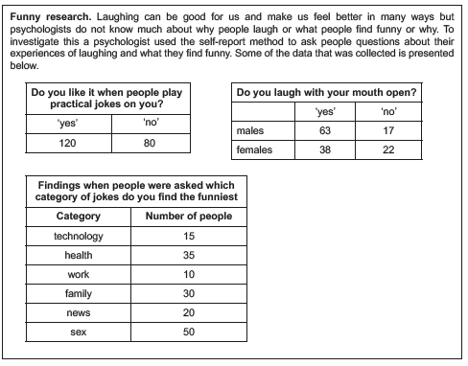

- What is the ratio of people who like it when practical jokes are played on them to those that do not? Present your answer in its simplest form and show your workings. (2)
- Identify the appropriate inferential statistical test to use in this study to analyse the data obtained from the question asking about whether people laugh with their mouth open or not. Give reasons for your answer. (3)
- Draw a fully labelled bar chart to display the data from the question asking people about which category of jokes they find the funniest. (4)
- Calculate the percentage of people who reported ‘sex’ as the category of jokes they found the funniest. Show your workings and present your findings to 2 significant figures. (3)
- What level of data is collected in the study? Justify your answer. (2)
- Evaluate the use of this level of data in this study. (3)
- Outline two conclusions from the data collected in this study. (4)
- Suggest two ways that social desirability may have influenced the data collected in the study. (4)

A psychologist was interested in the relationship between individuals’ language ability and their physical co-ordination. She used a correlational analysis to investigate this in a self-selected sample of 34 adult participants.
Each participant completed a language ability test. This test involved both having to spell a list of 20 words and answering 20 closed questions on the meaning of words. The participants’ physical co-ordination was then calculated by rating them on six different tasks including balancing on a beam, catching a ball and copying a dance routine.

- The psychologist’s hypothesis predicted a significant negative correlation. Using this information above, explain what she was expecting the results to show. (2)
- Write a closed question which could have been used to test participants’ understanding of the meaning of a word. (1)
- Explain why the data collected in this study is an example of quantitative data. (3)
- Name the graph that would be used to show correlational analysis. (1)
- Name the section of a practical report where a graph would be presented. (1)
- Describe one strength of using a self-selected (volunteer) sample in this study. (3)
- Describe one weakness of using a self-selected sample in this study. (3)
- Outline how each of the following ethical considerations could have been dealt with in this study:
- Confidentiality (2)
- Informed consent (2)
- Protection of participants (2)
- Explain why the data from the language ability test may be criticised for lacking construct validity. (3)

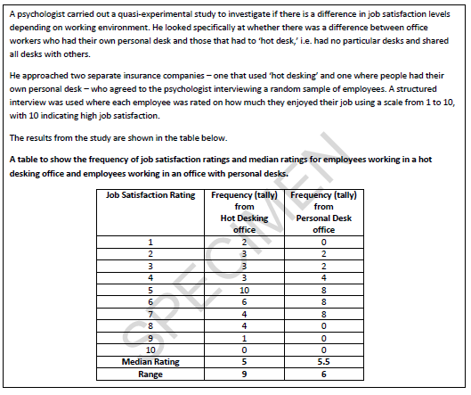

- Outline how a median is calculated. (2)
- Outline a conclusion that can be drawn from the table above. Refer to the median ratings as part of your answer. (2)
- State which office had a greater dispersion of scores. Justify your answer. (2)
- Outline the purpose of peer review in psychological research. (3)
- Following a peer review, the following statement was made: “there is a potential issue with social desirability when considering these findings”. Explain what this statement means in relation to this study. (5)

A researcher wanted to see whether cognitive behaviour therapy was an effective treatment for depression. Twenty depressed patients who had all recently completed a course of cognitive behaviour therapy were involved in the investigation. From their employment records, the researcher kept a record of the number of absences from work each patient had in the year following their treatment. This was compared with the number of absences from work each patient had in the year prior to their treatment.
Those patients who had fewer absences from work in the year following their treatment than in the year prior to their treatment were classified as ‘improved’ (+). Those patients who had more absences were classified as ‘deteriorated’ (-). Those patients who had the same number of absences were classified as ‘neither’ (0).
The results of the investigation are included in Table 1 below.

 | Patient | Improved | Deteriorated | Neither
 | 1 | +
 | 2 |  |  | 0
 | 3 |  | –
 | 4 | +
 | 5 | +
 | 6 | +
 | 7 |  | –
 | 8 |  | –
 | 9 |  |  | 0
 | 10 | +
 | 11 |  | –
 | 12 | +
 | 13 | +
 | 14 | +
 | 15 | +
 | 16 |  | –
 | 17 | +
 | 18 | +
 | 19 | +
 | 20 |  |  | 0
The researcher decided to use the sign test to analyse the data.
- Explain two factors that the researcher had to take into account when deciding to use the sign test. Refer to the investigation above in your answer. (4)
- Calculate the sign test value of s for the data in Table 1. Explain how you reached your answer. (2)
Table 2: Critical values for the sign test

 | n | 0.005 (one  tailed)  0.01 (two  tailed) | 0.01 (one  tailed)  0.02 (two  tailed) | 0.025 (one  tailed)  0.05 (two  tailed) | 0.05 (one  tailed)  0.10 (two  tailed)
 | 16 | 2 | 2 | 3 | 4
 | 17 | 2 | 3 | 4 | 4
 | 18 | 3 | 3 | 4 | 5

For significance, the value of the less frequent sign is equal to, or less than, the value of the table.
- With reference to the critical values in Table 2, explain whether or not the value of s that you calculated in response to the previous question is significant at the 0.05 level for a two tailed test. (2)
- The investigation above is based on secondary data. In what ways would the use of primary data have improved this investigation? (3)
- Outline the implications of psychological research for the economy. Refer to the investigation above in your answer. (5)

In an observational study, 100 cars were fitted with video cameras to record the driver’s behaviour. Two psychologists used content analysis to analyse the data from the films. They found that 75% of accidents involved a lack of attention by the driver. The most common distractions were using a hands-free phone or talking to a passenger. Other distractions included looking at the scenery, smoking, eating, personal grooming and trying to reach something within the car.

- What is content analysis? (2)
- Explain how the psychologists might have carried out content analysis to analyse the film clips of driver behaviour. (4)
- Explain how the two psychologists might have assessed the reliability of their content analysis. (3)

The psychologists then designed an experiment to test the effects of using a hands-free phone on drivers’ attention. They recruited a sample of 30 experienced police drivers and asked them to take part in two computer-simulated driving tests. Both tests involved watching a three-minute film of a road. Participants were instructed to click the mouse as quickly as possible, when a potential hazard (such as a car pulling out ahead) was spotted.
Each participant completed two computer-simulated driving tests:
  - Test A, whilst chatting with one of the psychologists on a hands-free phone
  - Test B, in silence, with no distractions.
The order in which they completed the computer tests was counterbalanced.
- Explain why the psychologists chose to use a repeated measures design in this experiment. (3)
- Identify one possible extraneous variable in this experiment. Explain how this variable may have influenced the results of this experiment. (3)
- Explain one or more ethical issues that the psychologists should have considered in this experiment. (4)
- Write a set of standardised instructions that would be suitable to read out to participants, before they carry out Test A, chatting on a hands-free phone. (5)
The computer simulator measured two aspects of driver behaviour:
  - the number of hazards detected by each driver
  - the time taken to respond to each hazard, in seconds.
The mean scores for each of these measures is shown in the table below.
Table to show the mean number of hazards detected and mean reaction times in seconds for Test A and Test B

 | Mean scores | Test A: with hands-free phone | Test B: in silence
 | Number of hazards detected | 26.0 | 23.0
 | Reaction time in seconds | 0.45 | 0.27
The psychologists then used an inferential statistical test to assess whether there was a difference in the two conditions.
Identify an appropriate statistical test to analyse the difference in the number of hazards detected in the two conditions of this experiment. Explain why this test of difference would be appropriate. (3)
They found no significant difference in the number of hazards detected (p > 0.05), but there was a significant difference in reaction times (p > 0.01).
- Explain why the psychologists did not think that they had made a Type 1 error in relation to the difference in reaction times. (2)
- Replication is one feature of the scientific method. The psychologists decided to replicate this experiment using a larger sample of 250 inexperienced drivers. Explain why replication of this study would be useful. (3)
A student teacher was interested in the relationship between empathy (consideration and feelings for others) and the time spent reading fiction. She decided to investigate whether or not such a relationship was present in children. The student teacher designed her own questionnaire to measure empathy in 8-year-old children. The higher the score achieved, the greater the empathy. Twenty children, all from one school, took part. Each child completed the questionnaire individually.
The student teacher designed another questionnaire to measure ‘time spent reading fiction’. Each child was given this questionnaire to take home and complete with his or her parents over a four-week period. ‘Time spent reading fiction’ included the time spent by parents reading to the child as well as the time the child spent reading independently. Using the responses to this questionnaire, the student teacher calculated how much time per week, on average, each child spent reading fiction. The data obtained are shown in the graph below.
Scattergram of children’s scores on a test of empathy and the average number of hours spent reading fiction per week.
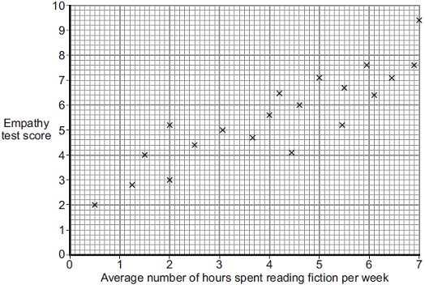

- Outline the relationship between empathy and the average number of hours spent reading fiction per week shown in the graph above. (1)
- Name an appropriate test to determine whether or not there is a significant relationship between the two variables in the graph above. Justify your answer with reference to levels of measurement. (2)
The student teacher decided to use a two-tailed test.
- Outline one way in which the student teacher could have assessed the validity of the empathy questionnaire. (2)
- Apart from the issue of validity, identify and briefly explain one methodological limitation of the study. (2)
- Explain why it was appropriate for the student teacher to use a correlation study rather than an experiment. (3)

Some studies have suggested that there may be a relationship between intelligence and happiness. To investigate this claim, a psychologist used a standardised test to measure intelligence in a sample of 30 children aged 11 years, who were chosen from a local secondary school. He also asked the children to complete a self-report questionnaire designed to measure happiness. The score from the intelligence test was correlated with the score from the happiness questionnaire. The psychologist used a Spearman’s rho test to analyse the data. He found that the correlation between intelligence and happiness at age 11 was +0.42.
- Write an operationalised non-directional hypothesis for this study. (2)
- Identify an alternative method which could have been used to collect data about happiness in this study. Explain why this method might be better than using a questionnaire. (4)
- A Spearman’s rho test was used to analyse the data. Give two reasons why this test was used. (2)
Extract from table of critical values from Spearman’s rho(rs) test

 | N (number of participants) | Level of significance for a two-tailed test
 |  | 0.10 | 0.05
 |  | Level of significance for a one-tailed test
 |  | 0.05 | 0.025
 | 29 | 0.312 | 0.368
 | 30 | 0.306 | 0.362
 | 31 | 0.301 | 0.356

Calculated rs must equal or exceed the table (critical) value for significance at the level shown.
- The psychologist used a non-directional hypothesis. Using the table above, state whether or not the correlation between intelligence and happiness at age 11 (+0.42) was significant. Explain your answer. (3)
Five years later, the same young people were asked to complete the intelligence test and the happiness questionnaire for a second time. This time the correlation was –0.29.
- With reference to both correlation scores, outline what these findings seem to show about the link between intelligence and happiness. (4)

A maths teacher wondered whether there was a relationship between mathematical ability and musical ability. She decided to test this out on the GCSE students in the school. From 210 students, she randomly selected 10 and gave each of them two tests. She used part of a GCSE exam paper to test their mathematical ability. The higher the mark, the better the mathematical ability. She could not find a musical ability test so she devised her own. She asked each student to sing a song of their choice. She then rated their performance on a scale of 1–10, where 1 is completely tuneless and 10 is in perfect tune.
- Suggest a suitable non-directional hypothesis for this study. (3)
- Why might the measure of musical ability used by the teacher lack validity? (3)
- Explain how the teacher could have checked the reliability of the mathematical ability test. (3)
- Explain why the teacher chose to use a random sample in this study. (3)
The results of the study are given in the table below.
Mathematical ability test scores and musical ability ratings for 10 students

 | Student | Mathematical ability  test score | Musical ability  rating
 | 1 | 10 | 10
 | 2 | 2 | 9
 | 3 | 9 | 3
 | 4 | 6 | 6
 | 5 | 3 | 9
 | 6 | 10 | 2
 | 7 | 2 | 1
 | 8 | 1 | 8
 | 9 | 8 | 4
 | 10 | 4 | 7

- In your answer book, sketch a graph to show the data in the table above. Give the graph an appropriate title and label the axes. (3)
- Discuss what the data in the table above and the graph that you have sketched seem to show about the relationship between mathematical ability and musical ability. (3)

A study was carried out to test the effectiveness of a new anger management programme. The programme had been designed by a team of psychologists working in a young offenders’ institution. Fifteen male offenders aged 17– 21 years took part in the programme. An anger score for each offender was obtained before the start of the programme. This score was based on a questionnaire designed by the psychologists. The questionnaire had 10 items. The maximum score was 50; the higher the score, the greater the level of anger. The month-long programme of anger management involved 8 two-hour sessions. Throughout the programme, the offenders were told to keep a diary of situations that made them angry and to record their anger in these situations. After the programme had ended, they were told to continue to keep their diary. Two weeks later, after the programme had ended, a second anger score was obtained for each offender. The same questionnaire was used.
The data obtained are shown in Table 1 below.
Table 1: Median anger scores and the ranges before and after the programme

 |  | Before | After
 | Median | 35 | 24
 | Range | 15 | 17
Explain why measures of dispersion are often used in addition to measures of central tendency to summarise data. Refer to the results of this study in your answer. (2)
A Wilcoxon signed ranks test was used to test for a significant difference between the anger scores at the start of the programme and after the programme had ended.
The calculated value of T was found to be 22.
Table 2: Critical values of T

 | Level of significance for two-tailed test | 0.1 | 0.05 | 0.02
 | Critical value of T (when N = 15) | 30 | 25 | 19

T must be equal to or less than the critical value to be significant.
Using Table 2 above, explain whether or not the result is significant. (2)
- Explain why the psychologists decided to use a Wilcoxon signed ranks test to analyse the data. (3)
- Explain two possible reasons for asking each offender to keep a diary. (4)
- An independent researcher reviewed the design of the study and noted that there was no control group. Explain how having a control group could have improved this study. (3)
- The independent researcher was also concerned that the psychologists had not checked the reliability and validity of the questionnaire used to measure the level of anger. Outline how the psychologists could check the reliability and the validity of the questionnaire. (5)

Two psychologists investigated the relationship between age and recall of medical advice. Previous research had shown that recall of medical advice tended to be poorer in older patients. The study was conducted at a doctor's surgery and involved a sample of 30 patients aged between 18 and 78 years. They all saw the same doctor, who made notes of the advice that she gave during the consultation.

One of the psychologists interviewed each of the patients individually, immediately after they had seen the doctor. The psychologist asked each patient a set of questions about what the doctor had said about their diagnosis and treatment. The patients' responses were recorded and then typed out. Working independently the psychologists compared each typed account with the doctor's written notes in order to rate the accuracy of the accounts on a scale of 1 – 10. A high rating indicated that the patient's recall was very accurate and a low rating indicated that the patient's recall was very inaccurate.
- The psychologists decided to propose a directional hypothesis. Why was a directional hypothesis appropriate in this case? (1)
- Write a suitable directional hypothesis for this investigation. (3)
- The psychologists were careful to consider the issue of reliability during the study. What is meant by reliability? (1)
- Explain how the psychologists might have assessed the reliability of their ratings. (3)
- This study collected both qualitative and quantitative data. From the description of the study above, identify the qualitative data and the quantitative data. (2)
- The psychologists used Spearman's rho to analyse the data from their investigation. They chose to use the 0.05 level of significance. The result gave a correlation coefficient of −0.52.
- Give two reasons why the psychologists used Spearman's rho to analyse the data. (2)
- Using the table below, state whether the result is significant or not significant and explain why. (2)
Extract from a table of critical values of Spearman's rho (r_{S})

 | Level of significance for a one-tailed test
 |  | 0.05 | 0.01
 | Level of significance for a two-tailed test
 |  | 0.10 | 0.02
 | N=29 | 0.312 | 0.433
 | 30 | 0.306 | 0.425
 | 31 | 0.301 | 0.418

Calculated r_{s} must equal or exceed the table (critical) value for significance at the level shown.
- Explain what is meant by a Type 1 error. (2)
- Use the information in the table above to explain why the psychologists did not think that they had made a Type 1 error in this case. (3)

The psychologists then wanted to see whether the use of diagrams in medical consultations would affect recall of medical information. In a laboratory experiment involving a medical consultation role-play, participants were randomly allocated to one of two conditions. In Condition A, a doctor used diagrams to present to each participant a series of facts about high blood pressure. In Condition B, the same doctor presented the same series of facts about high blood pressure to each participant but without the use of diagrams. At the end of the consultation, participants were tested on their recall of facts about high blood pressure. Each participant was given a score out of ten for the number of facts recalled.
- In this case, the psychologists decided to use a laboratory experiment rather than a field experiment. Discuss advantages of carrying out this experiment in a laboratory. (4)
- Identify an appropriate statistical test that the psychologists could use to analyse the data from the follow-up study. Give one reason why this test is appropriate. (2)

The psychologist was also interested in the effects of a restricted diet on memory functioning and he expected memory to become impaired. The psychologist’s hypothesis was that participants’ scores on a memory test are lower after a restricted diet than before a restricted diet. He gave the volunteers a memory test when they first arrived in the research unit and a similar test at the end of the four-week period. He recorded the memory scores on both tests and analysed them using the Wilcoxon signed ranks test. He set his significance level at 5%.
His calculated value was T = 53.
State whether the hypothesis for this study is directional or non–directional. (1)
Table: Extract from table of critical values from the Wilcoxon signed ranks test

 | Level of significance for a one-tailed test | 0.05 | 0.025
 | Level of significance for a two-tailed test | 0.1 | 0.05
 | N | T≤
 | 19 | 53 | 46
 | 20 | 60 | 52
 | 21 | 67 | 58
 | 22 | 75 | 65
 | Calculated T must be equal to or less than the critical value (table value) for significance at the level shown
Using the table above, state whether or not the psychologist’s result was significant. Explain your answer. (3)
A psychologist is using the observational method to look at verbal aggression in a group of children with behavioural difficulties. Pairs of observers watch a single child in the class for a period of one hour and note the number of verbally aggressive acts within ten-minute time intervals. After seeing the first set of ratings, the psychologist becomes concerned about the quality of inter-rater reliability. The tally chart for the two observers is shown in the table below.
Table: Observation of one child – number of verbally aggressive acts in ten-minute time intervals

Time slots | 0–10 | 11–20 | 21–30 | 31–40 | 41–50 | 51–60
Observer A | 2 | 5 | 0 | 6 | 4 | 3
Observer B | 4 | 3 | 2 | 1 | 6 | 5
- Use the data in the Table above to sketch a scattergram. Label the axes and give the scattergram a title. (4)
- Using the data in the Table above, explain why the psychologist is concerned about inter-rater reliability. (4)
- Identify an appropriate statistical test to check the inter-rater reliability of these two observers. Explain why this is an appropriate test. (3)
- If the psychologist does find low reliability, what could she do to improve inter-rater reliability before proceeding with the observational research? (4)

A psychologist was interested in testing a new treatment for people with eating disorders. She put up adverts in several London clinics to recruit participants. Thirty people came forward and they were all given a structured interview by a trained therapist. The therapist then calculated a numerical score for each participant as a measure of their current functioning, where 50 indicates excellent, healthy functioning and zero indicates failure to function adequately. The psychologist then randomly allocated half the participants to a treatment group and half to a no-treatment group. After eight weeks, each participant was re-assessed using a structured interview conducted by the same trained therapist, and given a new numerical score. The trained therapist did not know which participants had been in either group.

For each participant, the psychologist calculated an improvement score by subtracting the score at the start of the study from the score after eight weeks. The greater the number, the better the improvement.

Median and range of improvement scores for the
treatment group and for the no-treatment group
 |  | Treatment group | No–treatment group
 | Median | 10.9 | 2.7
 | Range | 2.1 | 0.8
- With reference to the data in the table above, outline what the findings of this investigation seem to show about the effectiveness of the treatment. (2)
- The psychologist used a statistical test to find out whether there was a significant difference in improvement between the ‘treatment’ and ‘no-treatment’ groups. She found a significant difference at the 5% level for a one-tailed test ( p ≤ 0.05).
- Identify an appropriate statistical test for analysing the participants’ scores. Explain why it would be a suitable test to use in this study. (4)
- What is the likelihood of the psychologist having made a Type 1 error in this study? Explain your answer. (2)
- The psychologist assumed that improvements in the treatment group were a direct result of the new type of treatment. Suggest two other reasons why people in the treatment group might have improved. (4)
- The psychologist could have used self-report questionnaires to assess the participants instead of using interviews with the therapist. Explain one advantage and one disadvantage of using self-report questionnaires in this study rather than interviews. (4)
- The psychologist needed to obtain informed consent from her participants. Write a brief consent form which would be suitable for this study. You should include some details of what participants could expect to happen in the study and how they would be protected. (5)
- What is meant by reliability? Explain how the reliability of the scores in this study could be checked. (4)

A psychologist wanted to test whether listening to music improves running performance. The psychologist conducted a study using 10 volunteers from a local gym. The psychologist used a repeated measures design. Half of the participants were assigned to condition A (without music) and half to condition B (with music). All participants were asked to run 400 metres as fast as they could on a treadmill in the psychology department. All participants were given standardised instructions. All participants wore headphones in both conditions. The psychologist recorded their running times in seconds. The participants returned to the psychology department the following week and repeated the test in the other condition.
- Identify the type of experiment used in this study. (1)
- Identify the operationalised dependent variable in this study. (2)
The results of the study are given in table 1.
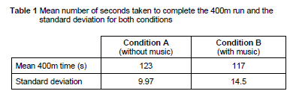
- Explain why a histogram would not be an appropriate way of displaying the means shown in table 1. (2)
- Name a more appropriate graph to display the means shown in table 1. Suggest appropriate X (horizontal) and Y (vertical) axis labels for your graph choice. (3)
- What do the mean and standard deviation values in table 1 suggest about the participants’ performances with and without music? Justify your answer. (4)
- Calculate the percentage decrease in the mean time it took participants to run 400m when listening to music. Show your workings. Give your answer to three significant figures. (4)
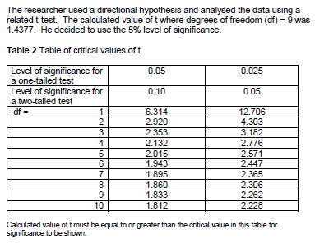
- Give three reasons why the researcher used a related t-test in this study and, using table 2, explain whether or not the results are significant. (5)
- What is meant by a type-II error? Explain why psychologists normally use the 5% level of significance in their research. (3)
- Identify one extraneous variable that could have affected the results of this study. Suggest why it would have been important to control this extraneous variable and how it could have been controlled in the study. (3)
- The report was submitted for peer review and a number of recommendations were advised. Describe the process and purpose of peer review. (6)

Design an observational study to investigate how people spend their time at the gym. In your answer you will be awarded credit for providing appropriate detail of:
-> type of observation with justification
-> operationalized behavioural categories
-> use of time and/or event sampling with justification
-> how reliability of data collection could be assessed.
You should refer to your own experience of research to inform your response. (15)
A psychologist wanted to see if verbal fluency is affected by whether people think they are presenting information to a small group of people or to a large group of people. The psychologist needed a stratified sample of 20 people. She obtained the sample from a company employing 60 men and 40 women. The participants were told that they would be placed in a booth where they would read out an article about the life of a famous author to an audience. Participants were also told that the audience would not be present, but would only be able to hear them and would not be able to interact with them.
There were two conditions in the study, Condition A and Condition B.
Condition A: 10 participants were told the audience consisted of 5 listeners.
Condition B: the other 10 participants were told the audience consisted of 100 listeners.
Each participant completed the study individually. The psychologist recorded each presentation and then counted the number of verbal errors made by each participant.
- Identify the dependent variable in this study. (2)
- Write a suitable hypothesis for this study. (3)
- Identify one extraneous variable that the psychologist should have controlled in the study and explain why it should have been controlled. (3)
- Explain one advantage of using a stratified sample of participants in this study. (2)
- Explain how the psychologist would have obtained the male participants for her stratified sample. Show your calculations. (3)
- The psychologist wanted to randomly allocate the 20 people in her stratified sample to the two conditions. She needed an equal number of males in each condition and an equal number of females in each condition. Explain how she would have done this. (4)

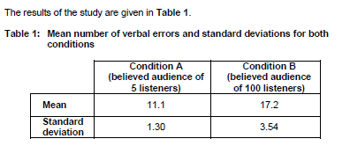
What conclusions might the psychologist draw from the data in table 1? Refer to the means and standard deviations in your answer. (6)

The psychologist had initially intended to use the range as a measure of dispersion in this study but found that one person in Condition A had made an exceptionally low number of verbal errors.

- Explain how using the standard deviation rather than the range in this situation would improve the study. (3)
- Name an appropriate statistical test that could be used to analyse the number of verbal errors in table 1. Explain why the test you have chosen would be a suitable test in this case. (4)
- The psychologist found the results were significant at P<0.05. What is meant by this? (2)
- Briefly explain one method the psychologist could use to check the validity of the data she collected in this study. (2)
- Briefly explain one reason why it is important for research to undergo a peer review process. (2)

The psychologist focused on fluency in spoken communication in her study. Other research has investigated sex differences in non-verbal behavior such as body language and gestures.
Design an observation to investigate sex differences in non-verbal behaviour of males and females when they are giving a presentation to an audience. In your answer, you should provide details of:
- the task for participants
- the behavioural categories to be used and how the data will be recorded
- how reliability of the data collection could be established
- ethical issues to be considered
You should refer to your own experience of research to inform your response. (15)
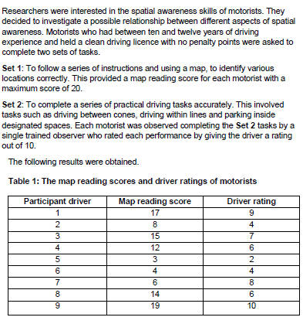
- Should the hypothesis be directional? Explain your answer. (2)
- Write a suitable hypothesis for this investigation. (3)
- Identify a suitable graphical display for the data in table 1 and briefly explain why this data would be appropriate. (2)
- Using the data in table 1, comment on the relationship between the map-reading scores and the driver-rating scores of the participants. (3)
- Briefly outline one problem of using a single trained observer to rate the participants’ driving skills in the practical task. Briefly discuss how this data collection method could be modified to improve the reliability of the data collected. (6)
- The researchers decided to analyse the data using Spearman’s Rho. Explain why this is a suitable choice of test for this investigation. (3)

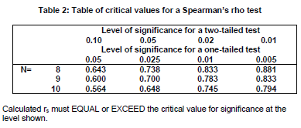
- After analysis of the data, the researchers obtained a calculated value of rs=.808. Using the information in table 2, what conclusion can the researchers draw about the relationship between the map-reading and driving skills of the motorists? Explain your answer. (4)
- Distinguish between a type I error and a type II error. (4)

When the researchers looked at the data collected more closely, they noticed possible gender differences in the results.

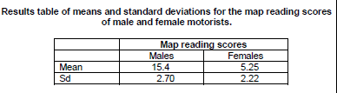

What do the mean and standard deviation values suggest about the male and female performances in the investigation? (4)

In a replication of the part of the study in which map reading skills were investigated, 20 men and 20 women completed the original map reading task and the researchers obtained the following data.
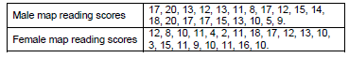
The mean map reading score for both groups together was 12.23.

- What percentage of the male group scored above the mean score and what percentage of the female group scored above the mean score? Show your calculations. (4)
- Using your answers to the previous two questions, comment on the performances of the male and the female participants in the study. (2)
- Briefly explain one reason why it is important for research to be replicated. (2)

Imagine you have been asked to design a study to investigate possible gender differences in card sorting behaviours. You decide you will ask participants to sort a shuffled pack of playing cards into their suits of hearts, clubs, diamonds and spades. You decide you will time the participants as they do this using a stop watch.

Discuss the following aspects of this investigation:
- with reference to the card sorting task, explain how you would ensure that this is made the same task for all participants
- one methodological issue you should take into account when obtaining suitable participants for this study and explain how you would deal with this issue
- how you would ensure that the experience of your participants is ethical. (9)

Following previous research indicating the social benefits of green space in urban areas, two psychology students decided to observe social behaviour in public spaces. They focused on two neighbouring towns, Greensville where most public spaces were planted with flowers and vegetables, and Brownton where most public spaces were paved with concrete.

The students compared the instances of considerate behaviours in the two towns.
Considerate behaviour categories included putting litter in the bin, having a dog on a lead and riding a bike with care.

The observations were carried out in four different areas of a similar size in each town on weekdays between the hours of 4.30pm and 6.00pm. The students worked together to ensure inter-observer reliability, recording each target behaviour whenever it occurred.

- Should the hypothesis for this research by directional or non-directional? Explain your answer. (2)
- Before the observation could begin, the students needed to operationalise the behaviour category ‘riding a bike with care’. Explain what is meant by operationalisation and suggest two ways in which ‘riding a bike with care’ could have been operationalised. (4)
- The students thought that having a dog on a lead was a useful measure of considerate behaviour because it had face validity. Explain what is meant by face validity in this context. (3)
- Identify and briefly outline two other types of validity in psychological research. (4)
- Identify the behaviour sampling method used by the students. (1)
- Explain how inter-rater reliability could be ensured by working as a pair. (3)

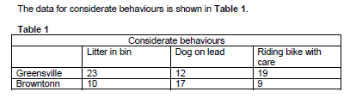

- The students noted that overall, more considerate behaviours occurred in Greensville than in Brownton. Calculate the ratio of considerate behaviours observed in Greensville to considerate behaviours observed in Brownton. Show your workings and present your answer in its simplest form. (3)
- The students carried out a Chi Squared test on their data. Explain why the Chi-Squared test was used in this case. (3)
- In order to interpret the results of the Chi-Squared test the students first needed to work out the degrees of freedom. They used the following formula:
Degrees of Freedom (DF) = (r-1) x (c-1)
r = number of rows and c = number of columns.
- Calculate the degrees of freedom for the data in table 1. Show your workings. (2)
- The calculated value of chi-squared was 6.20. Referring to table two, state whether or not the result of the Chi-Square test is significant at the 0.05 level of significance. Justify your answer. (3)
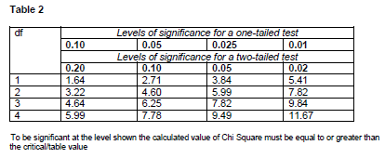

- In the discussion section of their report of this investigation, the students wanted to further discuss their results in relation to levels of significance. Write a short paragraph the students could use to do this. (4)
- As a follow-up to their observation, the students decided to interview some of their peers about inconsiderate behaviour in the sixth form centre. The interviews were recorded.
- Explain why the students could develop their interview findings by carrying out a content analysis and why the content analysis would be appropriate in this case. (3)
- Suggest one inconsiderate behaviour that the students might focus on in their content analysis. (1)

Design an experiment to investigate the effect of indoor plants on mood in office workers. For your measure of mood, you should devise a measure that would give data suitable for testing at the ordinal level of measurement. In your answer, you should provide detail of:
- design – including experimental design, variables and control
- materials/apparatus needed
- data analysis that could be used – refer to both descriptive and inferential statistics
You should refer to your own experience of research to inform your response. (15)

Students often claim that listening to music helps them to concentrate. A psychologist was not aware of any previous research in this area. She decided to investigate this claim.

Forty students from a nearby sixth form centre volunteered to take part in her study. They each answered the following question:

‘Do you think that you concentrate on your work ‘better’, ‘worse’ or ‘the same’ if you listen to music while working?’ She obtained the results in Table 1.
Table 1: Responses to question - ‘Do you think that you concentrate on your work ‘better’, ‘worse’ or ‘the same’ if you listen to music while working?’
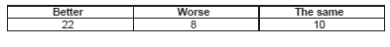
- Should the hypothesis for this study be directional? Explain your answer. (2)
- What percentage of the students reported that they would be able to concentrate ‘better’ if they listened to music while they worked? Show your workings. (2)
- Explain why using stratified sampling might improve this study. (2)
- The data collected in this study is primary data. Explain what is meant by ‘primary data’. (2)
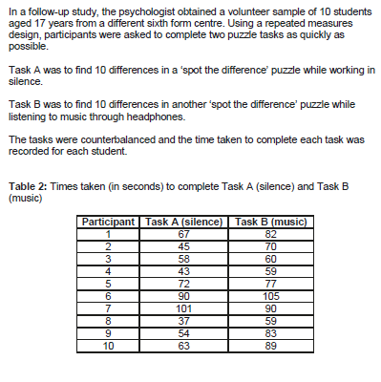
- Explain one reason why the mean would be the most appropriate measure of central tendency to summarise the data in table 2. (2)
- Calculate the mean values for both task A and task B. Show your workings. (4)
- The psychologist used counterbalancing in the follow-up study. Discuss the purpose of counterbalancing. (3)
- Identify one possible extraneous variable that the psychologist should have controlled in this follow-up study. Explain how this variable might have affected the results of the study if it was not controlled. (3)
- Explain how the follow-up study could be said to be an improvement on the original study. (4)

A psychologist wanted to see if creativity is affected by the presence of other people. To test this he arranged for 30 people to participate in a study that involved generating ideas for raising funds for a local youth club. Participants were randomly allocated to one of two conditions.

Condition A: there were 15 participants in this condition. Each participant was placed separately in a room and was given 40 minutes to think of as many ideas as possible for raising funds for a local youth club. The participant was told to write down his or her ideas and these were collected in by the psychologist at the end of the 40 minutes.

Condition B: there were 15 participants in this condition. The participants were randomly allocated to 5 groups of equal size. Each group was given 40 minutes to think of as many ideas as possible for raising funds for a local youth club. Each group was told to write down their ideas and these were collected by the psychologist at the end of the 40 minutes.

The psychologist counted the number of ideas generated by the participants in both conditions and calculated the total number of ideas for each condition.
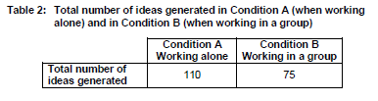
- Identify the experimental design used in this study and outline one advantage of using this design. (3)
- Describe one other experimental design that researchers use in psychology. (2)
- Apart from using random allocation, suggest one way in which the researcher might have improved this study by controlling for the effects of extraneous variables. Justify your answer. (2)
- Write a suitable hypothesis for this study. (3)
- From the information given in the description, calculate the number of participants in each group in condition B. (1)
- Using the information given in table 2 above, explain how the psychologist could further analyse the data using percentages. (2)
- At the end of the study, the psychologist debriefed each participant. Write a debriefing statement that the psychologist could read out to the participants in condition A. (6)

