Prep part A: Flipped Learning
Read the following 4 articles which show professional misconduct / fraud.
- Cyril Burt: http://intelltheory.com/burtaffair.shtml
- Hwang Woo-suk http://news.bbc.co.uk/1/hi/4763973.stm
- Dr Andrew Wakefield http://news.bbc.co.uk/1/hi/health/8700611.stm
- Dr Raj Persaud http://news.bbc.co.uk/1/hi/health/7465539.stm

Make sure you can explain which type of fraud (falsification, plagiarism and fabrication) is being shown by each example.

Prep part B: Short Answer Questions: Sections of a Scientific Report (14 marks)
1. What is the purpose of an introduction section? [2]
2. When would researchers choose a directional hypothesis? [1]
3. What should be included in an abstract? [1]
4. In which section should ethical issues be discussed? [1]
5. What section comes first, the abstract or the introduction? [1]
6. What are the appendices for? [2]
7. Where would the researcher discuss background research? [1]
8. Why does the researcher include background research? [2]
9. Why does the procedure have to be in plenty of detail? [2]
10. Put in order: method, appendices, title, abstract, discussion, introduction, results, references. [1]

Abstract | Descriptive and inferential statistics | Results
All of the reading which has been referred to | Details everything in around 250 words | Section
Allows people to replicate and verify the procedure | Discussion | Title
Allows the reader to judge whether the article is relevant to them | Enough detail about how the study was done to allow for replication | To acknowledge who was read and prevent plagiarism
Allows the reader to very quickly identify the purpose of the report | Introduces the topic area and prepares for peer review | To give any further information about the study.
Analysing the implications, applications & possible conclusions of the study | Introduction | To show the results of the study
Any materials not found elsewhere, like the consent forms | IV and DV | To stimulate discussion on and give ideas for further research or applications
Appendices | Method | What’s in it
Background research | References | Why is it there?

Sections of a Scientific Report
- Title
- Abstract
- Introduction
- Method
- Results
- Discussion
- References
- Appendices

Title
This is often derived from the variables under test, e.g., “The Effect of Exercise upon Stress Levels” and should be informative enough to enable the reader to know exactly what the study is about.

Abstract
This is always written last because it is a very brief summary (about 150 words) of the study. Researchers planning an investigation often look in published books of abstracts or on the Internet to find support or counter-evidence for their theory. Even scientific journals that charge to download documents provide abstracts free of charge. Abstracts provide an efficient way of gaining information without having to read an entire study. They contain all the essential information that a researcher would need to know to go about replicating the study, such as background information, the aim/hypothesis, the target population and sampling method, the design, the results and whether the null hypothesis was accepted or rejected.
T AIM RDRA

Introduction
This tells everyone why the study is being carried out and the commentary should form a ‘funnel’ of information. First, there is broad coverage of all the background research with appropriate evaluative comments: “Asch (1951) found...but Crutchfield (1955) showed...” Once the general research has been covered, the focus becomes much narrower finishing with the main researcher/research area they are hoping to support/refute. This then leads to the aims and hypothesis/es.

Aim
This covers exactly what it is they are hoping to find and how.

Hypothesis
This is a short, testable statement. The independent variable has to be operationalised and the dependent variable measureable. Justification has to be given for whether the test is to be directional or non-directional.

Method - this section is split into sub-sections:
Design:
- Experimental/non-experimental method used – laboratory/field/natural or correlation or survey method
- Design type – independent groups, repeated measures, matched pairs, correlation, observation, interview
- IV, DV, EV
- Use of counterbalancing/ measures taken to avoid bias
- Ethical issues

Participants:
- Details of target population – age/socio-economic status, gender, etc.
- Relevant details of sample population
- Sampling method used
- Allocation to conditions
- Reports of those who dropped out
Materials
- Description of all equipment used and how to use it (essential for replication)
- Stimulus materials for participants should be in the appendix
Procedure
- This is a step-by-step guide of how the study was carried out – when, where, how
- Instructions to participants must be standardised to allow replication
- Lengthy sets of instructions and instructions to participants should be in the appendix

Results
This section contains only a summary of the data. All raw data and calculations are put in the appendix. This generally starts with a section of descriptive statistics – measures of central tendency and dispersion. Summary tables must be clearly labelled and referred to in the text, e.g., “Table One shows that...” Graphical representations of the data must also be clear and properly labelled and referred to in the text, e.g., “It can be seen from Figure 1 that...” Once the summary statistics have been explained, there should be an analysis of the results of any inferential tests, including observed values, how these relate to the critical table value, significance level and whether the test was directional or non-directional. This section finishes with the rejection or acceptance of the null hypothesis.

Discussion
Begins with a statement of the findings and how these relate to the original hypothesis. All results are reported even if they do not fit the hypothesis or science would not progress. The findings are accounted for in terms of how these relate to the researchers in the introduction. All studies have flaws, so anything that went wrong or the limitations of the study are discussed together with suggestions for how it could be improved if it were to be repeated. Suggestions for alternative studies and future research are also explored. The discussion ends with a paragraph summing up what was found and assessing the implications of the study and any conclusions that can be drawn from it.

References
Every researcher cited in the text must be fully referenced using the Harvard System. Referencing is time consuming, but it is essential in order to prevent plagiarism.

Appendices
This contains all the material too bulky for the body of the report, such as consent and debriefing forms, instruction sheets or stimulus materials and raw data and calculations. These are numbered so they can be referred to in the text and easily found by someone reading the report.
Report writing
This is an important part of the research process where investigators present their research to be submitted to a journal.

 | This is presented at the beginning of a report and summarises the research. It outlines the aim, method, participants, results and discussion and is very useful when deciding if you want to read the entire article.
 | This part of the report is used to give some context about the area of research the study is in and any key developments in explaining the behaviour of interest. Usually this part will also explain the rationale for this specific piece of research and why it will further research in this area.
 | This is a step-by-step set of instructions about how you will carry out your research and should be clear enough that another person could replicate your procedure in exactly the same way. This means having precise timings and measurements that include the design, sample, materials/ apparatus and the procedure itself.
Results | This section of the report will firstly present the raw data and give a written summary of this along with descriptive statistics.  Further to graphical representations inferential statistics will be presented and the outcome of rejecting or accepting the null hypothesis will be outlined.
 | This section refers back to the rationale of the study and explains what progress the research has made in its field, if any. Further to this any criticisms of the study will be presented here along with suggestions for future research.
 | This is a record of all the sources of information the researcher/s have used such as books or journal articles.
 | This section is used to include any further information or analyses that may be of use to the reader and will be referred to in the article.

Abstract
Appendices
Discussion
Introduction
Method
References

Peer review
Before research can be it is reviewed by others who are experts in the same field as the ________ completed. They review work to ensure it has been carried out
and is of a high quality; if it is not then they can reject it and will not publish the work in order to maintain scientific .

Appropriately Credibility Journals
Published Research Scientific

What is referencing?
Referencing is a way of acknowledging other peoples’ ideas and work. You do this through a citation (in the text of your work) and a reference at the end of your work.
Citing within the text of your work
The citation within the text of your work is a brief acknowledgement (Surname, Year). If you are using a direct quotation or paraphrasing a specific idea you need to also include the page number, e.g. (Surname, Year, p.12). This is so your reader can locate the specific information you are referring to without needing to read the entire work. Quotations are in quotation marks.
References list and bibliography
References list: a list of all the sources that you have cited within your work
Bibliography: a list of everything that you have cited and everything that you have used to help improve your understanding of the topic. Check to see if your tutor wants a references list or a full bibliography.
Book
Format
Author surname, initials. (Year) Title. Edition if it is not the first edition. Place of publication: Publisher.
Example
Bowling, A. (2009) Research methods in health: investigating health and health services. 3rd ed. Maidenhead: Open University Press.
Journal article
Format
Author surname, initials. (Year) Title of article. Journal Name. Volume number (issue or part number), pp.first and last page numbers.
Example
Gilbert, D. A. and Hayes, E. (2009) Communication and outcomes of visits between older patients and nurse practitioners. Nursing Research. 58(4), pp.283-293.
Newspaper
Format
Journalist surname, initials. (Year) Title of news item. Name of newspaper. Day, Month, pp.first and last page numbers.
Example
Peters, R. (2009) Picking up Maxwell’s bills. Independent. 4 June, p.28.
Website
Format
Author (Year) Title. Source [online]. Available from: URL [Accessed date].
Example
COAP (2009) Children of addicted parents and people. COAP [online]. Available from: http://www.coap.org.uk [Accessed 18th July 2013].

Reorganise these into the correct references:
Grant et al (1998)
12, (6), 617–623.

(1998)

Applied Cognitive Psychology,

Grant, H. M., Lane, C. Bredahl, J. C., Clay. J., Ferrie, J., Groves, J. E., McDorman, T. A. & Dark, V. J.

Context dependent memory for meaningful material: Information for students.

Sperry (1968)
723–733.

Hemisphere deconnection and unity in conscious awareness.
American Psychologist, 23,

Sperry, R. W.
(1968)

Reference the book that is on your desk

Harvard Referencing
A | G | E | C | S | Y | E | R | T | R | E | E | Y | E | E | U | R | T | H | R
N | C | N | C | I | U | S | N | E | I | G | E | H | T | F | N | P | U | L | I
I | B | K | I | N | T | R | H | H | E | I | O | P | S | H | S | S | A | E | P
R | M | N | N | H | E | A | N | G | L | T | A | A | G | C | E | I | G | E | E
I | T | E | K | O | T | R | T | A | R | E | W | R | N | D | W | E | E | E | P
I | N | S | L | E | W | Y | E | I | M | E | M | G | I | P | E | I | E | E | N
Y | L | A | T | T | E | L | R | F | O | E | H | O | C | C | U | R | C | R | S
N | Y | A | A | D | I | Y | E | E | E | N | M | I | N | W | H | E | N | U | G
U | R | I | E | E | A | T | R | D | V | R | R | L | E | R | N | A | E | N | S
I | C | L | I | H | N | N | E | H | G | E | E | B | R | U | T | E | P | N | H
K | N | H | N | S | H | E | A | H | R | I | N | I | E | O | S | E | E | I | N
R | C | R | H | I | E | S | O | R | T | Y | N | B | F | O | E | I | N | N | T
U | Y | E | R | L | S | F | P | A | G | E | R | G | E | T | P | H | L | U | F
N | I | E | H | B | T | S | R | R | B | U | C | R | R | B | E | M | E | G | O
V | E | E | S | U | I | H | N | I | U | I | E | N | A | E | E | C | H | I | S
S | W | L | A | P | R | N | T | H | S | H | O | O | I | S | U | H | N | O | H
R | T | T | D | E | S | M | E | I | M | N | P | O | I | T | S | E | R | T | D
G | T | O | R | H | H | N | E | E | S | N | G | H | E | O | H | T | D | A | P
O | E | G | E | E | N | S | W | C | E | S | E | T | E | C | R | T | N | E | G
A | S | I | N | C | N | P | E | A | N | U | N | E | C | O | E | E | W | A | F

_____________________ is a way of _________________________ other peoples’ ideas and work. You do this through a _______________ in the text of your writing and a _________________ at the end of your work. The citation within the text of your work is brief _____________ and the year. The _______________________ is a list of ___________________ that you have cited or _______ to help improve your understanding of the topic. The format of the Harvard referencing is who, _______ what was written – ________________, where it was _____________ and by whom.

ACKNOWLEDGING
BIBLIOGRAPHY
CITATION
EVERYTHING
PUBLISHED
REFERENCE
REFERENCING
SURNAME
THE TITLE
USED
WHEN

Citing References Quiz – Identify the source
The following citations appear in Harvard style. Look at each one and decide which type of material is being described in each case. Some examples may not supply sufficient information for you to be able to make a definite decision. If this is the case, choose the response 'Insufficient information'.

Reference 1
Clarke, A. 2002. Online learning and social exclusion. Leicester: National Institute of Adult Continuing Education.

A. Chapter in a book
B. Book
C. Web site
D. Insufficient information

Reference 2
Leverenz, C. S. 1998. Citing cybersources: a challenge to disciplinary values. Computers and Composition 15(2), pp. 185-200.

A. Chapter in a book
B. Conference paper
C. Journal article
D. Insufficient information

Reference 3
Cox, S. 2000. How to herd cats in Piccadilly. Times Higher Education Supplement 14 April, pp. 36-37.

A. Book chapter
B. Newspaper article
C. Conference paper
D. Insufficient information

Reference 4
Weller, M. 2002. Delivering learning on the net.

A. Journal article
B. Book chapter
C. Web site
D. Insufficient information

Reference 5
DeLashmutt, M. W. 2004. Augustine's quest for the self: a threefold journey. e-sharp [Online] 1. Available at: http://www.sharp.arts.gla.ac.uk/e-sharp/articles/spring_2004/Michael_DeLashmutt-Augustines_Quest.htm [Accessed: 10 June 2004].

A. Thesis
B. Web site
C. Electronic journal article
D. Insufficient information

Reference 6
Barajas, M. and Owen, M. 2000. Implementing virtual learning environments: looking for an holistic approach. Education Technology and Society

A. Edited book
B. Journal article
C. Chapter in a book
D. Insufficient information

Reference 7
Mosco, V. 2000. The web. In: Browning, G. et al. eds. Understanding contemporary society: theories of the present. London: Sage. pp. 343-355.

A. Book
B. Journal article
C. Book chapter
D. Insufficient information

Peer Review
Publication is the goal of any research. Unless other people know of the research it is not useful. Typically research is first published in journals, these are stored in yearly volumes and they form a permanent scientific record.
The system begins with the research paper being submitted to a journal for consideration for publication.

The editor of the journal examines the topic and sends the paper to other psychologists who are experts in the field.

Their critical appraisal of the work is returned with recommendations about suitability for publication.

When we read the research that has been published in journals we need to know that it is of good quality and hasn’t simply been made up. In order to achieve this, research goes through a system of peer review.

The system of peer review
To ensure high standards are maintained, the editor will either accept the research for publication, or suggest revisions should be made before resubmitting it or they may decide to reject the research altogether. Peer review acts as a control mechanism only allowing only high quality research to appear in the public domain.

Despite the system’s best efforts to validate new knowledge, peer review is not without its problems. The UK Parliamentary Office of Science and Technology (2002) have identified a number of different types of fraudulent research:
Fabrication
Falsification
Plagiarism

Give a definition or an example to illustrate these 3 types of fraud:
Plagiarism
___________________________________________________________________________________________________________________________________________________________________________
Falsification
___________________________________________________________________________________________________________________________________________________________________________
Fabrication
___________________________________________________________________________________________________________________________________________________________________________
Outline one example of professional misconduct from your prep (e.g. the Cyril Burt Affair) which shows that peer review may not be infallible.
_____________________________________________________________________________________________________________________________________________________________________________________________________________________________________________________________________________________________

The Problems of Peer Review
Despite its best efforts, there are other problems of validating new knowledge. Match the name of the problem with its meaning.

Production bias |  | Although all psychologists try to objective, a reviewer may favour an opposing view making them less likely to provide an unbiased view.
File drawer phenomenon |  | It can be argued that science is conservative and resistant to large changes and so peer review could act to maintain the status quo. As such results that do not fit in with current knowledge may be rejected.
Objectivity |  | This can take a variety of forms; gender bias (favouring the work of one gender), institution bias (favouring one institution’s work over another) or that the reviewer may have a different viewpoint from the researcher.
Preserving the status quo |  | This is where the peer review tends to favour positive results and as such those pieces of research where the null hypothesis has been supported, have been found to be rejected or ‘filed in the draw’. This leads to an unrepresentative view of the findings.

Extension Give an example of when each of these may occur.

Design your own study questions

Paper 1 Section B will ask you to design your own research. The question wants you to describe HOW you would do this study in enough detail so someone else could replicate this work.

There are 4 types of question you could be asked:
- Experiment (like your own experiment on Kim’s Game)
- Observations (you did an observation on X factor bad auditions and how your friends present themselves on Facebook)
- Correlations (you looked at the number of hours slept and dreams)
- Self-reports (you chose to write questionnaire either pets & stress, gender & car colour, weather & mood)

You can see the question tracker at http://www.aldenhampsychology.com/exams.html to see which of these has been asked in the past.

The question is likely to have 4 bullet points with features you have to address. For each of the bullet points / features, you need to say:
- Feature (from each of the bullet points)
- Explained (how you would be doing this – enough for replication)
- in Context (using the unique words of the story)
- Justified (why it is right to do here)
- referring to Own research (to show a similarity).

You can practice these questions by using the practice questions at http://www.aldenhampsychology.com/exams.html

Designing Your Own Investigation
In Paper 1 section B (research design and response), you will be required to design your own investigation, from a novel source provided. In order to do well in this part of the exam it is essential that you apply knowledge from your own practical activities:
- self-report (e.g. colour and car choice, pet ownership)
- observation (e.g. viewing Facebook profile pictures, observing bad X factor auditions)
- experiment (e.g. Kim’s Game, ruler drop test)
- and correlation (e.g. height and shoe size).

What to Expect in The Exam?
You will be given a 12 or 15-mark question. You will be a given a scenario asking you to plan an investigation, such as:
- Explain how you would carry out a correlation between levels of ice cream consumption and number of accidents at the seaside.
- Explain how you would carry out an experiment to investigate memory improvement techniques used by students while revising.
- Explain how you would carry out an observation into the use of mobile phones in public places.
- Explain how you would carry out a self-report to investigate personality traits of those who regularly use Facebook.

The question will also ask you to refer to 3 or 4 required features within your answer. These could come from any part of the research methods content that you have learnt and could refer to the type of investigation, sampling method, experimental design, controls, ethics, reliability, validity, or even data analysis. For example:

Explain how you would carry out an experiment into the effect playing video games has on alertness. You must refer to:
- laboratory or field experiments
- experimental design
- sampling method
- at least one control you would use
- You should use your own experience of carrying out an experiment to inform your response. Justify your decisions as part of your explanation. (15 marks)

How to Do Well on these Questions?
To do well in this question, you need to answer each part of this question:
- Identifying each of the required Features (from each of the bullet points)
- Explaining (how you would be doing this – enough for replication)
- in context (using the unique words of the story)
- Justifying (why it is right to do here)
- referring to Own research (to show a similarity / experience)

Practice Question: Explain how you would carry out a self-report to investigate the effects of Facebook use. You must refer to:
- a questionnaire or an interview
- open or closed questions
- how you may check the reliability of responses
You should use your own experience of carrying out an experiment to inform your response. Justify your decisions as part of your explanation. 12 marks

For my investigation into the effects of Facebook use, I would carry out a questionnaire. The reason for this is that compared to an interview, they are a much quicker way of getting a large amount of data from many participants. This is because they just need to be handed out and returned; interviews are much more time consuming as interviewees are questioned one at a time, so the number of participants is also going be less than with a questionnaire. I found this out when I carried out my research at school into attitudes towards mental health in different age groups. I was able to get 20 members of my class to fill in their questionnaires for 5 minutes at the same time at the end of a lesson. However, when replicating Loftus and Palmer’s study, it took the same amount of time to interview one participant, therefore leading to me having a small sample and having difficulties generalising my results. As all my participants are all Facebook users I will send them the questionnaire online; they can then quickly fill in the questionnaire and email their responses back to me.

Within my questionnaire, I would use closed questions such as the following: using a Likert scale (ranging from 1 strongly disagree, to 5 strongly agree)
- Facebook makes friendships stronger
- I feel irritable if cannot log into Facebook
- I prefer chatting to my friends on Facebook or face to face I am naturally an outgoing person
- Facebook has made me more confident I am addicted to Facebook
- Facebook has helped me make friends

I would use closed questions to gain quantitative data. This is beneficial because the data is numerical from a Likert scale and can therefore be analysed more easily than qualitative data. I can also summarise my data more easily into graphs and charts and work out measures of central tendency. For example, I can work out the mean ‘Facebook addiction’ score for different personality types and compare ‘confidence’ scores in a bar chart. This is much preferable to qualitative data which is more difficult analyse. When I carried out research into reasons for obedience, I included open questions in my questionnaire and as result I got a wide range of responses from my friends which was difficult to categorise. Using closed questions overcomes this problem.

I would check the reliability of responses by using the split-half method; this enables the researcher to see if participants’ answers are consistent by asking the same question again in a slightly different way or in reverse. From my own research into attitudes towards mental health, my teacher advised that we used this technique in our questionnaire to check for the consistency of responses. For example, one participant answered that they strongly agreed that stigma towards mental health has reduced over the past 10 years; however, later on in the questionnaire they ‘strongly agreed’ that stigma has increased over the past 10 years. This participant’s results were removed as they lacked reliability. Within this questionnaire I would also use the split-half method by including questions such as: Facebook weakens friendships and Facebook has made me less confident, which are the reverse of the questions above. This is to check the reliability of participants’ responses; if these answers contradict each other the data will be removed as the results are unreliable. Therefore we can be sure that the results are reliable.

Examiner Commentary
This is clearly a ‘good’ top band answer and would achieve 12/12 marks. There is accurate and detailed knowledge and understanding of each feature in the context of the Facebook investigation. There is also good evidence of application of these required features in context. There is appropriate justification of all decisions and there is a well-developed line of reasoning that is clear and logically structured. There is explicit reference to practical work and there are links between own practical work and this investigation.

Mark Scheme for June 2018

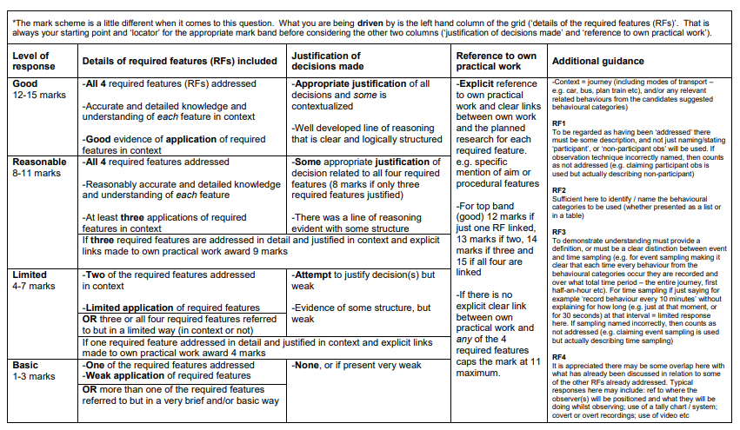
Question 22
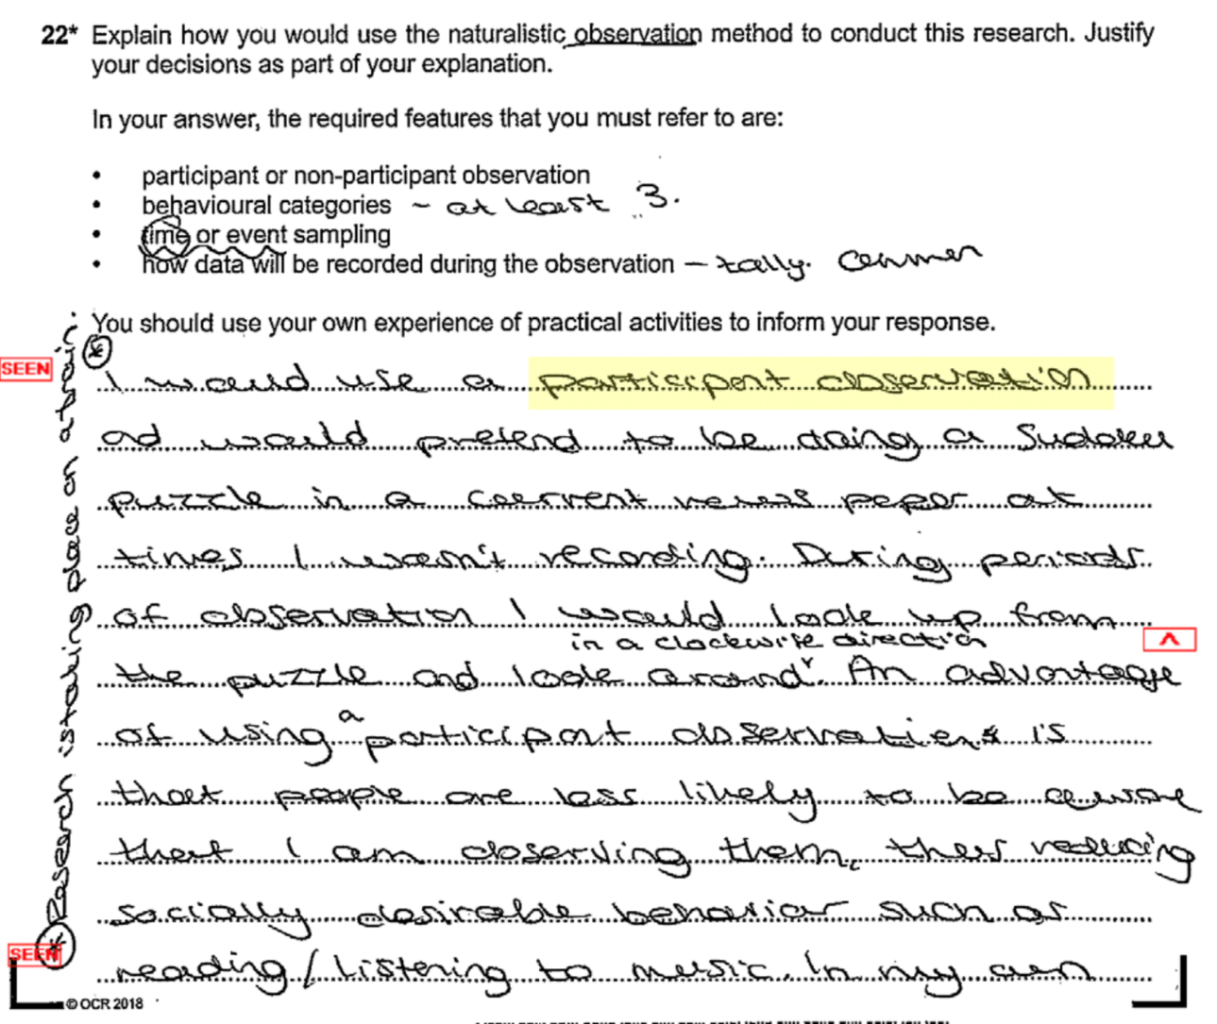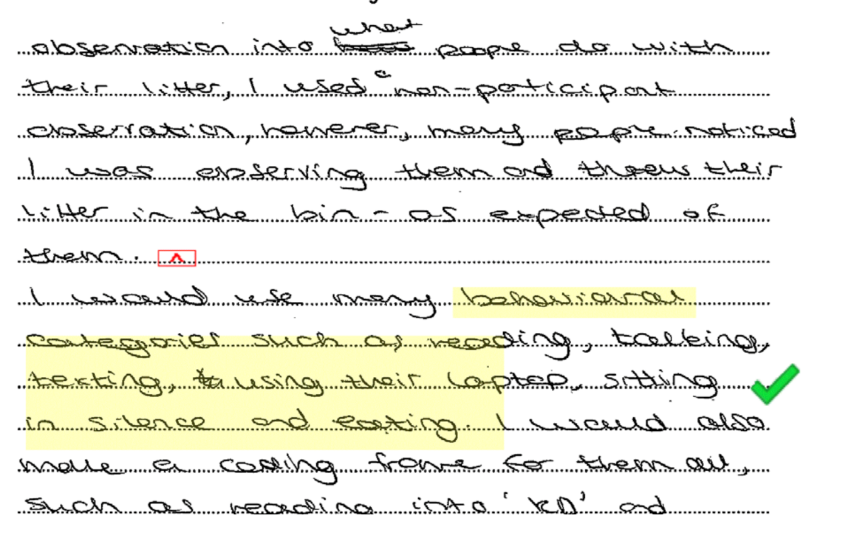

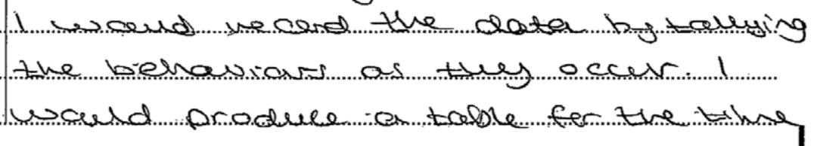
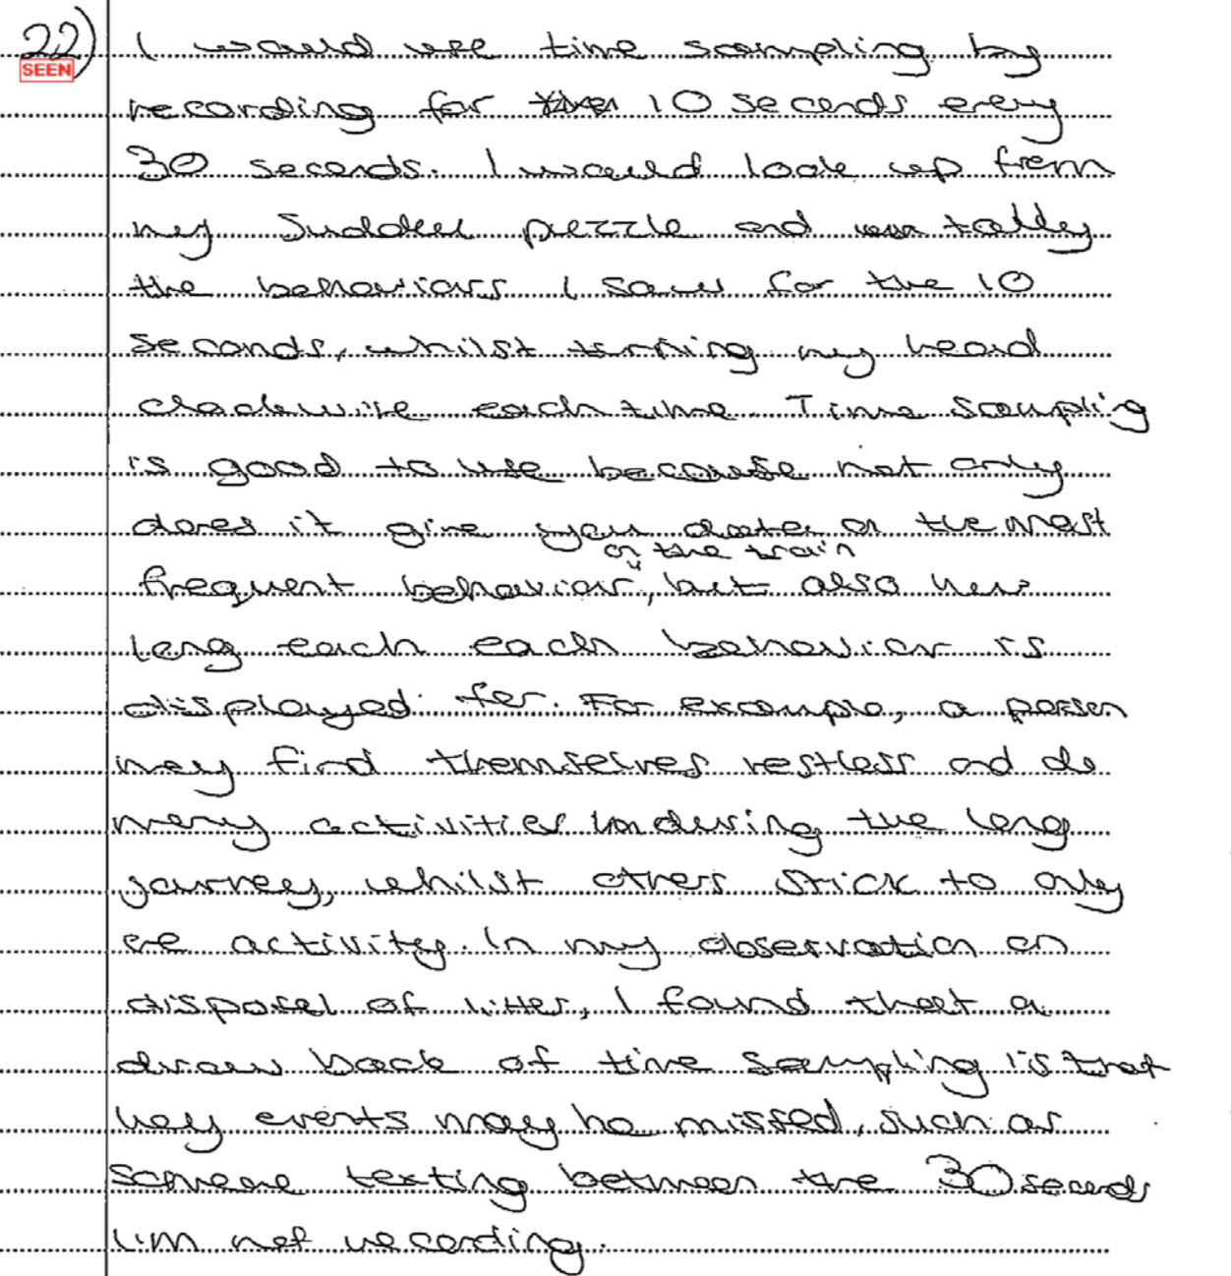

14 marks
This candidate’s response addresses all four required features in turn in the context of the research presented with appropriate justification of suggested decisions and links to their own practical work.
In order to achieve the highest marks candidates must show understanding of what each RF is, justify their decisions of how each RF will be addressed (some of which must be contextualised) and make explicit links to their own practical activities for each RF.
For understanding in terms of how each RF was addressed ... For RF1 participant observation is suggested and described in detail in context (doing a puzzle in a newspaper whilst a passenger on the train). For RF2 appropriate behavioural categories are suggested (e.g. passengers reading and texting). For RF3 the use of time sampling is described (making observations on the train by looking up from the newspaper for 10 seconds every 30 seconds). For RF4 a tally system is outlined.

The candidate justifies their suggestions in relation to all 4 RFs, with some in context (e.g. for RF2 discussing in detail how the use of pre-determined behavioural categories suggested will be an efficient way of recording behaviour on the train).

For links to their own practical work the candidate discusses each RF (three related to a litter study they conducted) and at times demonstrates how their own experiences has helped inform their decision making in relation to the planning of the current study (which very few candidates do explicitly). For example, in relation to RF1 they discuss how the problems they encountered when using non-participant observation in their own study helped them to decide to opt for participant observation in this study.

14 rather than 15 marks was awarded as it was felt that the link to their own practical work for RF4 could have been clearer/more explicit (regarding the use of nominal data in the form of a tally system)

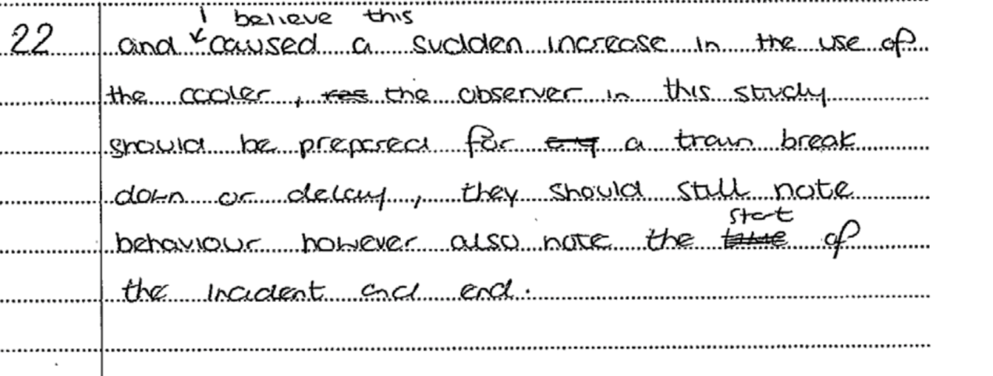
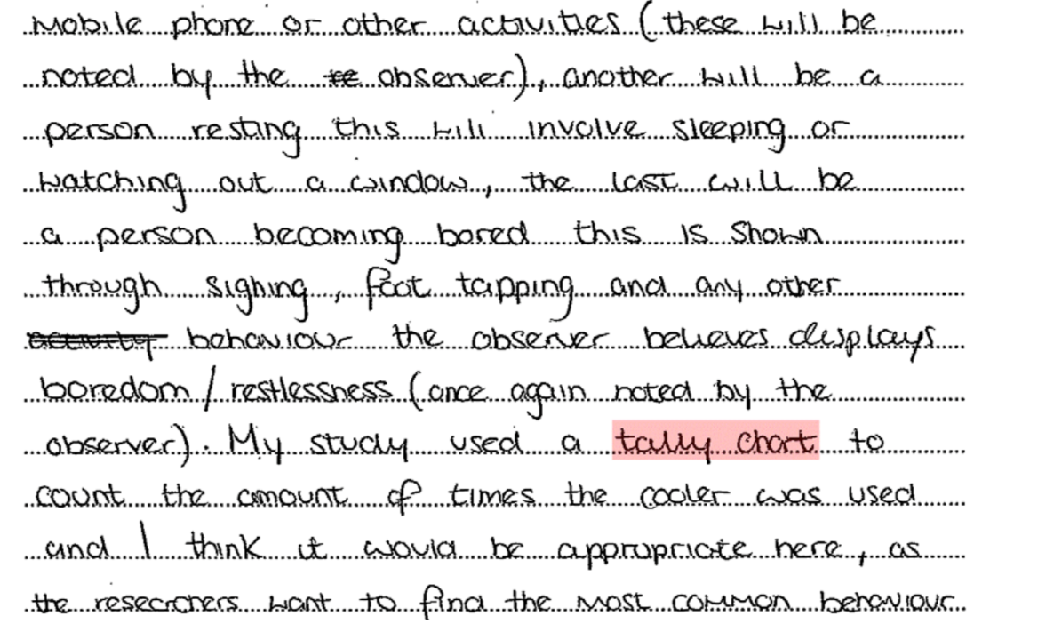
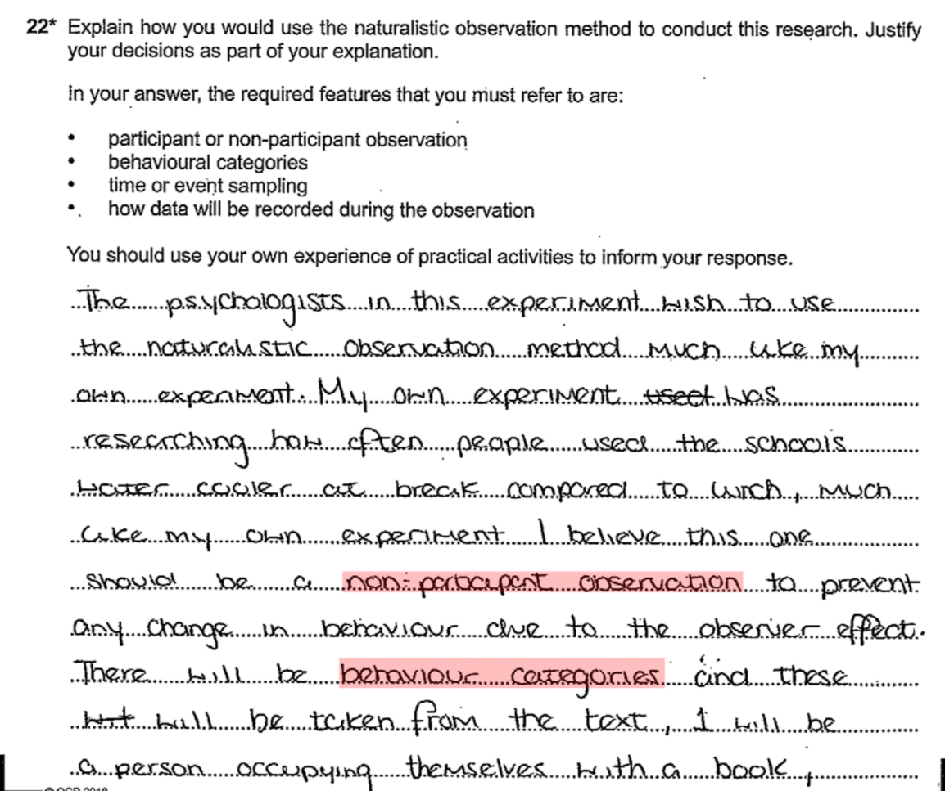

4 marks

This response does little more than name the RFs. For example, it states that non-participant observation will be used, but does not say in exactly what way, similarly for RF4, it just states that a tally chart will be used. This answer could be improved if the candidate said “…something like, participant observation will be used by posing as a passenger on the train, sat amongst other commuters reading a newspaper etc.” There is also very little in the way of justification of any (of the very poorly presented) decisions suggested and few links to the equivalent RFs from any of the candidate’s own practical activities. Could you give a tip for weak students to improve on – how to practice structuring answers…
The best way to structure responses here is to take each RF in turn and write a separate paragraph for each one (leave a line space between each paragraph) that shows understanding of what the RF is, by addressing (in context) how it will feature in the research presented. Then justify why such decisions have been made (e.g. say something like .... I would do this because ....). Finally, make a link to your own practical work that shows how the same RF featured and how the experiences of that helped inform the decision making for the current proposed research (e.g. say something like .... because of how I did xyz in my study about xyz I decided for this research to .... etc.)

Classwork practice questions

Experiments
Cognitive processes include memory and perception and just as our memories are likely to become distorted we are all susceptible to mistaken perceptions. Many of us are familiar with such classic illusions such as the Muller lyer illusion, where the line with the outgoing fins, figure (a) appears longer than the line with the ingoing fins, figure (b). In fact they are the same length.
(a) >-----------<
(b) < ---------- >

Explain how you would carry out an experiment in to whether older people more susceptible to visual illusions than younger people? Justify your decisions as part of your explanation, you must refer to:
- Field or lab experiments
- Independent measures or matched participants
- At least one control you would use
- Collection of data.
You should use your own experience of carrying out an experiment to inform your response. (15)

Self-reports
Questionnaires are often used to assess people attitudes to current events and to factors affecting attitude change. Psychologists have obtained information on such diverse topics as attitudes to body image and attitudes to drinking and driving this information has enabled research in to the factors affecting attitude to change.

Explain how you would carry out a questionnaire into ‘Attitudes to parental discipline’. Justify your decisions as part of your explanation, you must refer to:
- Open and closed questions
- At least one ethical issue
- Socially desirable answers
- Bar charts.

You should use your own experience of carrying out a self-report to inform your response. (15)

Correlations
Psychologists use correlational designs to investigate relationships between variables that are difficult to investigate experimentally. Correlational designs are often used to investigate the relationship between environmental variables and human behaviour. For example research has examined environmental variables such as heat, sunshine, pollution and social density (crowding) and their relationships with happiness, aggression, helping behaviours, and performance on cognitive tasks.

Explain how you would carry out a correlational analysis in to the relationship between levels of exposure to sunlight and happiness. Justify your decisions as part of your explanation, you must refer to:
- At least ordinal level data
- Data presentation
- Validly
- At least one ethical issue.

You should use your own experience of carrying out a correlation to inform your response. (15)

Observations
Naturalistic observations are conducted by psychologists when they want to find out how people behave without experimental manipulation. Today psychologists should adhere to the BPS guidelines to avoid unethical treatment of participants. With sufficient training, psychologists can detect small differences in behaviour, such as facial expression and gesture, to infer how people are feeling and thinking.

Explain how you would carry out an observation in to eating behaviour. Justify your decisions as part of your explanation, you must refer to.
- A behavioural checklist
- Participant or non-participant observation
- Time or event sampling
- Inter rater reliability.

You should use your own experience of carrying out an observation to inform your response. (15)

Section | What’s in it | Why is it there?
Title | IV and DV | Allows the reader to very quickly identify the purpose of the report
Abstract | Details everything in around 250 words | Allows the reader to judge whether the article is relevant to them
Introduction | Background research | Introduces the topic area and prepares for peer review
Method | Enough detail about how the study was done to allow for replication | Allows people to replicate and verify the procedure
Results | Descriptive and inferential statistics | To show the results of the study
Discussion | Analysing the implications, applications and possible conclusions of the study | To stimulate discussion and give ideas for further research or applications
References | All of the reading which has been referred to | To acknowledge who was read and prevent plagiarism
Appendices  Answers | Any materials not found elsewhere, like the consent forms | To give any further information about the study.

Report writing
This is an important part of the research process where investigators present their research, findings and conclusions to be submitted to a journal.

Abstract | This is presented at the beginning of a report and summarises the research. It outlines the aim, method, participants, results and discussion and is very useful when deciding if you want to read the entire article.
Introduction | This part of the report is used to give some context about the area of research the study is in and any key developments in explaining the behaviour of interest. Usually this part will also explain the rationale for this specific piece of research and why it will further research in this area.
Method | This is a step-by-step set of instructions about how you will carry out your research and should be clear enough that another person could replicate your procedure in exactly the same way. This means having precise timings and measurements that include the design, sample, materials/ apparatus and the procedure itself.
Results | This section of the report will firstly present the raw data and give a written summary of this along with descriptive statistics.  Further to graphical representations inferential statistics will be presented and the outcome of rejecting or accepting the null hypothesis will be outlined.
Discussion | This section refers back to the rationale of the study and explains what progress the research has made in its field, if any. Further to this any criticisms of the study will be presented here along with suggestions for future research.
References | This is a record of all the sources of information the researcher/s have used such as books or journal articles.
Appendices | This section is used to include any further information or analyses that may be of use to the reader and will be referred to in the article.

Peer review
Before scientific research can be published it is reviewed by others who are experts in the same field as the research completed. They review work to ensure it has been carried out appropriately and is of a high quality; if it is not then they can reject it and journals will not publish the work in order to maintain scientific credibility.

Answers
Reorganise these into the correct references:

Grant et al (1998)
12, (6), 617–623.

(1998)

Applied Cognitive Psychology,

Grant, H. M., Lane, C. Bredahl, J. C., Clay. J., Ferrie, J., Groves, J. E., McDorman, T. A. & Dark, V. J.

Context dependent memory for meaningful material: Information for students.

Grant, H. M., Lane, C. Bredahl, J. C., Clay. J., Ferrie, J., Groves, J. E., McDorman, T. A. & Dark, V. J. (1998) Context dependent memory for meaningful material: Information for students. Applied Cognitive Psychology, 12, (6), 617–623.

Sperry (1968)
Answers
Hemisphere deconnection and unity in conscious awareness.
American Psychologist, 23,

Sperry, R. W.
(1968)
723–733.

Sperry, R. W. (1968) Hemisphere deconnection and unity in conscious awareness. American Psychologist, 23, 723–733.

Referencing is a way of acknowledging other peoples’ ideas and work. You do this through a citation in the text of your writing and a reference at the end of your work. The citation within the text of your work is brief Surname and the year. The bibliography is a list of everything that you have cited or used to help improve your understanding of the topic. The format of the Harvard referencing is who, when what was written – the title, where it was published and by whom.

Answers

Answers
1. B
2. C
3. B
4. D
5. C
6. D
7. C
Answers

Production bias |  | Although all psychologists try to objective, a reviewer may favour an opposing view making them less likely to provide an unbiased view.
File drawer phenomenon |  | It can be argued that science is conservative and resistant to large changes and so peer review could act to maintain the status quo. As such results that do not fit in with current knowledge may be rejected.
Objectivity |  | This can take a variety of forms; gender bias (favouring the work of one gender), institution bias (favouring one institution’s work over another) or that the reviewer may have a different viewpoint from the researcher.
Preserving the status quo |  | This is where the peer review tends to favour positive results and as such those pieces of research where the null hypothesis has been supported, have been found to be rejected or ‘filed in the draw’. This leads to an unrepresentative view of the findings.

Production bias | This can take a variety of forms; gender bias (favouring the work of one gender), institution bias (favouring one institution’s work over another) or that the reviewer may have a different viewpoint from the researcher.
File drawer phenomenon | This is where the peer review tends to favour positive results and as such those pieces of research where the null hypothesis has been supported, have been found to be rejected or ‘filed in the draw’. This leads to an unrepresentative view of the findings.
Objectivity | Although all psychologists try to objective, a reviewer may favour an opposing view making them less likely to provide an unbiased view.
Preserving the status quo | It can be argued that science is conservative and resistant to large changes and so peer review could act to maintain the status quo. As such results that do not fit in with current knowledge may be rejected.  Answers

