Pre-A Level Academic Preparation Programme for  Psychology  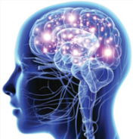  Week 2: Memory  Mrs Evagora  Mr Kirsten | Complete  Memory  Quiz to see how good your Memory is.  Can you remember all the finer details?  Once you have completed the quiz, create a quick mindmap showing what ‘memory’ means to you, what can affect memory and how you think memory can be improved.  'How Good Is Your Memory?' quiz  Time: 30 minutes | Watch  Memory  TED talk which discusses the reliability of memory and the impact of false memory. Reflect on the TED talk and make your own notes.  We will be meeting Loftus next academic year.  How reliable is your memory?  TED Talks – Elizabeth Loftus  Time: 40 minutes | Research  Memory  What is Eyewitness Testimony and what are the main factors that can affect it?  You must pay attention to and read the research study by Loftus and Palmer – this is highlighted as a link within the text. Make our own notes on the content.  Eyewitness Testimony  Simply Psychology  Time: 1hr
 | Complete  Memory  Produce a handout or PowerPoint detailing what eyewitness testimony is, the factors that can affect the accuracy of it, and briefly outlining some of the key research.  Time: 1hr | Watch  Memory – extension work  If you have access to Netflix watch ‘100 humans’  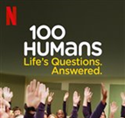  Time: 4hr30mins for all 8 episodes | Research  Memory – extension work  Choose one or more of the 17 articles to read from the New Scientist special edition on Memory.  Time: 1 hr

