Section A: Multiple choice questions

Question number | Question Focus | Answer
1 | Coding Frame | A
2 | Quasi experiment: IV is not directly manipulated | D
3 | Naturalistic observation | B
4 | Variance = measure of dispersion around the mean | B
5 | Significance at the 5% level of probability | B
6 | Type 1 error = incorrectly rejecting the null hypothesis | D
7 | Significant figures | C
8 | Calculating the median | C
9 | Measures of central tendency | D
10 | Non-parametric inferential statistical test | A
11 | Ratios | B
12 | Sections of a practical report | B
13 | Standard form | B
14 | Bandura: time sampling | D
15 | Bocchiaro: sampling method | C
16 | Nominal data | A
17 | Sections of a practical report | B
18 | Peer review | A
19 | Independent groups in Loftus and Palmer’s study | D
20 | Type of data collected in Loftus and Palmer’s study | A

1. What is the name used for the technique that enables qualitative data to be recorded in a quantitative way?
A coding frame

2. Which of these best describes a quasi-experiment?
D independent variable is not directly manipulated

3. What type of observation is conducted in a real-life setting where participants are not usually aware they are being studied?
B naturalistic

4. Which of these best describes what the variance is?
B measure of dispersion around the mean

5. Which of these indicates the research is significant at the 5% level of probability?
B p<0.05

6. Which of these refers to making a Type 1 error?
D incorrectly rejecting the null hypothesis

7. What is 7.864 written to two significant figures?
C 7.9

8 What is the median for this set of data 10, 12, 6, 5, 14, 3?
C 8.0

9 What is the collective term for the mean, median and mode?
D measures of central tendency

10 Which of these is a non-parametric inferential statistical test?
A Mann Whitney U

11 A newspaper includes 12 pages of sport and eight pages of TV. What is the ratio of sport to TV? Give your answer in its simplest form.
B 3:2

12 In which of the following sections of the write-up of a practical report would you find a full copy of the standardised instructions read to the participants?
B appendices

13 What is 2,830 written in standard form?
B 2.83 x 10³

14 Bandura et al. recorded children’s behaviour every five seconds for a period of 20 minutes in their study of the imitation of aggression. What type of sampling of behaviour is this aspect of the study?
D time

15 What sampling technique was used to obtain participants in the study of whistleblowers by Bocchiaro et al.?
C self-selected

16 Which of these is nominal data?
A classifying participants as ‘good’, ‘average’ or ‘poor’

17 In which section of the write-up of a practical report would you find details of work conducted by other psychologists?
B introduction

18 What is the term that describes the process whereby other psychologists comment on research before it is published?
A peer review

19 How many independent groups were there in experiment 1 of Loftus and Palmer’s study investigating the effects of language on memory?
D 5 (each of the 5 verbs used: smashed, collided, bumped, hit, contacted).

20 Which of these best describes the type of data collected in Loftus and Palmer’s study investigating the effects of language on memory?
A both quantitative and qualitative (experiment 1 DV speed mph = quantitative; experiment 2 DV answer to the question about glass = qualitative).

Answers which should NOT receive credit
For evaluation points written for Q21b, Q23, Q24, Q29, Q32c, Q33a, Q33b, do NOT accept answers which state that

- Self-selecting sampling method is less ethnocentric (incorrect), more valid (unclear which type and why), more reliable (unclear which type and why)

- Independent measures / repeated measures / matched pairs experimental designs are more valid (unclear which type and why), more reliable (unclear which type and why), give more data (this is determined by the sample not the experimental design)

- Mean is more ‘accurate’, as all 3 measures of central tendency are accurate.
- Mean is more ‘scientific’, as all 3 measures of central tendency are.

- Standard deviation is more ‘accurate’, as all 3 measures of dispersion are accurate.
- Standard deviation is more ‘scientific’, as all 3 measures of dispersion are.

- Correlations are
  - more valid (unclear which type & why)
  - more reliable (unclear which type & why)
  - give more data (this is determined by the data set not the research method)
  - Correlations can be plotted onto a graph (any data set can be).
  - Correlations are easy to analyse / interpret (lack of comparison or explanation to show why this is a strength)

Multiple Responses
λ
Where a question asks for ONE / TWO strengths / weaknesses, and more than this number are given,
- Mark the first one / two depending on the question,
- Add the lamda symbol into the text λ
- Ignore any further part of the answer which is also a strength / weakness.
- When marking on screen, this further part should be highlighted.

Section B: Research design and response

21a. Participants for the study will be obtained by putting up a poster on a notice board in a large local supermarket asking for volunteers for a study investigating factors influencing memory. What type of sampling technique is this? [1]

Self-selecting / selected / volunteer

21b. Describe 1 strength & 1 weakness of using this sampling technique in this study. [4]

For each evaluation point:
- 2 marks: Strength / weakness clearly described in context
- 1 mark: Strength/weakness described but not in context

Examples of evaluation points

Strengths:
- relatively easy to obtain a potentially diverse group of participants;
- cost effective
- can include specific details of type of participants desired.

Weaknesses:
- prone to (volunteer) bias
- limited to those shopping in the chosen supermarket at the time.

Words which show context of the cited study:
supermarket, shopping, memory, colour of words, green.
Examples for 2 marks
- It will achieve a wide variety of people, as many people go to the supermarket.
- A problem with this sampling method is that it limited to those shopping in the supermarket at the time.

Example for 1 mark
Only weirdoes will volunteer.

22. Write a one-tailed alternative hypothesis for this study. [3]

How the marks are awarded:
- 1 mark: one tailed hypothesis
- 1 mark: IV accurately operationalized
- 1 mark: DV accurately operationalized

Examples for 3 marks
- There will be a significant difference in the number of words correctly remembered with more words printed in green ink being remembered than those printed in black ink
- More words presented for learning printed in green ink will be remembered than words presented in black ink.

Example for 2 marks
- More words presented for learning printed in green ink will be remembered (IV not fully operationalized)

Example for 1 mark
- Green ink will improve memory recall.

23* Explain how you would conduct a study using the laboratory experiment method to investigate the effect of colour on memory for a list of words. Justify your decisions as part of your explanation. You must refer to:
- the use of independent measures design or repeated measures design;
- how the variables are operationalized;
- at least two control features;
- level of data collected.
You should use your own experience of carrying out an experiment to inform your response. [15]

Annotate C / A / J / R with a number for each of the required features, e.g. C1, J4.
Level 4 = 12-15 marks
- All 4 required features are addressed
- Accurate knowledge of each choice is demonstrated (C)
- Application to this scenario is demonstrated in relation to each choice (A)
- Appropriate justification of all or most techniques is demonstrated (J)
- Response explicitly draws on the candidates own research (R)
- The answer has sufficient coherence and detail to allow for replication.
Level 3 = 8-11 marks = reasonable
Level 2 = 4-7 marks = limited
Level 1 = 1-3 marks = basic

24. Evaluate the use of matched participants design if it had been used in this study. [6]

How the marks are awarded for each evaluation point:
- 1st mark: accurate point is stated
- 2nd mark: and explained using a value judgement
- 3rd mark: in the context of this study (context words = ‘supermarket’, ‘shopping’, ‘memory’, ‘colour of words’, ‘green’)

Example for 6 marks
Using matched pairs would be beneficial in this study as it would enable individual differences to be controlled in terms of existing levels of memory, allowing for greater comparison between the different IV conditions. However pre-testing the Ps to allow for matching can be time consuming and will not automatically allow for exactly similar Ps in each of the different IV conditions of green and black ink.

25. Psychologists want to conduct a follow-up study using the self-report method to investigate other things that may influence memory.
a. Suggest 1 open question that could be used in this study. [2]
b. Suggest 1 closed question that could be used in this study. [2]
c. Suggest 1 question using a rating scale that could be used in this study. [2]

How the marks are awarded
2 marks: Correct style of question, in context (context words: memory)
1 mark: Correct style of question
0 marks: Any question which refers to colour

Examples for 2 marks
a. Explain what kind of things case you the most problems with your memory?
b. Which of the following cause you problems with your memory?
❑ dates  names  facts  figures  events
c. Indicate on a scale of 1 (not very good at all) to 10 (excellent) how good is your memory for names?

Section C: Data analysis and interpretation

26. What level of data is obtained in this study? [1] Interval

27. What is the ratio of participant C’s Maths to his Physics test scores? [2]

1 mark for identifying the Maths & Physics test scores (working out) 6 and 24
1 mark for the ratio: 1:4

28. What is the mode for the Physics test scores? [1] 24

29. Suggest one advantage of using mean instead of the mode to analyse the data from the test scores. [3]

How the marks are awarded:
- 3 marks = advantage (P) clearly explained (E) in context (C)
- 2 marks = advantage (P) explained (E) without context or advantage stated (P) in context (C)
- 1 mark = advantage (P) stated but not in context (C)

The mean will allow all of the data to be taken into consideration (P), allowing it to be more reflective / representative (E) of the Maths / Physics test scores (C) for each of the subjects.

30. Identify two findings from the data presented in this table. [4]

Examples of findings which can be presented:
- overall test scores higher in physics test
- highest overall score was 30 in physics test
- lowest score was 4 in maths test
- larger range of scores in maths test (4 to 28)
- mode is 24 for physics scores
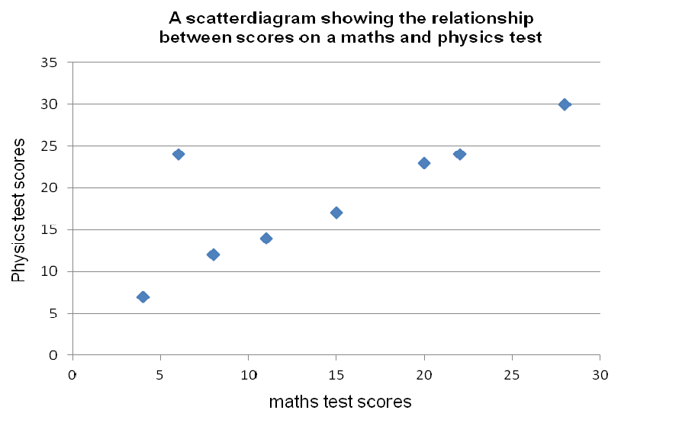
31. Draw a scatter diagram displaying the results of this study. [4]

How the marks are awarded
- 1 mark: correctly plotting the data
- 1 mark: including units of measurement on both axes
- 1 mark: clear labelling of each axis
- 1 mark: clear and appropriate title

32a.Calculate the range for each test taken. [2]

Maths test: 28 - 4 = 24 OR (28 - 4) + 1 = 25
Physics test: 30 - 7 = 23 OR (30 - 7) + 1 = 24

32b. What conclusion can be reached by interpreting the range for each test? [4]

Examples for 4 marks
- The ranges are very similar (24 and 23) indicating that the variation in individual performances in the tests is very similar for both the Maths & Physics test (suggesting people who are good at maths are also good at physics and vice versa)
- The range for the maths scores is quite large (24) indicating there is a big variation in individuals maths ability, with some scoring very high and others very low on the test; the range for the physics scores is quite large (23) indicating there is a big variation in individuals maths ability, with some scoring very high and others very low on the test.

32c. Suggest one advantage of using standard deviation instead of the range to analyse the data from each test. [3]

How the marks are awarded:
- 3 marks = advantage (P) clearly explained (E) in context (C)
- 2 marks = advantage (P) clearly explained (E) without context or advantage stated (P) in context (C)
- 1 mark = advantage (P) stated but not in context (C)

Example for 3 marks
The ranges here are quite similar, both being influenced by anomalies (P), as it only considers the highest and lowest values (E). Whereas the standard deviations take into account how spread about the mean all of the test scores are, which allows for inferences about the reliability of the Maths & Physics (c) to be made.

33. a. Suggest two strengths of using correlation in this study. [4]
33b. Suggest 2 weaknesses of using correlation in this study. [4]

How the marks are awarded for each evaluation point:
- 1st mark: accurate point is outlined
- 2nd mark: in the context (context words = test scores (both words needed for it to be unique to this study), Maths, Physics, GCSE)

Examples of advantages
- Quick / easy / useful preliminary research technique, allowing researchers to identify a link between Maths & Physics that can be further investigated
- Can be used to research topics that are sensitive/ otherwise would be unethical, as no variables are manipulated
- Deliberate manipulation of covariables (Maths & Physics) might be unethical or could put the Ps under undue stress.

Examples of disadvantages
- does not show cause-and-effect between the ability to perform well in Maths & physics;
- relationships could occur by chance;
- extraneous variables may be responsible for performance in Maths & Physics (e.g. completing puzzles etc.);
- only deals with quantitative data so unable to know why those who do well in maths also do well in physics

34. The psychologist used the Spearman’s ranked correlation coefficient test to analyse the data from this study. Explain why this was an appropriate test to use. [3]

How the marks are awarded:
1 mark for each of the following:
- Test of relationship / correlation
- Independent measures
- Interval data

