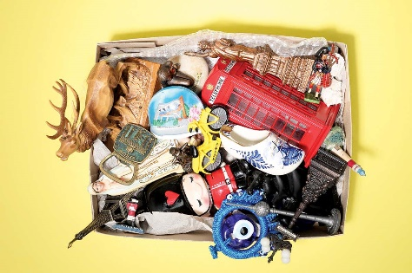
Why memories are an illusion and forgetting is good for you

Rather than a filing cabinet in the mind, it turns out memory is an exquisite illusion that shapes our sense of self. Here’s how to understand yours better

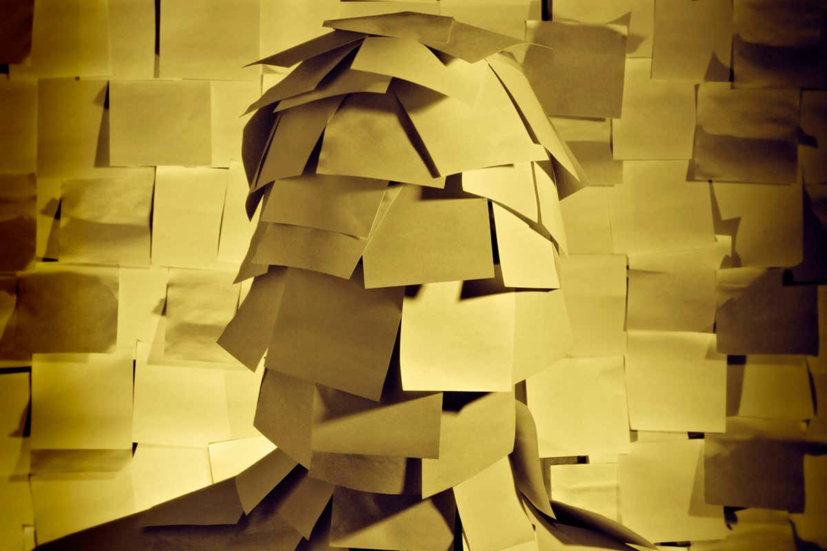
Memory FAQ: Answers to the common questions that baffle us all

Why can’t we remember being babies? Does closing your eyes help you recall? Why can’t I remember what I did 5 seconds ago? What is photographic memory? And more
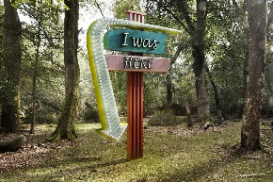

Do we even know what memory is for?

Remembering the past is useful, but the real purposes of memory may be quite different – from planning for the future to learning to communicate
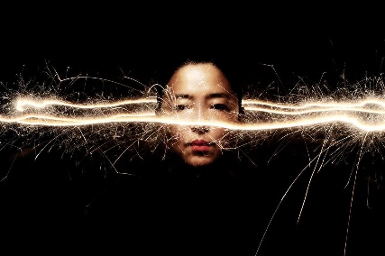

Can you supercharge your memory?

Want to remember whatever you like with no effort? Superhuman enhancements in the form of memory prostheses and implants are just around the corner
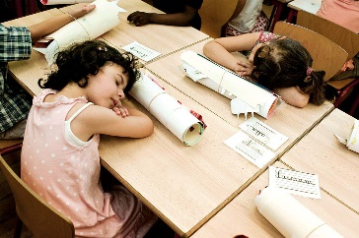

What happens to your memories while you sleep?

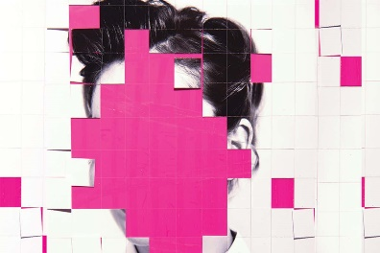
As you slumber, the brain is a whir of activity sorting and storing your memories. How does it know which to choose, and how can you game the system?

Can you choose what to forget?
If you want to forget an embarrassing encounter, you may just need to try. Forgetting isn’t a passive process – so here’s how to choose which memories you lose

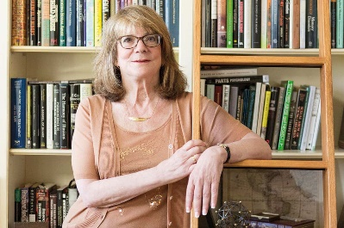
Can you trust your memories?

Psychologist Elizabeth Loftus exposed false memories in historic sex abuse cases. Now there are new reasons not to trust your memories, she says

Is technology making your memory worse?

From search engines to Instagram and a reliance on satnav, our relationship with technology is changing the way the brain makes memories, for better and worse
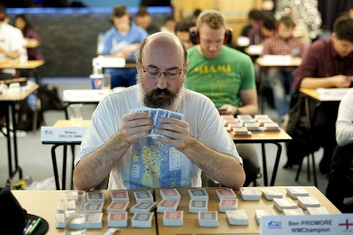

Is your memory normal?

Why do some people remember what they did years ago, whereas others have no clue, but never forget a face or are trivia masters? Here’s how to make sense of it
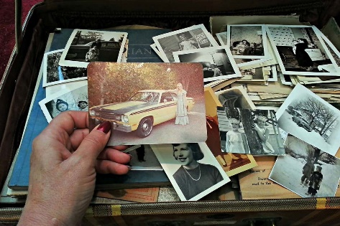

What happens to memories over time?

Memories fade, but that’s no accident. Forgetting is a useful trick of the mind, and even when memories are lost, they aren’t always forgotten

How can two people recall an event so differently?

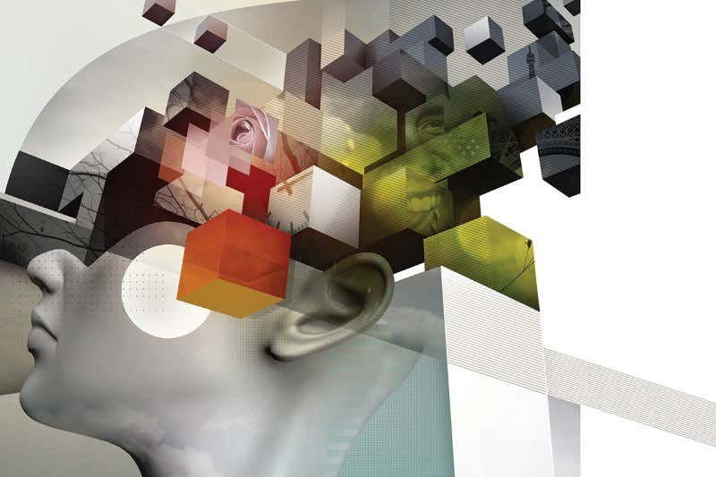
We each have a personal memory style determined by the brain, so next time you argue with someone about what really happened, remember that you may both be right

PICTURE A MEMORY

What does a memory in my brain look like?
https://www.newscientist.com/article/mg22830490-300-what-does-a-memory-in-my-brain-look-like/
Memories are not just about the past: they are what thought and self are made of. Clare Wilson visits the brain’s vaults to find out how they actually work

HAVE YOU READ THIS BEFORE?

Mystery of déjà vu explained – it’s how we check our memories
https://www.newscientist.com/article/2101089-mystery-of-deja-vu-explained-its-how-we-check-our-memories/
The phenomenon seems to be a sign of a healthy memory that forms accurate memories, déjà vu brain scans have revealed for the first time

BRAIN TRAINING

How to train your brain to be like a memory champion’s
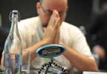
https://www.newscientist.com/article/2123945-how-to-train-your-brain-to-be-like-a-memory-champions/
Volunteers who practised a technique favoured by elite mnemonists more than doubled their memory capacity – and their brains became more champion-like

MEMORY BOOST

How to hack your unconscious… to boost your memory and learn better
https://www.newscientist.com/article/0-how-to-hack-your-unconscious-to-boost-your-memory-and-learn-better/
It seems like hard conscious work, but much of the learning process goes on deep in the mind. Here are the top tips to improve how you recall facts

REROUTING MEMORY

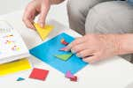
Brain implant boosts human memory by mimicking how we learn
https://www.newscientist.com/article/2153034-brain-implant-boosts-human-memory-by-mimicking-how-we-learn/
A device that zaps the brain with electricity has improved people’s scores on memory tests. It may have the power to help dementia, or boost other brain skills

MALLEABLE MINDS

Spotless mind: Manipulating the brain to rewrite memories
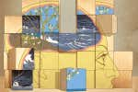
https://www.newscientist.com/article/mg23331110-700-spotless-mind-manipulating-the-brain-to-rewrite-memories/
Our memories are more malleable than we thought – providing new perspectives to treat maladies from trauma to Alzheimer’s

