Moray: Prep 35 marks

**Paper 2 Section A Style Questions**

1. From Moray’s study on auditory attention: Describe what a dichotic listening task is. [2]
2. Outline one way the dichotic listening task was controlled in this study. [2]

‘To what extent’ questions

* Make a choice / judgement (greater / lesser / somewhat)
* Explain one reason for your judgement
* Give a counter for your judgement.

1. To what extent can Moray’s study on auditory attention be considered valid? [3]
2. To what extent is Moray’s study on auditory attention be considered reliable? [3]

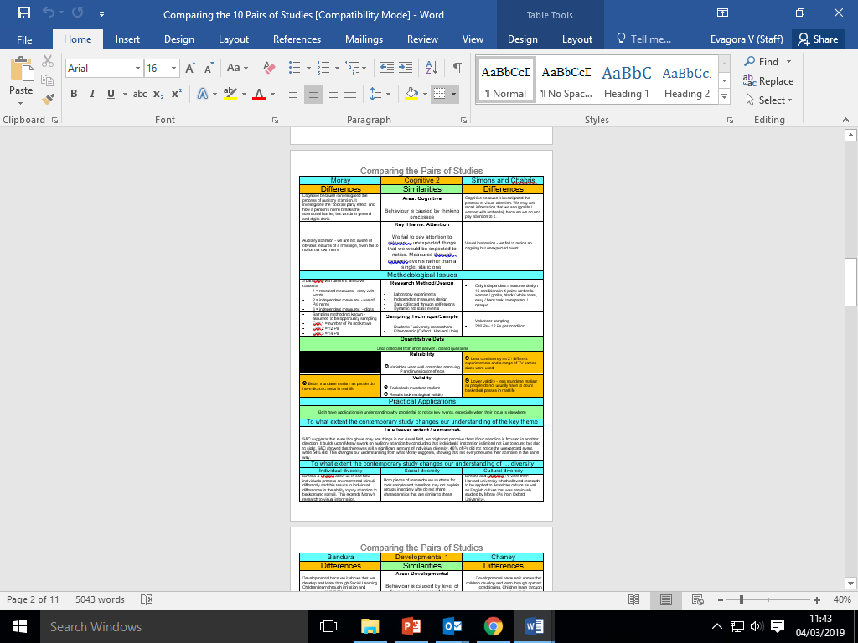

‘To what extent does the new study change our understanding of …’ questions

* Make a choice / judgement (greater / lesser / somewhat)
* Explain one reason for your judgement based on the old study
* Explain one reason for your judgement based on the contemporary study.

1. To what extent does the study by Grant change our understanding of memory? [3]
2. Outline how Moray’s study on auditory attention links to the cognitive area of psychology. [4]
3. Outline how Moray’s study on auditory attention links to the key theme of attention. [3]

**Paper 1 Section C style Question**

1. **Explain** how you would carry out an **experiment** to investigate whether having a mobile phone on the desk when studying affects attention. **Justify** your decisions as part of your explanation. You must refer to:

* laboratory or field experiment
* volunteer or opportunity sampling
* Independent or repeated measures
* collection of data

You should use your own experience of carrying out an experiment to inform your response. [15]

Repeat the following structure for each of the 4 choices given to you:

For each of the bullet points / features, you need to say:

• Feature (from each of the bullet points)

• Explained (how you would be doing this – enough for replication)

• in Context (using the unique words of the story)

• Justified (why it is right to do here)

• referring to Own research (to show a similarity).

Could you hear your partner across a crowded room?

*Why married couples find it easier to hear (and ignore) each other in a cocktail party*

* Researchers from Queen's University in Ontario, Canada, studied the ‘Cocktail Party’ effect
* It is named after the apparent ability of partners to ignore or hone in on each other... depending on how interested they are
* Tests found couples could hear their partners better in noisy surroundings
* They also found them easy to ignore in order to focus on something else
* But the effect only seems to occur in couples who spent 18+ years together

By Kieran Corcoran 29 December 2013 [**https://tinyurl.com/y3pzanjf**](https://tinyurl.com/y3pzanjf)

Couples who have been together for decades find it easier to pick out their partner’s voice in a crowded room, according to a new study.

The quirk, which is evident in partners who have spent more than 18 years together, also lets those who have been together for a long time screen out their partner’s voice more easily if they are not interested.

The subjects were asked to listen to three voices speaking at once. In some tests one of the voices was their partner’s and in some all were strangers.

The phenomenon is named after a cocktail party as it may explain how members of a couple can pick each other out in social situations when they choose to, but can also seem completely oblivious when their attention is elsewhere.

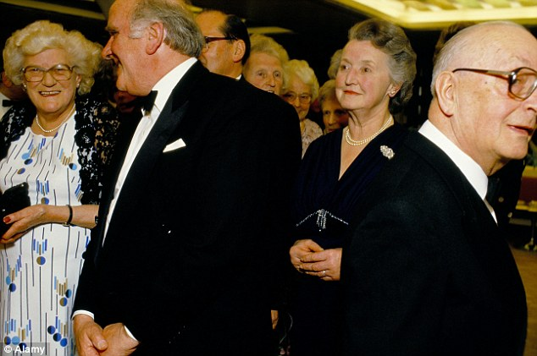The study found that whenever a partner’s voice featured, it was easier to retrieve the right information. Participants were able to ignore the other voices and focus on their partner for a better success rate.

Equally, when their partners were not speaking the key information, they found it easier to ignore them and focus on the strangers’ voices.

Even older couples, whose hearing had declined naturally with age, remained very perceptive when it came to their husband or wife.

### Cognitive area principles

You need to be able to define the key principles of cognitive psychology and understand how the researchers in this area apply these principles when investigating the cause of behaviour. Read the following study summaries and highlight any key phrases that show the links to the cognitive area of psychology.

Once you have done this complete the following questions:

1. What keywords (hashtags) are associated with the cognitive area when explaining behaviour?
2. What 2 key assumptions do cognitive psychologists make about how behaviour is caused? Use the key terms you identified in question 1.
3. Using the research summaries, suggest why cognitive psychologists tend to favour the following research choices:
4. Cognitive psychologists often use experiments because:
5. Cognitive psychologists often ensure high control in their research because:
6. Cognitive psychologists tend to collect quantitative data because:
7. Cognitive psychologists often rely on self-report because:

### C:\Users\Evagora\AppData\Local\Microsoft\Windows\Temporary Internet Files\Content.IE5\2M1IFKGR\yellowhighlighter[1].pngLoftus and Palmer (1974) Eyewitness Testimony

*Highlight the aspects of the study that show how the researcher uses cognitive psychology to explain behaviour.*

**Aim**: The aim of this research was to see if questions asked after an event can cause a reconstruction in ones memory of that event. Previous research has suggested that schemas work as mental shortcuts, based on previous experience, to speed up the processing of information.

**Method:** Loftus and Palmer used an experimental laboratory method to ensure they were testing what they set out to test. They were aware of the difficulty of measuring participant’s memory and controlled the environment carefully to ensure other variables such as emotion or legal pressure did not influence participants’ responses.

**Findings:** The results of experiment one suggest that changing just one word in a question can markedly and systematically affect a witnesses answer to a question. It can also be suggested that the way we process stimuli can be predicted. So we really do work like computers?

**Input – Processing – Response**

The results of experiment two suggest that verbs/ leading questions cause an actual distortion in memory as people unconsciously modify their memory of an event because the verb ‘smashed’ made more participants (16) think that they had seen broken glass. On the other hand, it is difficult to tell if it really is an individual’s cognition that is altered as more participants in all three groups accurately recalled that there had been no glass.

**Conclusions**: From this research we can see that two types of information influence a memory of a complex event like a car crash. Firstly, the information a person perceives at the event and secondly the information one receives after the event. This indicates that the processing of information changes and the outcome (the behaviour) is altered.

**Discussion**: If we can systematically change a person’s behaviour can we suggest that all people process information in a similar way? Loftus argues that by asking a participant ‘how fast the cars are going when they smashed?’ we are labelling the accident as a ‘smash’ and this influences the processing of this memory and changes the individual’s answer.

If this is the case are we arguably one step closer to showing that humans function in a mechanistic way, that is to say that we can view people as machines and see different outputs (behaviours) from different inputs (leading questions/ social influence/ verbs)?

### C:\Users\Evagora\AppData\Local\Microsoft\Windows\Temporary Internet Files\Content.IE5\2M1IFKGR\yellowhighlighter[1].pngGrant et al (1998) Context-dependent memory

*Highlight the aspects of the study that show how the researcher uses cognitive psychology to explain behaviour.*

**Aim:**to investigate the importance of environmental context-dependency effects on learning by assessing the ability for participants to recall information from their memory. They focused on what happened when information was encoded - silent / noisy conditions.

**Method:** In order to isolate the variables that may affect the processing going on in the mind Grant et al carried out a laboratory study; using this methodology ensured other variables didn’t have an effect on the participants’ memory recall like it would in everyday life.

An independent measures design was used to ensure that the participants’ were not using previous memories of the task to help them recall the correct answer.

**Findings:** The results were gathered by measuring the mean reading time and the mean number of correct answers on the two tests completed. The results suggest that all groups spent roughly equal amounts of time studying the material and processing information.

The results reliably showed that studying in the same environment (silent or noisy) as you are being tested in does produce better recall of the information learnt.

**Conclusions:** This study shows that there are context-dependency effects for newly learned meaningful material. This may mean that when learning material students should ensure the environment they learn subject material in is quiet and distraction free like an exam will be. This will ensure that when the cogs to do with processing and retrieving information are at work they are able to access the appropriate memory to use.

**Discussion:** This study focuses on the notion that we can analyse human processing to identify the factors that contribute to successful learning of material. By looking at the factors that mediate between our reaction and the initial stimulus we are able to suggest ways to improve human behaviour and performance.

Whilst quantitative data collected in this study suggests that mental processing is directly affected by the environment in which information is inputted the simplicity of this model is questioned. Why is this a rather simplistic view of human behaviour?

### C:\Users\Evagora\AppData\Local\Microsoft\Windows\Temporary Internet Files\Content.IE5\2M1IFKGR\yellowhighlighter[1].pngMoray (1959) Auditory attention

*Highlight the aspects of the study that show how the researcher uses cognitive psychology to explain behaviour.*

**Aim:** Moray set out to find out more about how auditory information is processed in the mind and the effect this has on behaviour. Previous models of attention suggest that it is like a flow chart with each stage being processed step-by-step. Moray favoured to theory that there are multiple processes occurring at once but wanted to find out how well individuals can process information if they are presented with more than one auditory message.

**Method:** Three experiments were conducted, the first one focused on testing Cherry’s previous research on shadowing that showed individuals are ignorant of a second message if two are simultaneously presented.

The other experiments focused on other variables that may influence the processing of information such as personalised instructions and the use of digits in the message. The suggestion put forward was that the attentional block of material in the second ear may be penetrated if the individual hears instructions aimed at them which direct their attention to the other message.

**Findings:** Experiment one found that there was no trace of the material from the second message that was rejected, this suggests little attention was paid to this message and therefore the information could arguably never have been processed in the first place.

**Experiments two** found that participants were able to ignore the secondary message, even when it as personalised, as many suspected this was done to distract them. Participants made decisions based on this judgement about which message to listen to.

The final experiment showed no significant difference in the recall of digits and suggested that individuals judged the shadowing material as insignificant and therefore concentrated on the message they were asked to.

**Conclusions:** This study suggests that paying attention to auditory information does involve decision making and cues such as names may encourage individuals to pay attention to information further. Without a value information is seemingly ignored and relevant information is prioritised which may help humans to process the huge amount of stimuli they encounter daily.

**Discussion:** Whilst this research carefully isolates auditory messages it lacks ecological validity. Why?

How can schema help explain the reason that people pay attention to different stimuli? Can you link this to key cognitive terms?

### Simons and Chabris (1999) Visual inattention

*Highlight the aspects of the study that show how the researcher uses cognitive psychology to explain behaviour.*

**Aim:** Everyday life is bursting with visual stimuli competing for your attention. This research aimed to unpick the factors that lead particular stimuli to be given attention and processed whilst other stimuli is simply ignored. The process by which we select visual attention is of interest here and may explain why certain events seem to go unnoticed before our very eyes. This study suggests that the mind can only process a certain amount of visual information and once the limit of this is met other information is ignored. By building on previous research this study aimed to investigate inattentional blindness in a dynamic scene.

**Method:** A laboratory experiment was carried out and set up to present an isolated scenario with one key change, the gorilla walking across the scene, to act as a potential distraction.

There were a number of independent variables to vary the distraction presented in terms of the object (umbrella woman or gorilla) and the clarity of this (transparent/ opaque) as well as the difficulty of the task (easy/ hard) to assess the factors that contribute to effective processing of information.

**Findings**: Overall 54% of participants in the experiment noticed the unexpected event which suggests that the visual processing system does register a lot of information in the visual field despite the mind focusing on a set task such as counting the number of passes.

Whilst there are a number of key findings it is interesting to note that more participants in the easy condition noticed the unexpected event than in the hard condition which suggests that the ‘load’ on the processing does impact how much information we can pay attention to.

**Conclusions:** This study showed that inattentional blindness occurs across a range of different circumstances and this is more prevalent as the task becomes more difficult. This study suggests that we have no conscious perception of an event if we do not pay attention to it initially.

**Discussion**: This piece of research suggests that the way the mind works is systematic and we can predict how individuals will respond. How could this be used as a real life application?

**Background**

There are two main methods of studying attention:

* + **Selective attention** – here people are presented with two or more simultaneous ‘messages’, and are instructed to process and respond to only one of them. The most popular way of doing this is to use shadowing in which one message is fed into the left ear and a different message into the right ear (through headphones). Participants have to repeat one of these messages aloud as they hear it. The shadowing technique is a form of dichotic listening which was first used by Cherry (1953) when he studied the **cocktail party** phenomenon.
  + **Divided attention** – this is a dual-task technique in which people are asked to attend and respond to both (or all) the messages. Whereas shadowing focuses attention on a particular message, the dual-task method deliberately divides people’s attention.

|  |  |  |
| --- | --- | --- |
|  | Selective | Divided |
| laboratory or field experiment |  |  |
| volunteer or opportunity sampling |  |  |
| Independent or repeated measures |  |  |
| Materials you would use |  |  |
| Procedure |  |  |

**Moray: Evaluation**

**Research method**: The conditions and the

that Moray created were highly in a laboratory, therefore showing high validity. However, due to the nature of the study and the sample, responses may have been a result of characteristics. Furthermore, listening to sounds through headphones and being asked to block out or

the noises is extremely and not true to real life; therefore, the study lacks ecological validity.

**Reliability**: The procedures of the study, including given to participants, are highly standardised which allows the study to be easily and to check for the reliability of the findings.

**Sampling bias**: As with many psychology studies, University students took part (as well as research workers). This sample is easily , so saves time and money on obtaining participants. However, the sample is not of everyone, as students and research workers are likely to have higher abilities and may perform better on attention tasks. Therefore the study lacks population validity.

accessible

artificial

cognitive

controlled

demand

experimental

instructions

internal

procedures

replicated

representative

shadow

Creating a Kahoot: Moray

Write 2 multiple choice questions each with 4 answers on Moray’s study.

Question 1 ______________________________________________________________________________________________________________________________________

Answer choices

1. ________________________________________________________________
2. ________________________________________________________________
3. ________________________________________________________________
4. ________________________________________________________________

The correct answer is _________________________________________________

Question 2 ______________________________________________________________________________________________________________________________________

Answer choices

1. ________________________________________________________________
2. ________________________________________________________________
3. ________________________________________________________________
4. ________________________________________________________________

The correct answer is _________________________________________________

Moray: Evaluation

**Research method**

The experimental conditions and the procedures that Moray created were highly controlled in a laboratory, therefore showing high internal validity. However, due to the nature of the study and the sample, responses may have been a result of demand characteristics. Furthermore, listening to sounds through headphones and being asked to block out or shadow the noises is extremely artificial and not true to real life; therefore, the study lacks ecological validity.

**Internal Reliability**

The procedures of the study, including instructions given to participants, are highly standardised which allows the study to be easily replicated and to check for the reliability of the findings.

**External reliability**

Samples used in each study were quite small so may not be consistent for wider population

**Internal validity**

Highly controlled lab experiment so extraneous variables controlled. However participants knew they were in the study so may have just not reported anything they remembered from the rejected message as they knew they were not supposed to.

**External validity**

Ecological validity may be lacking as Ps would not experience these conditions in real life.

**Ethnocentrism**

Not ethnocentric as investigating a species specific behaviour. However could be ethnocentric as only reflects how English speaking westerners' attentional processes work and other peoples brains may have been shaped differently based on language or culture.

**Sampling bias**

As with many psychology studies, University students took part (as well as research workers). This sample is easily accessible, so saves time and money on obtaining participants. However, the sample is not representative of everyone, as students and research workers are likely to have higher cognitive abilities and may perform better on attention tasks. Therefore the study lacks population validity.

**Ethics**

Conducted ethically as the tasks were clearly explained to participants and the procedure did not put the participants under any stress or discomfort.

**Psychology as a science**

Moray was very careful to ensure that his study was carried out in controlled laboratory settings. By doing this he ensured that this study was replicable, which is one of the standards required to consider psychology as a science.

**Links to the Cognitive Area**

Moray’s study belongs to the cognitive area because the process of attention is a mental process. The study investigates what material is required to ‘break’ the inattentional barrier.

**Links to the Key Theme: Attention**

This study is related to the key theme of ‘attention’. It investigated Cherry’s ‘cocktail party effect’ and found that information that is considered important to an individual (i.e. their name) will be significant enough to allow a participant to pay attention to it, even if they were paying attention to something else.

Evaluate Moray’s study in terms of _________________________________________ [6]

1. Ethics
2. 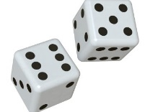Ethnocentrism
3. Methodology
4. Psychology as a science
5. Reliability
6. Validity

Write your answer for your topic area for others to use.

Annotate your POINT – EXPLANATION – CONTEXT – CONCLUSION structure.

__________________________________________________________________________________________________________________________________________________________________________________________________________________________________________________________________________________________________________________________________________________________________________________________________________________________________________________________________________________________________________________________________________________________________________________________________________________________________________________________________________________________________________________________________________________________________________________________________________________________________________________________________________________________________________________________________________________________________________________________________________________________________________________________________________________________________________________________________________________________________________________________________________________________________________________________________________________________________________________________________________________________________________________________________________________________________________________________________________________________________________

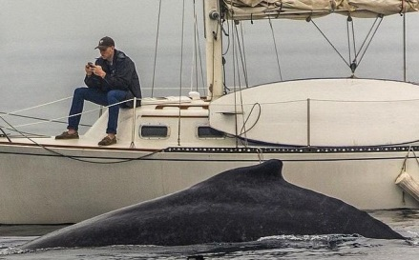Humans have shorter attention span than goldfish, thanks to smartphones

Are you so distracted by your smartphone that you struggle to concentrate and miss out on things?

According to scientists, the age of smartphones has left humans with such a short attention span even a goldfish can hold a thought for longer. Researchers surveyed 2,000 participants in Canada and studied the brain activity of 112 others using electroencephalograms.

The results showed the average human attention span has fallen from 12 seconds in 2000, or around the time the mobile revolution began, to eight seconds.

Goldfish, meanwhile, are believed to have an attention span of nine seconds.

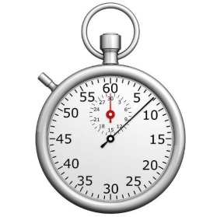The study, by technology giant Microsoft, did however find that the ability of humans to multitask has improved. It read: "Canadians [who were tested] with more digital lifestyles (those who consume more media, are multi-screeners, social media enthusiasts, or earlier adopters of technology) struggle to focus in environments where prolonged attention is needed.

**Eight seconds: the average attention span of humans**

"While digital lifestyles decrease sustained attention overall, it’s only true in the long-term. Early adopters and heavy social media users front load their attention and have more intermittent bursts of high attention. They’re better at identifying what they want/don’t want to engage with and need less to process and commit things to memory."

The research follows a study by the National Centre for Biotechnology Information and the National Library of Medicine in the US that found 79 per cent of respondents regularly "dual screen" by using portable devices while watching TV.

"Just because we may be allocating our attention differently as a function of the technologies we may be using, it doesn't mean that the way our attention actually can function has changed."

**Paper 2 Section C style questions**

1. Explain why this article can be viewed as being relevant to cognitive psychology. (4)
2. Briefly outline one core study and explain how it could relate to this article. (6)
3. Identify one psychological issue/problem or content raised by the above article. Support your answer with evidence from the article. (4)
4. Use your psychological knowledge to suggest a way to encourage people to use their phones less. (6)
5. Evaluate your suggestion. (6)