**Prep due Wed 26/6/19**

To what extent are the medical model’s explanations of mental illness determinist? [10] (Past paper question 2018)

**Phobia** = An irrational fear of an object or situation.

**Specific phobia**

* Phobia of a particular object or specific situation e.g. animal types, natural environment types (e.g. heights, water), blood-injection types (e.g. blood, syringes), situational types (e.g. lifts, planes) and other types that do not fit (e.g. clowns, choking).

There are 3 types of characteristics of specific phobias: behavioural, emotional and cognitive.

**Behavioural characteristics: Avoid and Panic**

The key behavioural characteristic of a phobia is avoidance. If a person with a phobia is presented with the object or situation they fear, their immediate response is to avoid it. For example, a person with arachnophobia will avoid being near spiders and people with a social phobia will avoid being in large crowds.

However, people are not always able to avoid their fears and sometimes they come face-to-face with an object or situation they fear, which results in panic, causing high levels of stress and anxiety. Sometimes, the fear response is so intense, it results in a person ‘freezing’, which is part of the ‘fight or flight’ fear response. The freezing response is an adaptive response to make a predator think that their prey is dead.

**Emotional characteristics**

They key emotional characteristics of a phobia, are excessive and unreasonable fear, anxiety and panic. An emotional response is triggered by the presence, or the anticipation of, a specific object or situation, which is excessive in relation to the danger actually posed.

**Cognitive characteristics**

The cognitive characteristics of phobias are also divided into two characteristics: selective attention and irrational beliefs.

If a person with a phobia is presented with an object or situation they fear, they will find it difficult to direct their attention elsewhere. Therefore, a person’s selective attention will cause them to become fixated on the object they fear, because of their irrational beliefs about the danger posed.

Furthermore, a person’s phobia is defined by their irrational thinking towards the object or situation. For example, a person with arachnophobia may believe that all spiders are dangerous and deadly, despite the fact that no spiders in the UK are actually deadly.

To what extent are the medical model’s explanations of mental illness determinist? [10] (Past paper question 2018)

**Overall conclusion**: The medical model’s explanations of mental illness are deterministic to a greater extent.

**Introduction:**

* Determinism is the view that …
* The Medical Model views mental illnesses just like other illnesses; they have a physical cause. The 3 explanations of mental illness from the Medical Model are: biochemical, genetic and brain abnormality.

Paragraph 2

* Point: Being deterministic is a strength / weakness of medical model’s explanations because …
* Explanation: which means / because
* Example: Gottesman’s correlational analysis showed that a cause of mental illness was genetic components and probable / pre-determined because …
* Conclusion: Being deterministic is helpful because it allows for generally effective treatments to be planned for the majority of people. For the genetic explanation, people can be advised whether or not to have children based on the likelihood of them passing on the genes for serious mental illness.
* Challenge: However ….

Paragraph 3

* Point: Being deterministic is a weakness of medical model’s explanations because …
* Explanation: which means / because
* Example: The biochemical / brain abnormality explanations suggest that ….
* Conclusion: Being deterministic is unhelpful because it neglects to consider people’s free will in their own mental illness, so ….
* Challenge: however …

Guess the Phobias Starter

AICHMOPHOBIA __________________________________________

AMATHOPHOBIA __________________________________________

BACTERIOPHOBIA __________________________________________

CHRONOMENTROPHOBIA _________________________________________

CYBERPHOBIA __________________________________________

DENTOPHOBIA __________________________________________

DIDASKALEINOPHOBIA __________________________________________

EISOTROPHOBIA __________________________________________

GAMOPHOBIA __________________________________________

HEMAPHOBIA __________________________________________

IATROPHOBIA __________________________________________

LIGYROPHOBIA __________________________________________

LINONOPHOBIA __________________________________________

OCTOPHOBIA __________________________________________

ORPHIDIOPHOBIA __________________________________________

PTERONOPHOBIA __________________________________________

SIDERODROMOPHOBIA __________________________________________

SINISTROPHOBIA __________________________________________

TRYPANOPHOBIA __________________________________________

*bacteria*

*blood*

*clocks*

*computers*

*dust*

*feathers*

*going to school*

*going to the dentist*

*going to the doctors*

*injections*

*left handed objects*

*looking at oneself in the mirror*

*loud noises*

*marriage*

*pointed objects*

*snakes*

*string*

*the number eight*

*trains and tunnels*

**ANSWERS**

Aichmophobia- *fear of pointed objects*

Amathophobia- *fear of dust*

Bacteriophobia-*fear of bacteria*

Chronomentrophobia- *fear of clocks*

Cyberphobia- *fear of computers*

Dentophobia- *fear of going to the dentist*

Didaskaleinophobia- *fear of going to school*

Eisotrophobia- *fear of looking at oneself in the mirror*

Gamophobia- *fear of marriage*

Hemaphobia- *fear of blood*

Iatrophobia-*fear of going to the doctors*

Ligyrophobia- *fear of loud noises*

Linonophobia- *fear of string*

Octophobia- *fear of the number eight*

Orphidiophobia- *fear of snakes*

Pteronophobia- *fear of feathers*

Siderodromophobia- *fear of trains and tunnels*

Sinistrophobia- *fear of left handed objects*

Trypanophobia- *fear of injections*

**AO1: The Medical Model’s View of Mental Illness in General**

The medical model views mental illnesses just like other illnesses. They have a physical cause. They can be diagnosed by listing the symptoms. They can be treated by adjusting the physical cause.

**Recap**

Example of a psychotic disorder: ______________________________________

Example of an anxiety disorder: ______________________________________

Example of an affective psychotic disorder: ______________________________________

The ICD-10 and DSM-V list the symptoms of mental illnesses. These have strong external

_________________________ but poor ___________________ validity.

There are 3 explanations from the medical model of mental illness:

1. biochemical
2. brain abnormality
3. genes

|  |  |  |  |
| --- | --- | --- | --- |
| Explanation | Example | How to study this | Treatment |
| Biochemical | Too much dopamine |  |  |
| Brain abnormality |  | Brain scans |  |
| Genetic |  |  | Gene counselling |

**AO3: Strengths of the medical model include:**

* Not blaming people for their abnormal behaviour. The person’s body has caused the behaviour, not their personality or intentions. This is **useful** as it has led to more humane treatment of the mentally ill.
* Objective evidence shows that biological causes can be linked to psychological symptoms, such as high dopamine levels in schizophrenia. This helps **Psychology to be viewed as a Science**, as objective, replicable and empirical methods have been used.

**Weaknesses of the medical model include:**

* Psychiatrists such as Szasz see the use of labels, such as ‘mentally ill’ as a way of pathologising people whose behaviour we do not like or cannot explain. This is a problem because the labels are being used for **political** not helpful reasons.
* There may be problems of **concurrent validity** in the diagnosis of mental health as there are a range of different diagnostic tools such as the DSM-V and ICD-10. This is a problem as some may be diagnosed and others not.
* There may be problems of **inter-rater reliability** in the diagnosis, especially as different diagnostic tools such as the DSM-V and ICD-10 are used. A diagnosis should have external reliability – consistency over time, place and people.
* The medical model takes a **reductionist approach** to mental illness. It ignores the behaviourist, cognitive and psychodynamic factors which may also cause the behaviour. This is problematic as an incomplete explanation of the illness will mean any treatment might not be fully curative.
* The medical model takes a **nature not nurture** approach to mental illness, especially if genetic explanations are given. This suggests that people are ‘born’ to become mentally ill and this level of determinism means that people may believe there is little or nothing that they can do about it.
* This view is also **determinist** as it suggests that a chemical imbalance will cause mental illness. However, it can be argued that not all individuals with psychological disorders have abnormal levels of neurotransmitters and not everyone with a chemical imbalance develops a mental illness.

**AO2: Nature /Nurture debate**

In the list below colour in ONE colour the words relating to the nature side of the arguments and colour in ANOTHER colour the terms relating to the nurture side

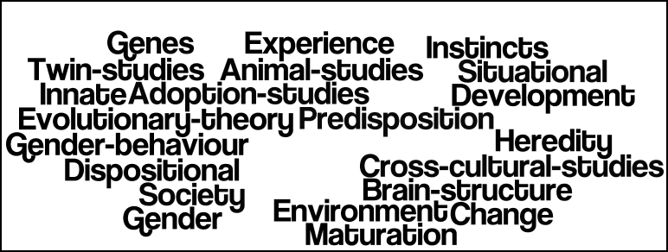

**AO1: The Biochemical Explanation of Mental Illness**

The cause of mental illness is abnormal levels of neurotransmitters.

Neurotransmitters are chemicals made by the body. They are released at the end of nerve cells (neurons). This happens an electrical charge has passed along the neuron. They pass across the gap (synapse) between nerve cells. They activate receptors in the next neuron, depending on the quantity required. The neurotransmitters have either excitatory or inhibitory effects on the next neuron. Excitatory (e.g. serotonin) neurotransmitters make the next (post-synaptic) cell more likely to fire. Inhibitory (e.g. GABA) make them less likely to fire.

Mental illness can result from too many or too few neurotransmitters binding to receptors.

|  |  |  |  |
| --- | --- | --- | --- |
| Action of the Neurotransmitter | Example | Too much | Too little |
| Excitatory |  |  |  |
| Inhibitory |  | Inhibits too much so there is no activity | Does not inhibit enough so there is too much activity |

**AO2: Getting Empirical Evidence**

* post mortems
* collecting spinal fluid
* giving medication to see any adjustment in behaviour

Pande et al (1999) randomly assigned 69 patients with social phobia to 2 groups:

* experimental group where they took medication to increase the levels of GABA for 14 weeks
* control group who took a placebo instead.

The experimental group showed a significant reduction in symptoms compared to the control group.

**AO3: Evaluation of the Biochemical Explanation**

* The **success of drug treatments** for some individuals supports the biochemical explanation, as these drugs stabilise levels of the neurotransmitters and reduce symptoms. This suggests that the cause was biochemical in the first place. But this shows the aetiological fallacy.
* Biological explanations of mental illness are unable to establish **cause and effect.** The abnormal levels of neurotransmitters may be the cause or a symptom of the mental illness
* Medication does not work for all patients (**individual differences**), and this ignores other causes such as cognitive, behavioural or psychodynamic explanations (**reductionist**).
* This view is also **determinist** as it suggests that a chemical imbalance will cause mental illness. However, it can be argued that not all individuals with psychological disorders have abnormal levels of neurotransmitters and not everyone with a chemical imbalance develops a mental illness.

**AO1: Brain Abnormality as an Explanation of Mental Illness**

Different parts of our brain are responsible for different behaviours (localisation of function), and the Medical Model suggest that different mental illnesses may be associated with specific parts of the brain. The cause could be over-activity in the brain leading to excess functioning, or underactivity which could cause deficits in behaviour.

**AO2: Brain Abnormality as an Explanation of Specific Phobias**

The prefrontal cortex suppresses (inhibits) the fear response. If the prefrontal cortex is not functioning effectively, it no longer stops fearful urges, like the fight or flight response which are sent from the amygdala.

The amygdala detects and responds to threats in the environment. People who suffer from anxiety and phobias have smaller amygdalae and these have greater blood flow. This leads to an inability to control the fear response to objects and situations.

**AO2: Getting Empirical Evidence**

* post mortems
* brain scans

**Ahs et al (2009)** used PET scans to measure blood flow in the amygdala and prefrontal cortex of patients with snake or spider phobia. They found:

* Increased blood flow and activity in the amygdala
* Reduced blood flow and activity in the prefrontal cortex

When they showed objects that were fearful to the patients.

**AO3: Evaluation of the Brain Abnormality Explanation of Mental Illness**

* The use of equipment such as PET scans and MRI scans ensures that supporting evidence for this explanation is valid. We measure brain abnormalities in an objective, **scientific** way, which can easily be replicated.
* There is evidence that our behaviour is controlled by our brains which supports the **determinism** debate.
* However, this ignores the role of **free will** in that we are in control of our own cognitions and behaviours.
* There is a danger of **biological determinism**: just because an individual has a smaller amygdala does not mean they will definitely develop phobias, this is just one of a number of risk factors.
* This explanation also supports the **individual debate** in that our individual characteristics such as anatomical differences can cause mental illness, regardless of the situations that we are exposed to.

|  |  |  |
| --- | --- | --- |
|  |  |  |
|  |  |  |
|  |  | C:\Users\vevagora\AppData\Local\Microsoft\Windows\Temporary Internet Files\Content.IE5\RJXJF1R3\Bingo[1].jpg |

**AO1: Genes as an Explanation of Mental Illness**

The genetic explanation suggests that:

* Family and twin studies show some mental illnesses are at least partly caused by innate factors
* People inherit mental illnesses from their parents, through genes
* People with mental illnesses are more likely to have close relatives with mental illnesses too

**AO2: Genes as an Explanation of Specific Phobias**

Perhaps all humans have inherited, through natural selection, a tendency to fear certain potentially dangerous things e.g. heights. Seligman argues this is because long ago people who did not fear and avoid them, died – so their genes were not passed on

**AO2: Gaining Empirical Evidence: Genes as an Explanation of Mental Illness**

One way of finding out whether a disorder has a genetic component is to see whether it runs in families. If relatives of sufferers have a higher than average risk of getting the disorder themselves, then it may be that the disorder has a genetic component.

However, family members typically share similar environments. Consequently, increased risk amongst close relative may simply indicate that that are exposed to the same set of environmental risks.

An alternative approach is to do a twin study. This looks at the concordance (similarity) of twins with respect to the disorder being considered. Concordance rates are expressed as a percentage. The percentage is the probability of one twin having the disorder if the other already has it.

In a twin study, MZ (identical) and DZ (non-identical) twins are compared. Whilst MZ twins have a greater degree of genetic similarity, both types of twin pair grow up in identical environments. So if we discover that MZ twins have a higher concordance, this cannot be because their environments are more similar than those of DZ twins; it must therefore be because their genes are more similar.

When interpreting twin study data, we look for the following features:

|  |  |
| --- | --- |
| MZ concordance is significantly higher than DZ concordance | The disorder has a genetic **component** |
| MZ concordance is same or similar to DZ concordance | The disorder is environmentally **caused**. |
| MZ concordance is 100% | The disorder is genetically **caused** |
| MZ concordance is significantly less than 100% | The disorder has an environmental **component** |

|  |  |
| --- | --- |
| January | Discuss the reliability of research into the Medical Model’s explanations of mental illness. [10] |
| February | **Discuss** the nature / nurture debate in relation to the Medical Model’s explanations of mental illness. [10] |
| March | **Discuss** the free will /determinism debate in relation to the Medical Model’s explanations of mental illness. [10] |
| April | **To what extent** isthe Medical Model’s explanations of mental illness scientific. [10] |
| May | **Discuss** the reductionism / holism debate in relation to the Medical Model’s explanations of mental illness. [10] |
| June | **Assess** the ethnocentrism of **research** into the Medical Model’s explanations of mental illness. [10] |
| July | **To what extent** is **research** into the Medical Model’s explanations of mental illness socially sensitive? [10] |
| August | **Discuss** the individual / situational explanations of behaviour in relation to the Medical Model’s explanations of mental illness. [10] |
| September | **Assess** the usefulness of the Medical Model’s explanations of mental illness. [10] |
| October | **Evaluate** ethical considerations of the Medical Model’s explanations of mental illness. [10] |
| November | **Discuss** methodological issues when **researching** the Medical Model’s explanations of mental illness. [10] |
| December | **Discuss** the validity of **research** into the Medical Model’s explanations of mental illness. [10] |

Debates and Issues for Paper 3

|  |  |
| --- | --- |
| **Nature/nurture** | |
| **Nature**   * Behaviour caused by innate characteristics * Determinist - all behaviour is inherited   **Strengths**   * Objective methods used * Can show cause & effect   **Weaknesses**   * no control over own behaviour * Reductionist | **Nurture**   * Behaviour is **determined by the environment**   **Strengths**   * Allows for intervention programmes. * Wide range of research methods used   **Weaknesses**   * Reductionist * Harder to establish cause and effect |
| **Freewill/Determinism** | |
| **Determinism assumes that:**   * behaviour controlled by forces outside your control * Behaviour is predictable and controllable.   **Strengths**   * Emphasis on cause and effect * Encourages interventions / therapies   **Weaknesses**   * Ignores free will over behaviour * Behaviour is too complex and variable * Doesn’t blame people for their behaviour | **Free will assumes that a person:**   * has control over their behaviour and is responsible for their actions. * behaviour is not predictable.   **Strengths**   * Individual responsibility. * Emphasis on the individual. * Suggests behaviour is free   **Weaknesses**   * Unscientific - behaviour can’t be predicted or objectively measured * No clear definition of the term ‘free will’ |
| **Reductionism/Holism** | |
| **Reductionism**   * All psychological can be reduced to simple parts. * Claims behaviour is predictable as it is determined by one factor.   **Strengths**   * Allows detailed look at components that affect behaviour. * Explains certain types of behaviours * Scientific and open to testing.   **Weaknesses**   * Over simplifies complex behaviours. * Does not take into consideration other factors affecting behaviour. | **Holism**   * Looks at the whole picture/ individual * Useful when studying individuals   **Strengths**   * Looks at everything that may impact on behaviour. * Considers more than one cause.   **Weaknesses**   * Non- scientific. * Does not explain mental illness adequately. * Over complicates behaviours which may have a simple explanation |
| **Individual/Situational Explanation** | |
| **Situational =** Environment causes behaviour (e.g.; upbringing, poverty)  **Strengths**   * behaviour is predictable so cause and effect can be found. * Behaviour can be changed by improving one’s environment.   **Weaknesses**   * Reductionist * Tends to rely on observations | **Individual =** Behaviour caused by a feature of the person (e.g. personality, genes)  **Strengths**   * Free will - gives people the responsibility to change themselves. * Holism: Takes into account individual differences   **Weaknesses**   * Difficulties generalising * Reductionist |
| **Usefulness of Research =** research is useful if it (D.R.U.G.V.)   * **develops** therapies, interventions, preventative action or treatments * provokes further **research** in the field * progresses **understanding** beyond previous findings * is **generalisable** to a wide population * is **valid** so that results are accurate | |
| **Ethical Considerations**  Consent**,** Debrief, Confidentiality, Deception, Right to withdraw, Protection from Harm | |
| **Conducting Socially Sensitive Research =** Socially sensitive research can S.C.A.R.  Subject to social norms Controversial Able to shape the law / policy Risking stereotyping and prejudice | |
| **Psychology as a science**  Falsifiable, Objective, Replicable, Quantitative data, Experiment | |
| **Methodological Issues**   * Research method (correlations, observations, self-reports, experiments). * Research length (snapshot, longitudinal). * Experimental design (repeated, independent, matched pairs). * Collection of data (quantitative / qualitative / what measures were used). * Sampling method (random, opportunity, self-selecting, snowball). * Sample size and features (nomothetic, idiographic, androcentric, ethnocentric). * Reliability (consistency, use of controls and standardised procedures, replicability). * Validity (internal – face / construct / content / concurrent; external – population / ecological / criterion / temporal). | |
| **Ethnocentrism**   * **Severe ethnocentrism**: belief that one’s own group (ethnic, social, cultural) is the most important * **Softer ethnocentrism**: people from 1 certain culture find it difficult to think outside their own cultural experience * **Sampling** may lack generalisability * **Research design / conclusions** may makes sense to their own cultural group, but may have little meaning to other cultural groups.   **Studying ethnocentrism h**elps to understand and prevent discrimination | |

Gottesman et al. (2010) Disorders in Offspring with Two Psychiatrically Ill Parents

**Summary and Background**

Gottesman et al (2010) investigated couples who have psychiatric illnesses and their offspring to calculate the risk of their offspring also being diagnosed with a psychiatric illness.

**Aim of the study**

To investigate the importance of genetic influence on offspring, where both parents have been admitted with a severe psychiatric disorder.

**Procedure and results**

Records of families from the national register in Denmark were used. Participants were born or alive after 1968 and offspring followed up to 52 years old. Patients were diagnosed using ICD-8 and ICD-10 which had been checked for concurrent validity. The study measures the cumulative incidences of schizophrenia and bipolar disorder in the offspring up to the age of 52.

|  |  |  |  |  |  |  |
| --- | --- | --- | --- | --- | --- | --- |
|  | **Both Parents with Sz** | **One Parent with Sz** | **Both parents with bipolar disorder** | **1 parent with bipolar disorder** | **Neither parent ever admitted** | **General Population (unclean)** |
| No. of couples | 196 | 8006 | 83 | 11995 | 1.08million | 1.28million |
| No. of offspring | 270 | 13878 | 146 | 23152 | 2.23million | 2.7million |

**Results**

|  |  |  |  |  |  |  |  |
| --- | --- | --- | --- | --- | --- | --- | --- |
|  | **Both Parents with Sz** | **One Parent with Sz** | **Both parents with bipolar disorder** | **1 parent with bipolar disorder** | **1 parent with Sz**  **1 parent with bipolar disorder** | **Neither parent ever admitted** | **General Population (unclean)** |
| Sz admission in offspring | 27.3% | 7% | - | - | - | 0.86% | 1.12% |
| Bi-polar admission in offspring | 10.8% | - | 24.95% | 4.4% | 11.7% | 0.48% | 0.63% |
| Any psychiatric diagnosis | 67.5% | - | 44.2% | - | - | 11.9% | 14.1% |

**Conclusion**

It can be concluded that there is a greater risk of being admitted with a psychological disorder if both parents have been admitted with a disorder, compared to the general population.

**Correlational Hypotheses**

**a. Identify which type of hypotheses the following are**

**b. Highlight the words which show operationalisation:**

1. There will be a significant positive relationship between number of pets owned and the amount of money spent on pet food per week.

*Null / non-directional / directional hypothesis*

1. There will be no significant relationship between a person’s mood and the amount of chocolate they consume.

*Null / non-directional / directional hypothesis*

1. There will be a significant negative relationship between the amount of time spent watching reality TV shows and final exam grades.

*Null / non-directional / directional hypothesis*

1. There will be a significant relationship between amount of exercise in hours per week and weight in kilos.

*Null / non-directional / directional hypothesis*

A psychologist is researching whether there is a relationship between the amount of time listening to music and self-esteem. She gives participants a questionnaire with two items: how many hours they spend listening to music per week on average, and a likert scale question asking them to rate their self-esteem from one to ten (where one is low and ten is high).

**Write three hypotheses for the research above:**

1. **Alternate one tailed (directional) hypothesis**

______________________________________________________________________________________________________________________________________________________

1. **Alternate two tailed (non-directional) hypothesis**

______________________________________________________________________________________________________________________________________________________

1. **Null hypothesis**

______________________________________________________________________________________________________________________________________________________

Scatter diagrams

Use the labels below to label each of the graphs

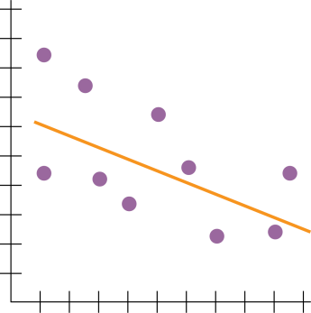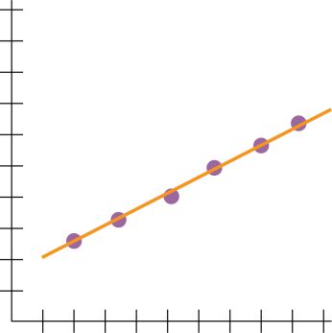

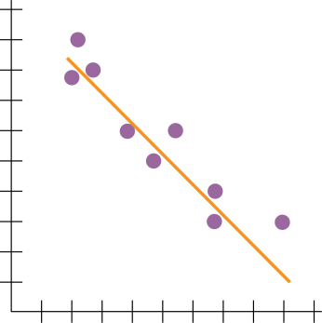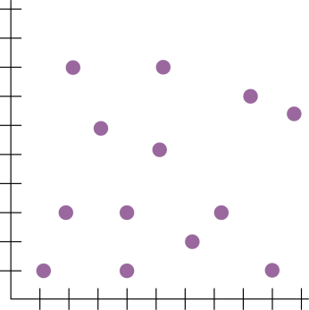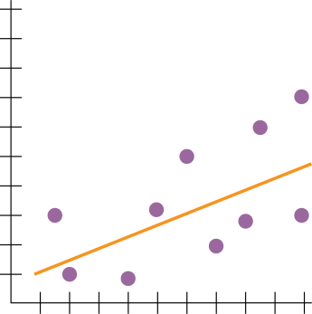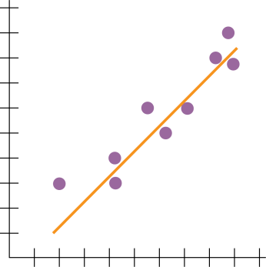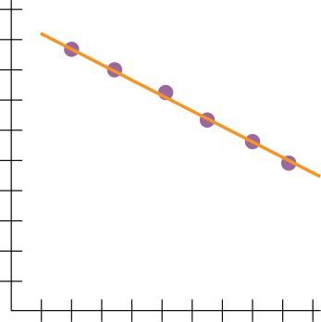

|  |  |  |
| --- | --- | --- |
| Strong positive correlation | Weak positive correlation | No correlation |
| Strong negative correlation | Weak negative correlation | Perfect positive correlation |
|  | Perfect negative correlation |  |

Correlation Coefficients

For each of the following identify their strength (strong, moderate, weak) and their direction (no, positive, negative)

|  |  |
| --- | --- |
| +1.0 |  |
| +0.8 |  |
| +0.5 |  |
| +0.3 |  |
| 0 |  |
| -0.3 |  |
| -0.5 |  |
| -0.8 |  |
| -1.0 |  |

moderate

moderate

negative

negative

negative

negative

no

perfect

perfect

positive

positive

positive

positive

strong

strong

weak

weak

Correlation Coefficients

For each of the following identify their strength (strong, moderate, weak) and their direction (no, positive, negative)

|  |  |
| --- | --- |
| +1.0 | perfect negative correlation |
| +0.8 | strong positive correlation |
| +0.5 | moderate positive correlation |
| +0.3 | weak positive correlation |
| 0 | no correlation |
| -0.3 | weak negative correlation |
| -0.5 | moderate negative correlation |
| -0.8 | strong negative correlation |
| -1.0 | perfect negative correlation |

**Paper 1 Section B Style Questions #2**

Sleepy head? It’s something we all do at least once a day yet varies a lot between people and can influence many other aspects of our life. The amount of sleep we get and the quality of the sleep can have both physical and cognitive consequences. However, too much sleep may be as bad as not getting enough. There are clearly lots of opportunities here to explore the relationship between sleep and behaviour. One such area of research could be to investigate if there is a correlation between the amount of sleep a person has and their ability to concentrate the next day.

1. Write a null hypothesis for this study. **[3]**
2. Explain how you would use the correlation technique to conduct this research. Justify your decisions as part of your explanation.

In your answer, the required features that you must refer to are:

* how you would obtain participants for the study
* how you would obtain data for variable 1
* how you would obtain data for variable 2
* how you would attempt to reduce the influence of one possible extraneous variable

You should use your own experience of practical activities to inform your response. **[15]**

1. **(a)** Describe **one** strength of having quantitative data in this study. **[3]**

**(b)** Describe **one** weakness of having quantitative data in this study. **[3]**

1. Outline **one** way that some qualitative data could be obtained in this study. **[3]**
2. **(a)** Outline **one** way that the external validity of this study could be considered to be high. **[3]**

**(b)** Outline **one** way that the external validity of this study could be considered to be low. **[3]**

1. Explain what the term ‘demand characteristic’ refers to in relation to your study. **[2]**

**Genetic explanation of mental illness**

**The genetic explanation suggests:**

|  |
| --- |
|  |

**Family studies are interesting when studying mental illness because…**

|  |
| --- |
|  |

**The aim of the Gottesman et al. (2010) study was:**

|  |
| --- |
|  |

**The sample was taken from:**

|  |
| --- |
|  |

**They gathered this information:**

|  |
| --- |
|  |

**They found:**

|  |
| --- |
|  |

**It was concluded that:**

|  |
| --- |
|  |

**Evaluation**

|  |  |
| --- | --- |
| **Strengths** | **Weaknesses** |
| * High in ecological validity * Representative sample * Ethical – records were available. Anonymity assured * Valid – diagnosis over time from ICD-8 to ICD-10 was valid * Useful to advise people on risks associated with having children, adopting and genetic counselling | * Difficult to rule out influence of shared environment * May be unethical to use results to discriminate people from having children, adopting or for increasing health insurance premiums * May only apply to Denmark |

Point

________________________________________________________________________________

Explanation

________________________________________________________________________________________________________________________

Conclusion

________________________________________________________________________________________________________________________

Point

________________________________________________________________________________

Explanation

________________________________________________________________________________________________________________________

Conclusion

________________________________________________________________________________________________________________________

# Issues and debates

|  |  |
| --- | --- |
| **Deterministic** |  |
| **Reductionist** |  |
| **Families share the same environment** |  |
| **Individual/situational explanations** |  |
| **Validity** |  |
| **Ethics** |  |
| **Usefulness of research** |  |
| **Socially Sensitive Research** |  |
| **Ethnocentrism/Sampling Bias** |  |

**AO2 = Application: Biological treatment of one specific disorder**

Drugs are a quick way of altering the chemical balance of a person in order to treat the symptoms of a mental illness. Research has shown that drug therapy works **faster** than both cognitive and behavioural treatments.

Benzodiazepines are prescribed for specific phobias.

Commonly prescribed benzodiazepines include:

* Valium (diazepam)
* Xanax (alprazolam)
* Klonopin (clonazepam)
* Ativan (lorazepam)

Benzodiazepine is a depressant and slows down the workings of the brain and the central nervous system. They are used medically to reduce anxiety, to help people sleep and to relax the body. They should only be prescribed by a doctor for short periods of time as it is possible to become dependent on them after as little as two weeks’ regular (e.g. daily) use.

**AO2: Getting Empirical Evidence: Pande et al (1999)**

randomly assigned 69 patients with social phobia to 2 groups:

* experimental group where they took medication to increase the levels of GABA for 14 weeks
* control group who took a placebo instead.

The experimental group showed a significant reduction in symptoms compared to the control group.

**AO3: Evaluation**

**Effectiveness** – explain whether it is effective or not in treating the abnormality

BZs are effective in treating specific phobias, as shown by Pande et al.

**Outcome studies** – how does the treatment compare with placebos

In the study by Pande et al, the experimental group showed a significant reduction in symptoms compared to the control group.

**Appropriateness** – explain whether or not it is appropriate to use. Refer to:

* + availability on the NHS – it is available on the NHS for short periods of time
  + **Palliative** versus **curative** – it is a palliative treatment. It maintains the patient in good mental health as long as they are taking the medication.
  + Whether it can be used alone or in **combination** with other therapies – it can be taken in combination with behaviourist and cognitive treatments such as CBT, flooding and systematic desensitisation.

Side effects of chemotherapies should ONLY be referred in relation to ‘treatment compliance’. Side effects of low doses include:

* Impaired memory
* Depression
* Drowsiness
* Feeling hungover the next day

Left: Outline 1 biological treatment for 1 specific disorder. [8]

Right: Evaluate 1 biological treatment for 1 specific disorder. [8]