Supplementing class and homework with independent learning is the ONLY way to secure a credible grade.
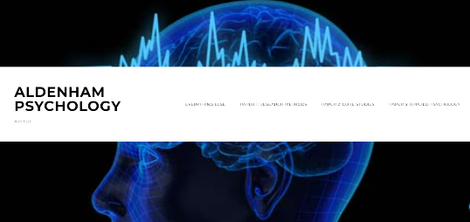
Make your lesson notes your own using www.aldenhampsychology.com

Know what the examiners want using www.ocr.org.uk - Psychology H567 – use the podcasts, candidate exemplars, question banks.
Practice and summarise your work using Quizlet https://quizlet.com/join/D6hvV863X

Take the practise tests on Dynamic Learning http://my.dynamic-learning.co.uk/ Centre ID: 18399 Generic Username: OCRPsyALTL Password: student

Research further - Best Websites
http://psychologywithmisssmith.wordpress.com
www.holah.co.uk
http://psychyogi.org/

Research further - Best Youtube videos
- Thomas Pond
- Jonathan Evans
- MissOwen1 for Research Methods
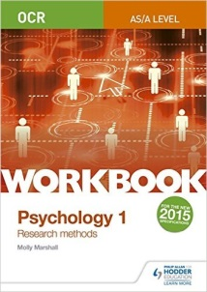
Complete the exercises in your textbook and Revision workbooks
Paper 1: ISBN: 1471845214
Paper 2: ISBN: 1471845206
Paper 3: ISBN: 1471845222

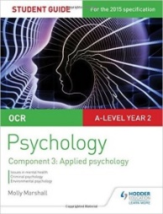
Practise further with text / revision books
ISBN 1471859460
ISBN: 1847623247

