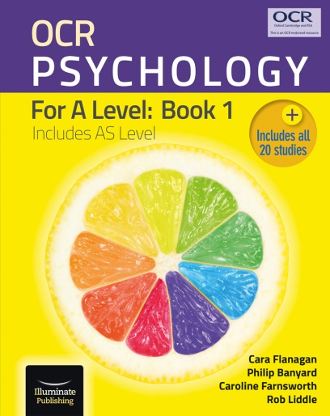
Prep: Casey Textbook questions page 241
- State what behaviour is linked to the inferior frontal gyrus. [1]
- State what behaviour is linked to the ventral striatum. [1]
- Identify the DV in each experiment. [2]
- What criteria were used to select Ps for experiment 1? [1]
- Describe the characteristics of the hot stimuli. [2]
- Why were only ‘hot’ faces used in experiment 2? [1]
- Explain the go/no-go task. [2]
- Go and go-go trials were presented in a pseudo-randomised order. What does pseudo-randomised mean? [1]
- In experiment 1, what did each trial consist of? [2]
- What percentage of the trials in experiment 1 were go trials? [1]
- How does fMRI scanning work? [2]
- Identify 3 differences between high and low delayers. [3]
- Give an example of an alluring stimulus in this study. [1]

- Summarise Casey’s Core Study into 5 marks worth of material (aim, sample, procedure, results, conclusions). [5]

Stretch and challenge
Watch Jonathan Evans' 4 videos on Casey on youtube.
https://www.youtube.com/watch?v=2leQcAYMdE4&t=26s

Answers
- Inferior frontal gyrus = resisting temptation
- ventral striatum = instinct
- DV: Performance on an impulse control task (go/no go task). This was measured in terms of reaction times and accuracy. Imaging from an fMRI scanner was also measured in the second experiment.
- Had previously participated in Mischel’s study at the age of 4, continued with the 1993 and 2003 follow ups.
- The “hot” version of the go/no-go task = fearful and happy facial expressions
- The cool version of the go/no go task had the same effect on both low and high delayers, so the hot version (social cues) would have produced greater differences in neural activity between high and low delayers.
- A go/no go task is a cognitive task in which participants are given the instructions to respond in a particular manner to a particular type of stimulus. For example click when you see a picture of a smiling face, but not when you see a picture of a non-smiling face.
- Numbers generated by a computer to be randomised.
- 160 trials
- 120/160 = 75%
- A face presented on the screen for 500 milliseconds and followed by a 1 second interval.
- 48. 35 were go and 13 were no go.
- 35 / 48 = 73%
- Magnetic field causes the atoms of the brain to change their alignment when the magnet is on and these emit various radio signals when the magnet is turned off. A detector reads the signals and uses them to map the structure of the brain.
- low delayers had
- more false alarms
- Reduced activity in right inferior frontal gyrus in correct no-go trials
- Greater activity in the ventral striatum (instinct and rewards) on happy ‘no-go’ trials
- Reduced activity in fronto-striatal region (ability to resist temptation)
- Happy face.
- Social or emotional cues
- integrates motivational (ventral striatum) and control (inferior frontal gyrus) processes.

R. personality test
 | Strongly  Agree  4 | Agree  3 | Disagree  2 | Strongly  Disagree  1
- I often view my past actions negatively
- When I have a moment to think, I reflect on my mistakes
- I would change the majority of things I have done
- It is alright to make mistakes because I learn from them
- I often reflect on my decisions and think of better solutions
- What has happened in the past often affects my future choices and decisions
- There are many things I wish I had done
- I don’t mind if I don’t finish what I start
- I rarely have trouble sleeping
- Memories of missed opportunities upset me quite a bit
- I can’t think of any actions I would change
- It’s easy to remember what my last silly decision was
- My conscience often reminds me that I have messed up.

Scoring:
My score is:
Add up your scores for each of the items.
Reverse the scores for the shaded items, so 4 = 1, 3 = 2, 2 = 3, 1 = 4.

13 – 25
You often do not show any regret for your behaviour and can sometimes come across as arrogant to others.

26 – 40
You show regret at times, though this does not affect you too badly, by keeping you up at night. Others are more likely to like you as you can show vulnerability, but not self-obsession.

40 – 52
You show a considerable amount of regret and this does affect you quite badly. People are likely to want to avoid you as your worrying can come across as allowing yourself to be a victim.
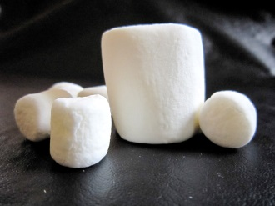
What behaviours do the children who EAT show? What behaviours do the children who DON’T eat show? What is the difference between them?

Use iPAD / phone / books to help you provide definitions for these
- Delay of gratification

- Longitudinal study

- Cognitive control

- fMRI

- Inferior frontal gyrus

- Prefrontal cortex

- Ventral striatum

- Limbic system

- The Marshmallow Test

Adolescent Self-Regulatory Inventory (ASRI) | Not at all true for me  1 | Not very true for me  2 | Neither true nor untrue for me  3 | Somewhat true for me  4 | Really true for me  5
1. It’s hard for me to notice when I’ve ―had enough (sweets, food, etc.).
2. When I’m sad, I can usually start doing something that will make me feel better.
3. If something isn’t going according to plan, I change my actions to reach my goal.
4. I can find ways to make myself study even when my friends want to go out.
5. I lose track of the time when I’m doing something fun.
6. When I’m bored I fidget or can’t sit still.
7. It’s hard for me to get started on big projects that require planning in advance.
8. I can usually act normal around everybody if I’m upset with someone.
9. I am good at keeping track of lots of things going on around me, even when I’m feeling stressed.
10. When I’m having a tough day, I stop myself from whining about it to people.
11. I can start a new task even if I’m already tired.
12. I lose control whenever I don’t get my way.
13. Little problems detract me from my long-term plans.
14. I forget about whatever else I need to do when I’m doing something really fun.
15. If I really want something, I have to have it right away.
16. During a dull class, I have trouble forcing myself to start paying attention.
17. After I’m interrupted or distracted, I can easily continue working where I left off.
18. If there are other things going on around me, I find it hard to keep my attention focused on whatever I’m doing.
19. I never know how much more work I have to do.
20. When I have a serious disagreement with someone, I can talk calmly about it without losing control.
21. It’s hard to start making plans to deal with a big project or problem, especially when I’m feeling stressed.
22. I can calm myself down when I’m excited or all wound up.
23. I can stay focused on my work even when it’s dull.
24. I usually know when I’m going to start crying.
25. I can stop myself from doing things like throwing objects when I’m mad.
26. I work carefully when I know something will be tricky.
27. I am usually aware of my feelings before I let them out.
28. In class, I can concentrate on my work even if my friends are talking.
29. When I’m excited about reaching a goal (e.g., getting my driver’s license, going to college), it’s easy to start working toward it.
30. I can find a way to stick with my plans and goals, even when it’s tough.
31. When I have a big project, I can keep working on it.
32. I can usually tell when I’m getting tired or frustrated.
33. I get carried away emotionally when I get excited about something.
34. I have trouble getting excited about something that’s really special when I’m tired.
35. It’s hard for me to keep focused on something I find unpleasant or upsetting.
36. I can resist doing something when I know I shouldn’t do it.

Adapted from: Moilanen, K. L. (2007). The Adolescent Self-Regulatory Inventory: The development and validation of a questionnaire of short-term and long-term self-regulation. Journal of Youth and Adolescence, 36, 835-848. Shaded questions have a reverse score (1 = 5, 3 = 3, 5 = 1)
Add all the scores together. Higher scores indicate an ability to self-regulate. My score is _______________________________
Scores can range from 36 – 180. 144 is the median
Short-term vs. long-term self-regulation capacity can also be measured.
Short-term regulation items are: 2, 6, 8, 9, 11, 13, 14, 16, 17, 18, 19, 21, and 22. Higher scores = greater ability to self-regulate in short-term.
Long-term regulation items are: 3, 4, 12, 15, 20, 23, 25, 26, 27, 28, 29, 30, 31, and 36. Higher scores = greater ability to self-regulate in the long-term

AIM: To investigate the extent to which the ability to resist temptation at preschool age affected the same participants in adulthood. Control over impulses and sensitivity to social cues at the behavioural and neural level were examined.

Method
- The study was longitudinal, tracking the same Ps from age 4 until they reached their 40s.
- It was composed of 2 natural (quasi) experiments as the IV was naturally occurring.

What was the IV and how was it operationalized?

Participants
The sample was drawn from an initial cohort of 562 pupils aged 4 who had attended Stanford’s Bing Nursery School and completed the original delay gratification task during the late 1960s and early 1970s. From this, 155 then completed a self-control scale in their 20s, reducing to 135 Ps who undertook the same measure in their 30s. Of those who scored either above or below in terms of delay-of-gratification and self-control across all previous tests, 117 were contacted. 59 of these (23 males, 36 females) consented to take part in Experiment 1. Of these, 27 (13 males and 14 females) also took part in Experiment 2. The researchers excluded one male participant’s results from Experiment 2 owing to poor performance on the behavioural task.

Procedure and design
Experiment 1:
 | GO | NO GO
Male | Male/Go | Male/No-go
Female | Female/Go | Female/No-go

Experiment 1-Overview
- Sample divided into 32 high delayers (12 male and 20 female) and 27 low delayers (11 male, 16 female).
- Given consent to take part in a ‘hot’ and ‘cool’ impulse task.
- Completed in own homes with a pre-programmed laptop.
- Instructed to either press a button (go) or withhold from pressing (no-go).
- Cool-included the presentation of faces. One sex was the ‘go’ stimulus, the other sex was the ‘no go’ stimulus.
- Faces were drawn from the NimStim set of facial expressions.
- Ps were instructed to respond as quickly and accurately as they can.
- Each face appeared for 500 milliseconds followed by a 1 second interval.
- 160 trails were used in a random order (this is known as a 2 x 2 factorial design-see table).
- The hot task varied by facial expressions only (not neutral anymore e.g. happy and fearful).
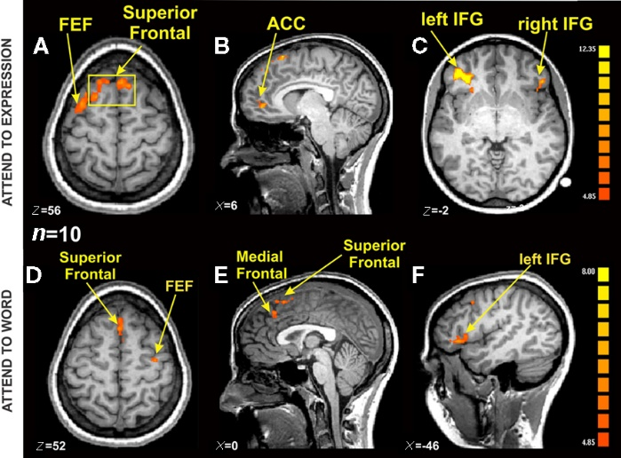
Experiment 2-Overview
- Sample contained 15 high delayers (5 males and 10 females) and 11 low delayers (7 male and 4 female).
- Ps were scanned with fMRI (functional magnetic resonance imaging) whilst completing a ‘hot’ version of the go/no go task.
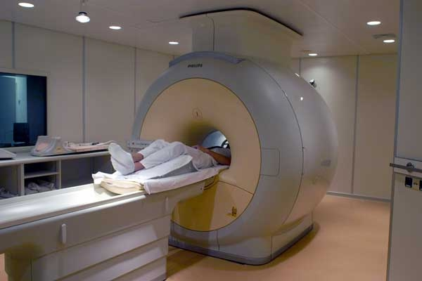
- An electronic response pad was used to record responses to facial stimuli and reaction times.
- 48 trails were presented during each run (35 go and 13 no-go).
- Each face appeared for 500 milliseconds followed by intervals ranging from 2 seconds to 14.5 seconds.
- Researchers collected imaging data for 26 no-go trials and 70 go trials per facial expression.

Results
Experiment 1: Both groups were highly accurate in their correct responses to go trials in both ‘cool’ and ‘hot’ conditions (99.8% and 99.5%). Low delayers were slightly more likely to respond mistakenly in no-go trials and performed slightly worse than high delayers in the ‘hot’ version of the task. Low delayers identified at 4 years of age showed greater difficulty suppressing their responses to happy faces than high delayers.
Experiment 2: No significant difference between the two delay groups on reaction times in current go trials. Accuracy across both groups was very high for go trials, as in experiment 1. Similarly, low delayers had higher false-alarm rates in no go trials (14.5%). As expected the right inferior frontal gyrus is critical in withholding responses with low delayers showing reduced activity in this region during the key no-go trails, as compared to high delayers or during go-trials. There were high levels of activity in the reward-related region (ventral stratum) for low delayers compared to the high-delay participants. This was most prominent during happy no-go trials for the low delayer.

Maths moment: In experiment 1, low delay participants committed more false alarms (14.5%) than high delay participants (10.9%). Draw and label a bar chart below to illustrate this.

Conclusions
- Resistance to temptation appears to be relatively stable characteristics of an individual over time.
- Cognitive control can be strongly influenced by contextual factors (e.g. ‘hot’ cues in alluring situations).
- Ventral fronto-striatal circuitry supports resistance to temptation, with a combination of lowered activity in their interior frontal gyrus and increased activity in the ventral stratium in low delayers.
Longitudinal
- Research which follows P over a long period of time
- Usually involved repeated measures design

Strengths of longitudinal research
1) Accurate method of assessing change over time
2) Not affected by individual differences, as it is the same Ps

Weaknesses of longitudinal research
1) Subject attrition (dropping out)
2) Could cause researcher bias

Snapshot
- Research where P's from different groups are studied simultaneously
- Carried out once
- The results are compared
Strengths of snapshot research
Quick way of gathering a lot of data
Less likely to have subject attrition
Weaknesses of snapshot research
Increase in individual differences
May over-estimate the effect of variables

N | E | O | O | A | E | Q | A | O | X | M | A | Y | Y | L | S | Y | I | N | I
A | V | C | O | O | L | C | U | E | S | I | T | I | H | T | A | R | S | N | L
T | I | T | I | F | P | N | R | A | E | I | T | S | L | N | S | R | F | R | A
U | T | V | E | I | M | E | H | I | L | F | I | O | T | I | M | E | E | Y | N
R | A | G | I | I | A | T | I | I | O | I | N | C | E | E | R | P | V | C | R
A | T | C | V | G | S | E | B | H | N | G | T | A | V | I | M | S | V | R | E
L | I | L | O | A | L | A | T | K | I | L | X | A | O | U | Y | C | E | E | T
S | T | N | A | P | I | C | I | T | R | A | P | R | T | G | O | T | X | I | N
L | N | O | I | L | I | D | U | D | U | G | F | A | N | I | O | N | P | S | I
A | A | N | E | R | O | D | E | I | S | R | I | I | D | D | V | N | E | E | A
C | U | R | M | L | I | L | A | A | O | R | L | T | V | E | L | E | R | U | S
I | Q | F | C | N | A | T | V | N | T | R | E | A | A | T | G | S | I | C | N
G | E | I | A | P | D | P | T | S | N | V | A | P | N | S | I | I | M | T | A
O | N | L | T | Y | M | A | L | C | A | S | E | Y | E | R | K | N | E | O | P
L | Y | O | L | C | L | A | T | L | P | E | A | I | A | A | E | T | N | H | S
O | P | R | M | G | R | V | O | L | U | N | T | E | E | R | T | T | T | C | H
I | E | T | Y | T | I | I | L | M | N | N | R | L | T | I | R | E | X | T | O
B | A | R | N | Y | T | I | D | I | L | A | V | T | L | S | P | U | D | E | T
E | U | E | O | U | V | B | R | N | E | L | N | D | R | A | R | R | U | E | A
S | V | I | E | G | R | U | E | P | A | A | N | A | R | T | D | H | Q | R | E

- Biological
- Casey
- Cool cues
- DV
- Experiment
- External
- fMRI
- Go
- Hot cues
- Inferior frontal gyrus
- Internal
- IV
- Laptop
- Longitudinal
- Natural
- No-go
- Participants
- Qualitative
- Quantitative
- Reliability
- Repeated
- Sample
- Snapshot
- Sperry
- Task
- Validity
- Ventral striatum
- Volunteer

Timed Test: Casey Total ___/14

- Casey’s study was a longitudinal study, whereas Sperry’s was a ‘snapshot’ study. A strength of a longitudinal study is _______________________________________________________________ _______________________________________________________________

- A weakness of a longitudinal study is ______________________________________________________________________________________________________________________________

- A smiling face is an example of a ___________________

- A male neutral face is an example of a ___________________

- Pressing a buzzer is an example of a ___________________

- Stopping yourself from reacting is an example of a ___________________

- Casey’s first experiment was in a _________________________ environment

- Casey’s second experiment was in a _______________________ environment

- The independent variable of Casey’s study was...
______________________________________________________________________________________________________________________________

- The dependent variable of Casey’s first experiment was... _______________________________________________________________
_______________________________________________________________

- In experiment #1, both groups were very ______________________________ in their correct responses to “Go” trials in both the cool and hot conditions.

- In experiment #2, each face stimulus was presented for _______ milliseconds.

- The right inferior frontal gyrus part of the brain is involved in _______________________________________________________________

- The ventral striatum part of the brain is involved in _______________________________________________________________

- 1,000
- 500
- Accurate
- Controlled
- Cool cue
- Field
- Go task
- Hot cue
- Inaccurate
- Laboratory
- Natural
- Responding to rewards
- Showing change over time
- Subject attrition
- The participants' accuracy on the go/no tasks
- Whether a person was a high or low delayer
- Withholding responses

Answers

- Showing change over time
- Subject attrition
- Hot cue
- Cool cue
- Go task
- No Go Task
- Natural
- Controlled
- Whether a person was a high or low delayer
- The participants' accuracy on the go/no tasks
- Accurate
- 500
- Withholding responses
- Responding to rewards

Research Method
Identify the research method used:

Laboratory OR Field OR Natural
Experiment
Identify the strengths and weaknesses of this research method.
Strengths

Weaknesses

Research Timeframe
Identify the research timeframe used:

Longitudinal OR Snapshot
Identify the strengths and weaknesses of this research timeframe.
Strengths

Weaknesses

Experimental Design
Identify the research design used:

Repeated OR Independent Measures OR Matched Pairs

Identify the strengths and weaknesses of this research design.
Strengths

Weaknesses

Reliability - ‘Is the study consistent?’
Did all participants experience the same procedure?
Is the study replicable?

Validity - ‘Is the study measuring what it is supposed to measure?’
Would the participants be affected by demand characteristics (did they know the purpose of the study)?
Is this procedure valid?
Data – ‘What type of data were collected?’
How were data recorded?
Were the findings quantitative or qualitative? Explain why.
How might the strengths and weaknesses of this type of data affect this study?
Ethics - 'Does the study break any ethical guidelines?’
Consent? | Informed consent WAS gained
Deception? | There was no deception
Confidentiality? | All of the people’s details were kept confidential
Debrief? | All of the Ps were offered a debrief
Withdrawal? | All of the Ps were advised that they could leave at any time
Protection from harm?

E
Both
B C
D G
H J
N O
P C

Topic
- Delay of gratification
- Different regions of the brain have different roles (localisation of function)
- Perception and Memory

Research Method and Design
- Experiments - took place in a controlled environment
- Laboratory experiment
- Longitudinal study
- Natural experiment
- Repeated measures design
- Snapshot study

Sampling Technique and Sample
- Restricted – Ps were chosen from those who had undergone previous operation / experiment.
- 11
- 27
- 59

Data
- The measurement of the DV produced quantitative data
- The tasks lacked mundane realism, so the results may lack ecological validity.

Applications
- Useful in understanding specific problems from brain damage

Key theme in Biological Psychology
- The corpus callosum unites streams of conscious thought in left and right hemispheres
- The prefrontal cortex and ventral striatum are important in resisting temptation.

Tasks
- Place the letters A – R in the correct area of the Venn Diagram.
- Explain what each of the statements A – R mean.
- Explain one strength and one weakness of statements E – I

 |  | Strength | Weakness
E. | Laboratory experiment
F. | Longitudinal study
G. | Natural experiment
H. | Repeated measures design
I. | Snapshot study
Topic
- ______________________________________________________________________________________________________________
- ______________________________________________________________________________________________________________
- ______________________________________________________________________________________________________________
Research Method and Design
- ______________________________________________________________________________________________________________
- ______________________________________________________________________________________________________________
- ______________________________________________________________________________________________________________
- ______________________________________________________________________________________________________________
- ______________________________________________________________________________________________________________
- ______________________________________________________________________________________________________________
Sampling Technique and Sample
- ______________________________________________________________________________________________________________
- ______________________________________________________________________________________________________________
- ______________________________________________________________________________________________________________
- ______________________________________________________________________________________________________________
Data
- ______________________________________________________________________________________________________________
- ______________________________________________________________________________________________________________
Applications
- ______________________________________________________________________________________________________________
Key theme in Biological Psychology
- ______________________________________________________________________________________________________________
- ______________________________________________________________________________________________________________

 |  | Strength | Weakness
E. | Laboratory experiment | Control = reliability | Artificial – lacks validity
F. | Longitudinal study | Change over time | Subject attrition
G. | Natural experiment | High ecological validity | Small sample
H. | Repeated measures design | Less Ps needed | Boredom and subject attrition
I. | Snapshot study | Quicker | Results could be anomalies

Strengths | Research to illustrate | Weaknesses | Research to illustrate
Very scientific – the biological approach adopts all the features of science including objectivity and reliability. Brain imaging techniques are not open to subjective interpretation. |  | Reductionist by way of reducing the cause of complex behaviours to a physiological basis, ignoring other possible causes of behaviour.
Usefulness of research – provided in the extensive application of treatments. |  | Deterministic by way of assuming biology is the cause of behaviour would imply individuals have no free will in how they behave.

Debates in Psychology
The biological area can be reductionist in its approach. This is because it breaks complex down into more ones. For example, the biological area explains behaviour through the consequences of genetics and physiology and rejects the influence of the on our behaviour.

The biological area offers a good counter to the nurture side of the nature vs. nurture debate. For example, the biological area seeks to explain processes and behaviour by on the function of the brain and nervous system.

The biological area can be considered deterministic. One of its basic is that all that is psychological is first physiological. This reduces the amount of free will an individual has in their . For example, abnormality is explained by genetics.

The biological area adopts many features of in its approach.
is achieved through the use of brain scanning techniques. I the experimental method which increases the reliability of its results.

Abnormality
Argument
Assumptions
Behaviour
Considered
Environment
Focusing
Fundamental
Mental
Objectivity
Processes
Science
The Biological Area:
Paper 2 Section B style questions and answers

- Outline the biological area of psychology. (2)
The biological area studies the physiological causes of human behaviour (e.g. genes, hormones, brain function, etc.). It assumes that behaviour is determined by biological factors.

- Explain how any one core study can be considered to be located within the area of biological psychology. (5)
The biological area studies the physiological causes of human behaviour (e.g. genes, hormones, brain function, etc.). This links to the aim of Sperry’s study which was to study how the behaviour of split-brain patients during tactile and visual tasks would be affected by having a severed corpus callosum.

The biological area assumes that behaviour is determined by physiological causes. This was supported by Sperry’s finding that split-brain patients could not verbally describe visual information presented to their left visual field, due to being sent to the right hemisphere where there are no language centres. This behaviour was biologically determined by the split-brain patients’ brain physiology (lack of corpus callosum).

- Explain one strength of the biological area of psychology. (3)
One strength is that research in this area is very scientific. For example, Casey’s experiment used highly standardised procedures as all participants completed the same trials using the same computer programme and were monitored using an fMRI scanner. This makes the study highly replicable and thus more scientific.

- Explain one weakness of the biological area of psychology. (3)

One weakness is that research in this area often lacks ecological validity. For example, Casey found that low-delayers made more errors on the happy face No-Go trials due to being unable to resist this rewarding stimulus. However, rewarding stimuli may be processed differently in a computer trial than in real life so these findings cannot be generalised to real life settings.

- Explain how the biological area of psychology is different to the social area of psychology. (12)

Similarities:
- Both areas are deterministic as certain factors are assumed to determine behaviour (e.g. lack of corpus callosum determines performance on visual and tactile tasks / presence of authority determines obedience)
- Both areas are reductionist as they explain behaviour using only one concept (e.g. delayed gratification caused by brain function, ignores social factors / obedience to authority caused by situational context, ignores individual factors)

Differences:
- Biological area used more objective/scientific data collection methods than social area (e.g. biological – fMRI scans, social – observation)
- Biological area supports ‘nature’ debate (delayed gratification caused by brain activity – Casey), social area supports ‘nurture’ debate (obedience caused by situational influences – Milgram).

- Explain how one core study supports the nature debate. (5)
Casey found that resistance to temptation is a relatively stable individual difference (4 year olds who were unable to delay gratification in the Marshmallow Test continued to show reduced self-control in tests carried out in their 20s and 30s). This suggests that people may be born destined to be ‘low-delayers’ or ‘high-delayers’ – determined by genetic factors that control brain activity (‘nature’).

Casey also found that low-delayers showed increased brain activity in the ventral striatum and decreased activity in the inferior frontal gyrus when trying to resist rewarding stimulus (happy faces) in No-Go trials. This supports the idea that behaviour (self-control) is linked to biological factors in the brain (‘nature’).

The Biological Area:
Paper 2 Section C style questions and answers
A sweet experiment
During a psychological experiment, Bryan was asked to sit down and pick a treat from a tray of sweets, biscuits and corn sticks. Bryan chose the sweets. Although he’s now fifty-four, Bryan still loved those little multi-coloured sweets. “I know I shouldn’t still like them at my age” he says, “but since I was a child I’ve never been able to resist!” A researcher than made Bryan an offer: he could either eat one sweet right away or, if he was willing to wait while he stepped out for five minutes, he could have two sweets on his return. The test started. At 3 minutes 30 seconds Bryan ate the sweet.

- Explain why this article can be viewed as being relevant to the biological area of psychology. [4]

The biological area assumes that all thoughts, feelings and behaviours ultimately have a physiological cause (e.g. genes, hormones, brain function, etc.). The article states that 54-year old Bryan loves sweets and that since he was a child he’s “never been able to resist” – this suggests that his inability to resist temptation (delay gratification) is an individual characteristic that is stable over time, which means it could be determined by genetic factors.

- Briefly outline one core study and how it can be viewed as relevant to the behaviour described in the article. [5]

Casey’s study found that, compared to high-delayers, low-delayers showed increased activity in the ventral striatum (associated with emotion) and decreased activity in the inferior frontal gyrus (associated with cognitive control) during the ‘no-go’ trials for the ‘hot’ (emotional) task. As Bryan was unable to resist eating the sweet, it is likely that he is a low delayer and would have shown similar brain activity while trying to resist the sweet.

Casey also found that resistance to temptation is a relatively stable individual difference (4 year olds who were unable to delay gratification continued to show reduced self-control in self-control tests carried out in their 20s and 30s). This appears to be the case for 54-year old Bryan who says he has been unable to resist sweets ever since he was a child, suggesting that his inability to resist temptation is an individual difference unique to Bryan’s personality.

- Identify one psychological issue raised by the above article. Support your answer with evidence from the article. [4]

One psychological issue raised by the article is that individuals who struggle to delay gratification (low delayers) may suffer negative consequences in their lives. For example, Bryan appears to be unable to control his desire to eat sweets (shown by eating the sweet after 3.5 minutes), and since he was a child he’s “never been able to resist” – this could mean that people like Bryan could suffer from obesity if also unable to resist other unhealthy foods. It is also possible that low-delayers will struggle with self-control in other contexts, e.g. addiction to alcohol or drugs.

