Name______________________________________________________________

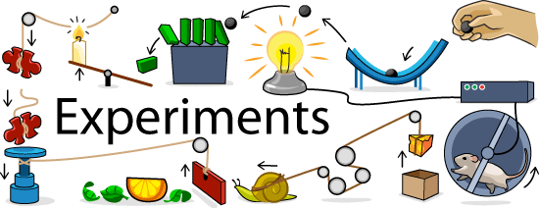
Experiments
- Can manipulate one variable and keep everything else the same.
- Allocate participants into groups.
- If the groups think or behave differently then you know it’s the thing you have manipulated (the independent variable - IV) that caused the different result (the dependent variable - DV), as everything else was kept the same.

- Identify as many things as you could manipulate between two groups to see if it makes a difference in their intelligence test scores (e.g.: hot room/cold room, drinking coffee/not drinking coffee)?

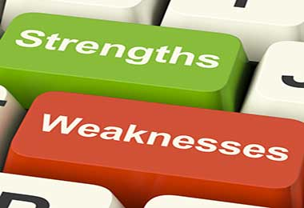
Evaluation
• Experiments are one of the most scientific ways to find evidence.
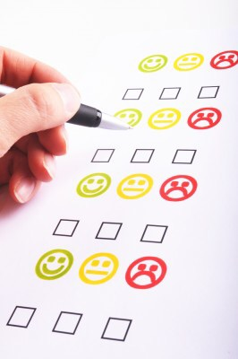
• But they are often done in unrealistic environments.

Self-Report
- Can ask people how they think and behave.
- Can conduct interviews or fill in questionnaires.
- Psychologists collect the data and make conclusions about how people think and behave.

- How many different ways can you conduct a self-report?

- What is a topic people are unlikely to tell you the truth about?

Evaluation
People can sometimes not understand themselves, or not tell you the truth, or only tell you about their intentions.

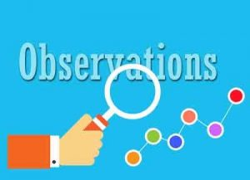
Observation
• Can watch how they behave.
• Focuses on their observable behaviour.
• Gather data and make conclusions based only on what you can observe.

- Why might two different people who have observed the same event not agreed on what they saw?

- Why might people complain about being observed?

Evaluation
People may change their behaviour if they know they are being observed.

Correlations
Determining the extent of a relationship between 2 variables (things that change)

- Does having no friends make us unhappy or does being unhappy make us lose friends?

- Identify two variables that are related – positively or negatively correlated? (e.g. height/shoe size, age/intelligence)

Evaluation
- Correlations tell us about the relationships between variables, but not if one variable caused the other.
- Helpful to do when it is unethical to split people into different groups and treat them differently (such as deliberate neglect of a group of children) or when it is impractical or impossible to manipulate the variables (such as make one group rich and one group poor).
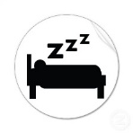
How can the different research methods be used to study the same topic?
- Does sleep affect your learning?
Experiment / Self-Report / Observation / Correlation
Ask people for their experiences of how well they perform in thinking tasks when deprived of some sleep.
Depriving people of sleep and then testing them using the Bop it
Matching the data from a sleep quality app and A Level performance
Watching sleep-deprived people do tricky thinking tasks

For your chosen research area, identify HOW you would study it, using the 4 different research methods. My research area: __________________________

- Correlation
__________________________________________________________________________________________
_____________________________________________

- Observation
_______________________________________________________________________________________________________________________________________

- Experiment
_______________________________________________________________________________________________________________________________________

- Self –report
_______________________________________________________________________________________________________________________________________

Stretch and challenge:
Independent variable in my area of research is ________________________
Dependent variable in my area of research is ________________________

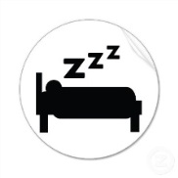
Evaluating the Research Methods in Context
Does sleep affect your learning?
Mark scheme: 1 mark for each of the following:
- for identifying an appropriate advantage
- for an explanation of the advantage
- for explaining the advantage in this context
- for identifying an appropriate disadvantage
- for an explanation of the disadvantage
- for explaining the disadvantage in this context

- Explain one strength and one weakness of using a self-report method (A) for this study. [6]
- Explain one strength and one weakness of using an experimental method (B) for this study. [6]
- Explain one strength and one weakness of using a correlational analysis (C) for this study. [6]
- Explain one strength and one weakness of using an observation (D) for this study. [6]
__________________________________________________________________________________________________________________________________________________________________________________________________________________________________________________________________________________________________________________________________________________________________________________________________________________________________________________________________________________________________________________________________________________________________________________________________________________________________________________________________________________________________________________________________________________________________________________________________________________________________________
Stretch and challenge: annotate where each of the 6 marks should be allocated to your answer.

